

**Text to Talk: Connecting Schools and Families**

**Simple Machines Study Texts**

***Simple Machines* texts**

Text 1:

Our new words are force, lever, pulley, wedge. Help your child learn the words. Click https://sites.temple.edu/texttotalk/machine1 for definitions.

Text 2:

Our new words are wheel and axle, operate, investigate. Help your child learn the words. Click https://sites.temple.edu/texttotalk/machine2 for definitions.

Text 3:

Our new words are tilt, angle, friction, surface. Help your child learn the words. Click https://sites.temple.edu/texttotalk/machine3 for definitions.

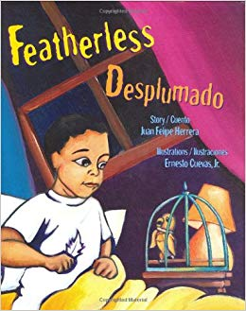***Featherless*by Juan Felipe Herrera**

Text 1:

Our new words are pebble, thimble, wheelchair. Help your child learn the words. Click <https://sites.temple.edu/texttotalk/feather> for definitions.

Text 2:

Ask your child to find pebbles. Talk about what it would be like to use a wheelchair.

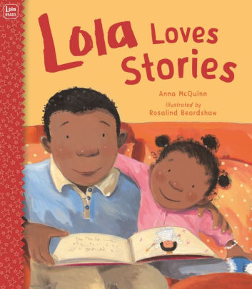

***Lola Loves Stories* by Anna McQuinn**

Text 1:

Our new words are Paris, Lagos, fierce, amazing. Help your child learn the words. Click https://sites.temple.edu/texttotalk/lola for definitions.

Text 2:

Ask your child what animals are fierce. Ask if something amazing happened to them today or tell them something amazing that happened to you.

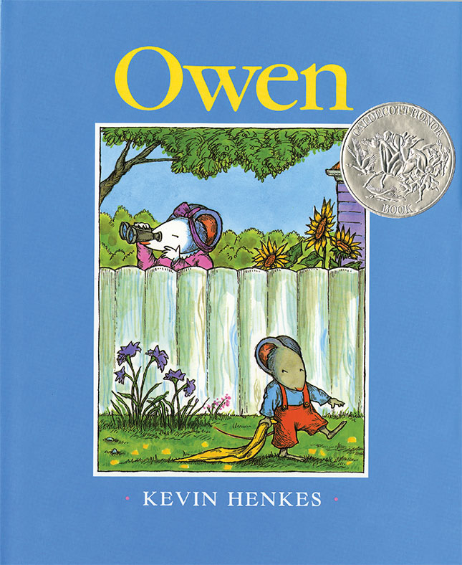***Owen* by Kevin Henkes**

Text 1:

Our new words are essential, vinegar, handkerchief, terrific. Help your child learn the words. Click https://sites.temple.edu/texttotalk/owen for definitions.

Text 2:

Ask your child what vinegar tastes like. Talk about what things are essential.

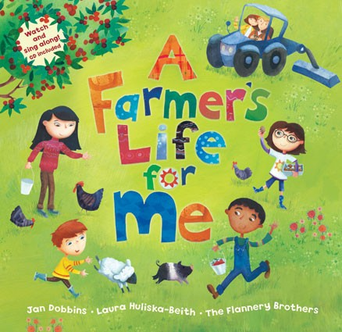***A Farmer's Life for Me* by Jan Dobbins and Laura Huliska-Beith**

Text 1:

Our new words are orchard, ripen, water trough, shed. Help your child learn the words. Click https://sites.temple.edu/texttotalk/farmer for definitions.

Text 2:

Ask your child what grows in an orchard. Ask what animal drinks out of a water trough or what you might store in a shed.