

**Text to Talk: Connecting Schools and Families**

**Balls Study**

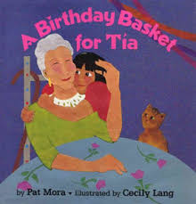

***A Birthday Basket for Tia***

Text 1:

Our new words are pineapple, watermelon, basket, musician. Help your child learn the words. Click <https://sites.temple.edu/texttotalk/birthday/> to see definitions.

Text 2:

Ask your child to describe pineapple and watermelon. Ask your child what they might put in a basket. Talk about your favorite musicians.

***Bounce***

Text 1:

Our new words are bounce, roller skates, bunny, market. Explain the words to your child. Click <https://sites.temple.edu/texttotalk/bounce/> to see definitions.

Text 2:

Ask your child what a baby rabbit is. Ask your child what toys bounce. Ask your child what they might buy at a market.

***Have a Ball***

Text 1:

Our new words are plastic, metal, glass, round. Talk about the words with your child and click <https://sites.temple.edu/texttotalk/have-a-ball/> to see definitions.

Text 2:

Find objects in your house that are plastic, metal, glass, and round and help your child learn the differences between the words.

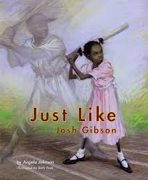***Just Like Josh Gibson***

Text 1:

Our new words are plate, bases, fielder, and baseball glove. Help your child learn the words. Click <https://sites.temple.edu/texttotalk/gibson/> for definitions.

Text 2:

Learn words through play! Pretend to be play a baseball game, set up bases, plates, assign a fielder and use a baseball glove.

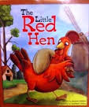***Little Red Hen***

Text 1:

Our new words are harvest, kneaded, chore, aroma. Help your child learn the words. Click <https://sites.temple.edu/texttotalk/little-red-hen/> for definitions.

Text 2:

Talk about what crops are harvested from the land. Ask your child to do a chore around the house or smell the aroma of dinner.

***Play Ball***

Text 1:

Our new words are juggle, marble, coach, and mitt. Help your child learn the words. Click <https://sites.temple.edu/texttotalk/play-ball/> for pictures.

Text 2:

Ask your child what a coach does. Play with a baseball mitt, marbles, or try juggling together!

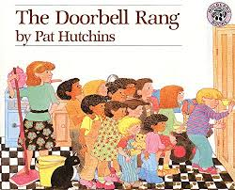

***The Doorbell Rang***

Text 1:

Our new words are share, stare, enormous, tray. Help your child learn the words. Click <https://sites.temple.edu/texttotalk/doorbell/> for pictures.

Text 2:

Ask your child to show you what staring means. Ask your child to find an enormous cloud in the sky.

***Three Billy Goats Gruff***

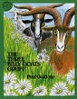

Text 1:

Our new words are valley, hooves, wobble, stomp. Explain the words to your child. Click <https://sites.temple.edu/texttotalk/goat/> to see pictures.

Text 2:

Show your child a picture of a valley and different animals’ hooves. Ask your child to stomp their foot and wobble on their legs.