Text to Talk: Connecting Schools and Families
Trees Study Texts

What Texts Should I Send?
We have prepared all the texts for you to send. (If you want to send additional texts about other words or books that is fine! We just ask that you send our texts at a minimum.) You can see the Trees Study texts that are to be sent over Remind starting on page 2 of this document. There are texts from nine Creative Curriculum books, with four words for you to focus on in class and for the families to help the children learn. You will send these texts around the time you read each book.

For example, if you read Abiyoyo on Monday, you can send Text 1 on Monday and Text 2 on Tuesday or Wednesday. Or, if you wish to send the first text before you read the book and the second after, that is ok too.
.
Thank you for all you do!

Trees Study Books and Words

Trees Study Books | Trees Study TtT words
Abiyoyo | roots, creature, landscape, bask
Trees Count | trunk, seeds, golden, blossom
The Grouchy Ladybug | grouchy, puffed, jaws, flipper
Chick Chicka Boom Boom | coconut, tangle, loop, wiggle
Henny Penny | pecking, shortcut, den, feast
Who Lives in Trees? | nest, owl, glide, woodpecker
Our Tree Named Steve | grouchy, puffed, jaws, flippers
A Grand Old Tree | roots, creature, landscape, bask
Growing Trees | hike, forester, sprout, root

Trees Study Texts

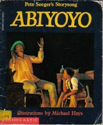
Abiyoyo
Text 1:
Our new words are ukulele, magician, wand, disappear. Help your child learn the words. Click https://sites.temple.edu/texttotalk/abiyoyo/ for definitions.

Text 2:
Ask your child what instrument Abiyoyo plays (a ukulele). Ask your child to pretend to be a magician with a wand.

Trees Count

Text 1:
Our new words are trunk, seed, golden, blossom. Help your child learn the words. Click https://sites.temple.edu/texttotalk/count/ for pictures and definitions.

Text 2:
Play a finding game with your child and help them find tree trunks, seeds, blossoms, and something with a golden color.

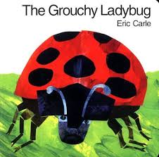
The Grouchy Ladybug

Text 1:
Our new words are grouchy, puffed, jaws, flippers. Help your child learn the words. Click https://sites.temple.edu/texttotalk/the-grouchy-ladybug/ for pics and definitions.

Text 2:
Ask your child to show you a grouchy face. Help your child find their jaw and puff up their cheeks. Ask them what animals have a flipper.

Chicka Chicka Boom Boom
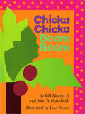
Text 1:
Our new words are coconut, tangle, loop, and wiggle. Explain the words to your child. Click https://sites.temple.edu/texttotalk/chika/ for pictures.

Text 2:
Ask your child to draw a loop with his or her finger. Ask you child about coconuts. Ask your child to show you how to wiggle.

Henny Penny
Text 1:
Our new words are pecking, shortcut, den, feast. Help your child learn the words. Click https://sites.temple.edu/texttotalk/henny-penny/ for pictures and definitions.

Text 2:
Ask your child to show you how a hen might peck her food. Show your child a shortcut for getting home. Help your child make a pretend den.

Who Lives in Trees?
Text 1:
Our new words are nest, owl, glide, and woodpecker. Help your child learn the words. Click https://sites.temple.edu/texttotalk/who-lives/ for pics and definitions.

Text 2:
Check if your child is learning. Ask your child to pretend to be an owl or woodpecker or to glide through the air. Do they understand?

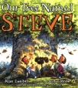
Our Tree Named Steve
Text 1:
Our new words are pronounce, camp out, hammock, protect. Help your child learn the words. Click https://sites.temple.edu/texttotalk/steve/ for definitions.

Text 2:
Ask your child what the words pronounce, camp out, hammock, or protect mean. If they don’t know, help explain the word’s meaning.

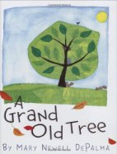
A Grand Old Tree

Text 1:
Our new words are roots, creatures, landscape, bask. Help your child learn the words. Click https://sites.temple.edu/texttotalk/grand/ for definitions.

Text 2:
Ask your child why trees have roots. Ask him or her what creatures live in trees. Ask your child what it feels like to bask in the sun.

Growing Trees
Text 1:
Our new words are hike, forester, sprout, root. Help your child learn the words. Click https://sites.temple.edu/texttotalk/growing-trees/ for pictures and definitions.

Text 2:
Ask your child if they can tell you what hike, forester, sprout, and root mean. If they don’t know, show them pictures and help them learn.

Final Message
Continue using the words with your child in conversation and helping them to use them when they talk and play. Thank you for all the work you are doing!

