Text to Talk: Connecting Schools and Families

Signs Study Texts

What Texts Should I Send?
We have prepared all the texts for you to send. (If you want to send additional texts about other words or books that is fine! We just ask that you send our texts at a minimum.) You can see the Signs Study texts that are to be sent over Remind starting on page 2 of this document. There are texts from six Creative Curriculum books, with three or four words for you to focus on in class and for the families to help the children learn. You will send these texts around the time you read each book.

For example, if you read Marisol McDonald Doesn’t Match on Monday, you can send Text 1 on Monday and Text 2 on Tuesday or Wednesday. Or, if you wish to send the first text before you read the book and the second after, that is ok too. For Text to Talk, the critical thing is for the texts to be sent; the exact timing of when they are sent is less important and is left up to the teacher.

The goal is to send all the texts for each Study. Even if you are not able to read a particular book, the parents will still appreciate receiving the texts and new words. For the purposes of our study, it’s important that all are sent out. For example, if you don’t read Marisol McDonald, please still talk about the words in class and send the texts home to the families.

Signs Study Books and Words

Signs Study Books | Signs Study TtT words
Marisol McDonald Doesn’t Match | match, clash, sign my name
Signs of All Kinds | triangle, circle, diamond, square
Estela’s Swap | music box, tune, price, earn
The Dot | polar bear, jab, frame, blank
Bean Soup | garlic clove, fragrant, pebbles
Quinito’s Neighborhood | climb, slide, long, short

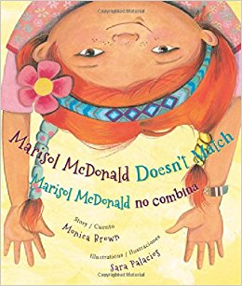
Marisol McDonald Doesn’t Match

Text 1.
Our new words are match, clash, sign my name. Click https://sites.temple.edu/texttotalk/marisol to see pictures and definitions and talk about the words.

Text 2:
Talk with your child about the difference between matching and clashing. Practicing signing your name together.

Signs of All Kinds

Text 1:
Our new words are triangle, circle, diamond, square. Click https://sites.temple.edu/texttotalk/signs to see pictures and definitions. Explain the words.

Text 2:
Look for objects and signs of different shapes. Can your child find a sign that is the shape of a triangle, circle, diamond, or square?

Estela’s Swap

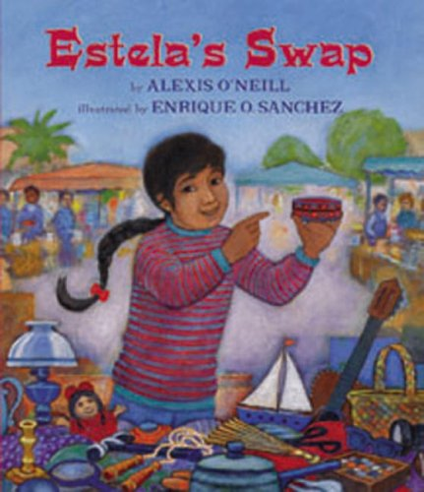
Text 1:
Our new words are music box, tune, price, earn. Explain the words to your child. Click https://sites.temple.edu/texttotalk/estela to see definitions.

Text 2:
Ask your child what his or her favorite tune is. Talk about the price of things in the store, or how people earn money to buy things.

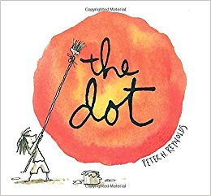
The Dot

Text 1:
Our words are polar bear, jab, frame, blank. Talk about the words with your child. Click https://sites.temple.edu/texttotalk/dot for definitions.

Text 2:
Ask your child to tell you what they know about the words polar bear, jab, frame, or blank. Be proud of how much they are learning!

Bean Soup

Text 1:
Our words are garlic clove, fragrant, pebbles. Click https://sites.temple.edu/texttotalk/bean for definitions. Talk about the words with your child!

Text 2:
Have your child help you use a garlic clove in the kitchen. Smell your food and talk about whether it is fragrant. Look for pebbles in the neighborhood.

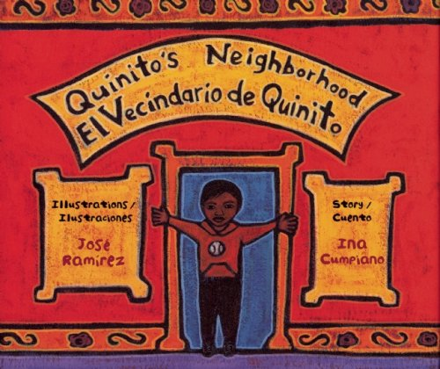
Quinito’s Neighborhood

Text 1:
Our new words are climb, slide, long, short. Click https://sites.temple.edu/texttotalk/quinito
for definitions. Talk about them with your child!

Text 2:
Ask your child to show you what climbing and sliding looks like. Ask your child to find long and short sticks in the neighborhood.

