Text to Talk: Connecting Schools and Families

Sand Study Texts

What Texts Should I Send?
We have prepared all the texts for you to send. (If you want to send additional texts about other words or books that is fine! We just ask that you send our texts at a minimum.) You can see the Sand Study texts that are to be sent over Remind starting on page 2 of this document. There are texts from six Creative Curriculum books, with four words for you to focus on in class and for the families to help the children learn. You will send these texts around the time you read each book.

For example, if you read The Gigantic Turnip on Monday, you can send Text 1 on Monday and Text 2 on Tuesday or Wednesday. Or, if you wish to send the first text before you read the book and the second after, that is ok too. For Text to Talk, the critical thing is for the texts to be sent; the exact timing of when they are sent is less important and is left up to the teacher.

The goal is to send all the texts for each Study. Even if you are not able to read a particular book, the parents will still appreciate receiving the texts and new words. For the purposes of our study, it’s important that all are sent out. For example, if you don’t read The Gigantic Turnip, please still talk about the words in class and send the texts home to the families.

Sand Study Books and Words

Sand Study Books | Sand Study TtT words
The Gigantic Turnip | turnip, gigantic, canary, hen
Where the Wild Things Are | forest, vine, roots, claw
I Know the River Loves Me | river, tug, flow, leap
Sand Dwellers: From Desert to Sea | camouflage, hibernation, nocturnal, flipper
Xochitl and the Flowers | bouquet, vase, valley, breeze
Little Chanclas | chanclas, sunrise, sunset, vehicle

Sand Study Texts

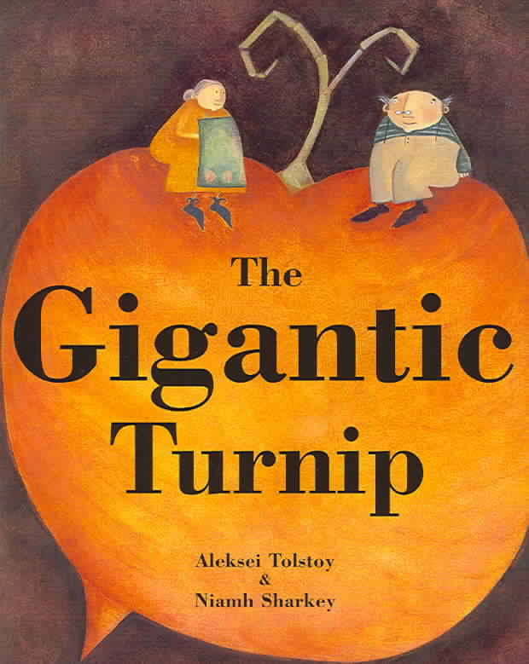
The Gigantic Turnip
Text 1:
Our new words are turnip, gigantic, canary, hen. Help your child learn the words. Click https://sites.temple.edu/texttotalk/turnip for pictures and definitions.

Text 2:
Look with your child for gigantic buildings, trees, or turnips. Talk about the color of canaries (yellow). Talk about who lays eggs (hens).

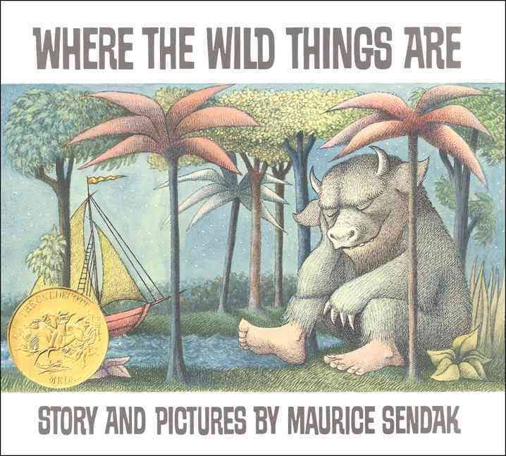
Where the Wild Things Are

Text 1:
Our new words are forest, vine, roots, claw. Help your child learn the words. Click https://sites.temple.edu/texttotalk/wild for pictures and definitions.

Text 2:
Play a finding game and look for vines and roots in your neighborhood. Talk about what animals in the forest have claws.

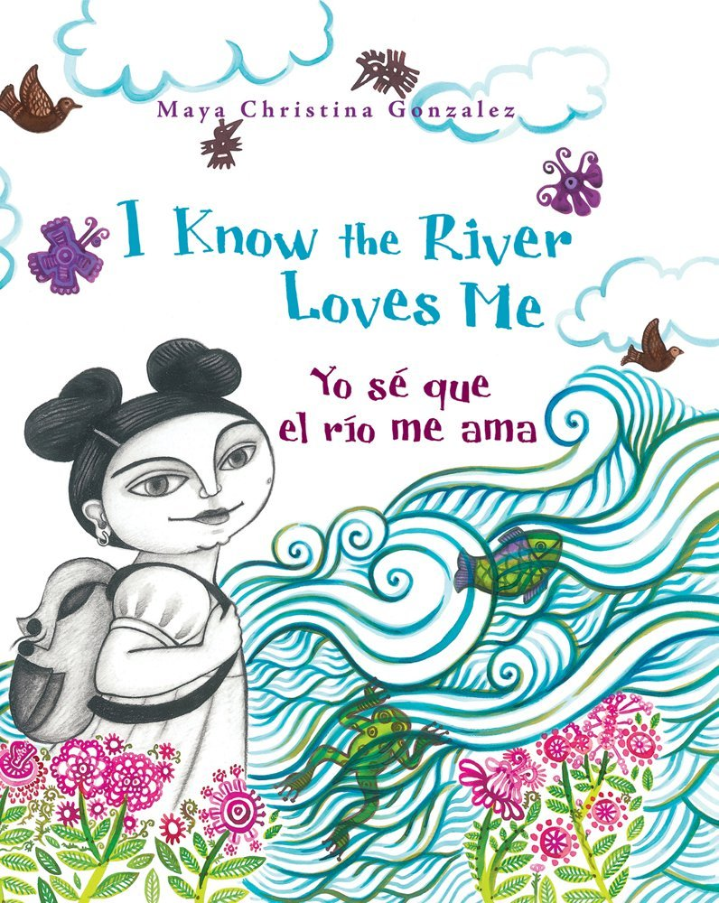
I Know The River Loves Me

Text 1:
Our new words are river, flow, tug, leap. Help your child learn the words. Click https://sites.temple.edu/texttotalk/river/ for pics and definitions.

Text 2:
Talk about the shape of a river, and how rivers flow. Demonstrate what tug and leap means. Praise your child when they use new words!

Sand Dwellers: From Desert to Sea

Text 1:
Our new words are camouflage, hibernation, nocturnal, flipper. Explain the words to your child. Click https://sites.temple.edu/texttotalk/sand for pictures.

Text 2:
Pretend to be a sand-dwelling animal with your child. Can they camouflage or hibernate? What would they do if they were nocturnal?
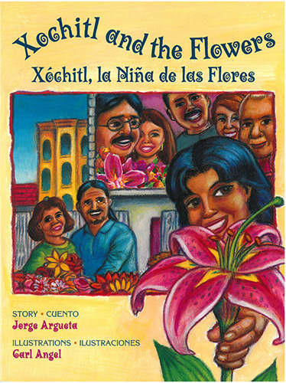
Xochitl and the Flowers
Text 1:
Our new words are bouquet, vase, valley, breeze. Help your child learn the words. Click https://sites.temple.edu/texttotalk/xochitl/ for pics and definitions.
Text 2:
Help your child gather a bouquet of flowers or leaves to put in a vase. Draw a picture of a valley together. Notice the breeze outside.

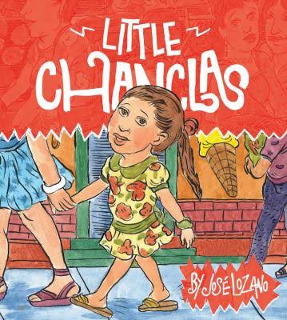
Little Chanclas

Text 1:
Our new words are chanclas, sunrise, sunset, vehicle. Help your child learn the words. Click https://sites.temple.edu/texttotalk/little/ for definitions.

Text 2:
Ask your child about the differences between sunrise and sunset. Play a game to find different vehicles on the street. Thank you!

At the End of The Study
Text 1:
Dear parents, thank you for all your work building your child’s vocabulary. Your child has learned about many words in the past few weeks.
Text 2:
Please review the words with your child. You can look at our previous texts and see if your child understands what the words mean.
Text 3:
Continuing watching the videos of the books, or take the books out from the library. Praise your child when they work hard to learn a new word.

