Text to Talk: Connecting Schools and Families

Roads Study

What Texts Should I Send?
We have prepared all the texts for you to send. (If you want to send additional texts about other words or books that is fine! We just ask that you send our texts at a minimum.) There are texts from eleven Creative Curriculum books, with four words for you to focus on in class and for the families to help the children learn.

You will send these texts around the time you read each book. If you wish to send the first text before you read the book and the second after, that is ok too. For Text to Talk, the critical thing is for the texts to be sent; the exact timing of when they are sent is less important and is left up to the teacher.

The goal is to send as many of the texts for each Study. Even if you are not able to read a particular book, the parents will still appreciate receiving the texts and new words.

Roads Study Books and Words

Roads Study Books | Roads Study TtT words
Crow Boy | crow, imitate, village, and study
David’s Drawings | row, neatly, gray
Tomas and the Library Lady | eager, huge, pile, storyteller
Along a Long Road | Tunnel, bridge, track, gaining bend
The Diggers are Coming | bulldozer, soil, massive, load
The Mighty Street Sweeper | street sweeper, tanker truck, bulldozer, and freight truck.
New Road | map, underneath, detail, instruction
Welcome to Zanzibar Rd | rusty, scrap, mixture, cake tin
Backseat ABC | detour, no entry, rail, yield
Tinyville Town | engineer, reporter, expert, crew
Goodnight, Goodnight, Construction Site | load, crane, beam, heap

Crow Boy

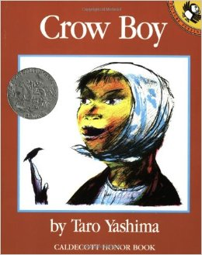
Text 1:
Our new words are crow, imitate, village, and study. Help your child learn the words. Click https://sites.temple.edu/texttotalk/crow/ to see pictures.

Text 2:
Talk about the words. Look for a crow outside. Talk about the difference between a village and a city. Ask your child to imitate a crow.

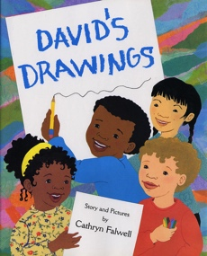
David’s Drawings

Text 1:
Our new words are row, neatly, gray. Help your child learn the words. Click https://sites.temple.edu/texttotalk/david/ to see pictures.

Text 2:
Look for a gray animal together. Ask your child to line up toys, raisins or cereal neatly in a row.

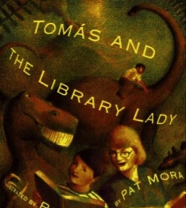
Tomas and the Library Lady

Text 1:
Our new words are eager, huge, pile, storyteller. Help your child learn the words. Click https://sites.temple.edu/texttotalk/tomas/ to see pictures.

Text 2:
Ask your child what eager means. Try to make a huge pile of laundry or leaves together. Pretend to be storytellers together.

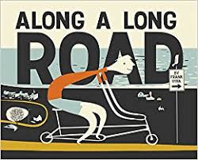
Along a Long Road by Frank Viva

Text 1:
Our new words are tunnel, bridge, track, and gaining. Click https://sites.temple.edu/texttotalk/along to see definitions.

Text 2:
Help your child look for tunnels, bridges, or tracks in the city. Play a game in the car or on the bus, looking for vehicles that are gaining on you.

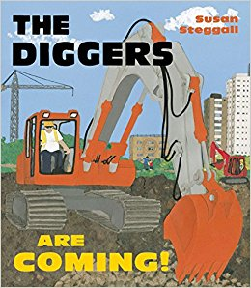
The Diggers Are Coming! by Susan Steggall
Text 1:
Our new words are bulldozer, soil, massive, load. Click https://sites.temple.edu/texttotalk/diggers to see definitions.

Text 2:
Help your child look for a bulldozer in the city pushing soil or a massive load.

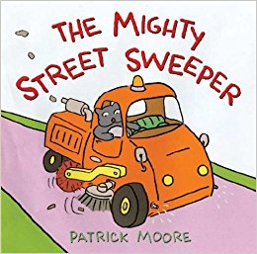
The Mighty Street Sweeper by Patrick Moore
Text 1:
Our words are street sweeper, tanker truck, bulldozer, and freight truck. Click https://sites.temple.edu/texttotalk/mighty to see definitions.

Text 2:
Ask your child to look for a street sweeper, tanker truck, bulldozer, or freight truck. See how many he or she can count.

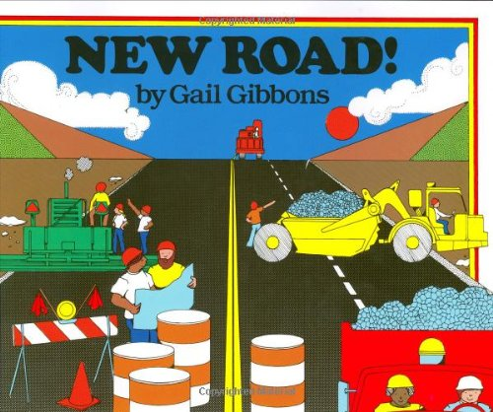
New Road! by Gail Gibbons
Text 1:
Our words are map, underneath, detail, instruction. Click https://sites.temple.edu/texttotalk/new to see definitions.

Text 2:
Ask your child what a map does. Help him or her draw a map with details. Talk about what underneath means.

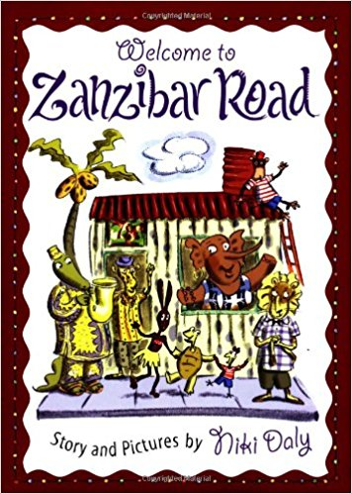
Welcome to Zanzibar Road by Niki Daly
Text 1:
Our words are rusty, scrap, mixture, cake tin. Click https://sites.temple.edu/texttotalk/welcome to see definitions.

Text 2:
Look for rusty scraps with your child. Bake a cake together, mix a mixture, and pour in a cake tin.

Backseat ABC by Maria van Lieshout
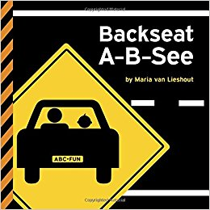
Text 1:
Our words are detour, no entry, rail, yield. The words come from street signs. Click https://sites.temple.edu/texttotalk/backseat to see definitions.

Text 2:
Look for signs around the neighborhood. Ask your child what they mean. Look for a detour, no entry, rail, or yield sign.

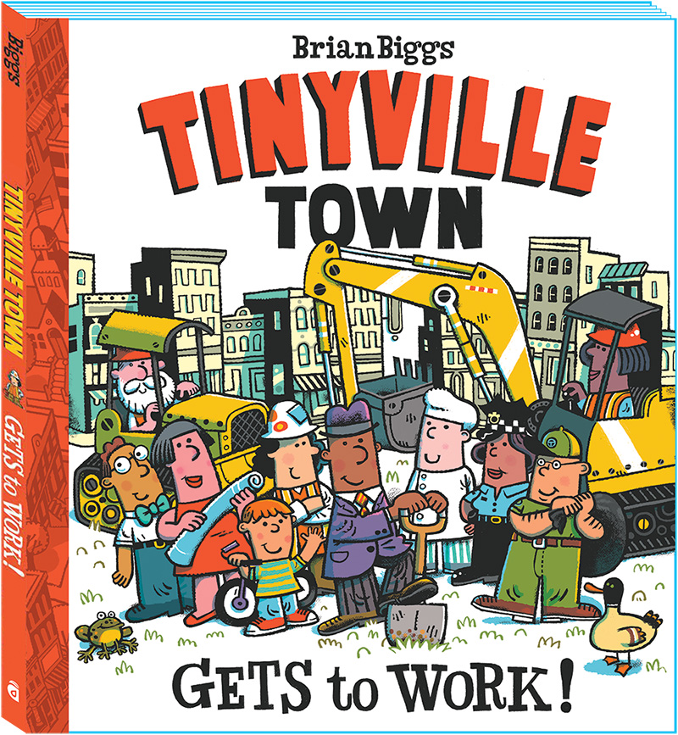
Tinyville Town Gets to Work! by Brian Biggs
Text 1:
Our words are engineer, reporter, expert, crew. Click https://sites.temple.edu/texttotalk/tinyville to see definitions.

Text 2:
Ask your child what an engineer or reporter does. Ask what a construction crew does. Ask what an expert is.

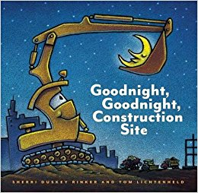
Goodnight, Goodnight, Construction Site

Text 1:
Our words are load, crane, beam, heap. Click https://sites.temple.edu/texttotalk/goodnight to see definitions.

Text 2:
Help your child look for an example of a load, crane, beam or heap in your neighborhood.

