Text to Talk: Connecting Schools and Families

Reduce, Reuse, Recycle Study

What Texts Should I Send?
We have prepared all the texts for you to send. (If you want to send additional texts about other words or books that is fine! We just ask that you send our texts at a minimum.) There are texts from Creative Curriculum books, with four words for you to focus on in class and for the families to help the children learn.

You will send these texts around the time you read each book. If you wish to send the first text before you read the book and the second after, that is ok too. For Text to Talk, the critical thing is for the texts to be sent; the exact timing of when they are sent is less important and is left up to the teacher.

The goal is to send as many of the texts for each Study. Even if you are not able to read a particular book, the parents will still appreciate receiving the texts and new words.

Reduce Study Books and Words

Reduce Study Books | Reduce Study TtT words
Something from Nothing | torn, vest, pebble, material

Something from Nothing
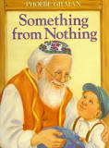

Text 1:
Our new words are torn, vest, pebble, and material. Help your child learn the words. Click https://sites.temple.edu/texttotalk/something/ for definitions.

Text 2:
Ask your child what torn, vest, pebble, and material mean, and if they don't know, explain the meaning to them or show them an example.

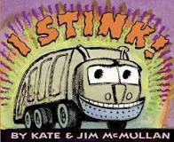
I Stink!
Text 1:

Our new words are stink, wide, engine, and crush. Explain what the words mean to your child. Click https://sites.temple.edu/texttotalk/stink/ for definitions.

Text 2:

Ask your child what stink, wide, engine, crush mean, and if they don't know, explain the meaning to them or show them an example.

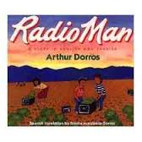
Radio Man

Text 1:
Our new words are voice, radio, listen, and radio station. Help your child learn the words. Click for definitions.

Text 2:
As you’re going through the week, talk about each word three times. Ask your child what each word (voice, radio, listen, and station) means.

Sam Helps Recycle

Text 1:
Our new words are recycle, bin, litter, and energy. Explain the words to your child. Click https://sites.temple.edu/texttotalk/sam/ for definitions.

Text 2:
As you’re going through the week, try to talk about each word three times.

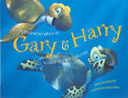
Adventures of Gary and Harry

Text 1:
Our new words are adventure, hull, algae, and gasping. Help your child learn the words. Click https://sites.temple.edu/texttotalk/adventures/ for definitions.

Text 2:
As you’re going through the week, try to talk about each word (adventure, hull, algae, gasping) three times.

Don’t Lose It, Reuse It

Text 1:
Our new words are reuse, telescope, horn, and decorate. Help your child learn the words. Click https://sites.temple.edu/texttotalk/dont-lose-it/ for definitions.

Text 2:
As you’re going through the week, try to talk about each word (reuse, telescope, horn, and decorate) three times.

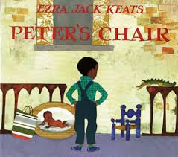
Peter’s Chair

Text 1:
Our new words are stretched, fussing, mutter, and rascal. Help your child learn the words. Click https://sites.temple.edu/texttotalk/peters-chair/ for definitions.

Text 2:
As you’re going through the week, try to talk about each word (stretched, fussing, mutter, and rascal) three times.

Hush! A Thai Lullaby
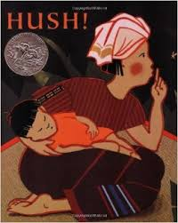

Text 1:
Our new words are lullaby, nearby, weep, and sniffle. Help your child learn the words. Click https://sites.temple.edu/texttotalk/hush/ for definitions.

Text 2:
As you’re going through the week, try to talk about each word (lullaby, nearby, weep, and sniffle) three times.

