Text to Talk: Connecting Schools and Families

Pets Study

Initial Text:
Text 1:
Hello families! We are starting our Pets Study. We will be learning and reading books about pets and how to care for them.

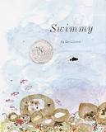
Swimmy

Text 1:
Our new words are eel, seaweed, swift, gulp. Explain the words to your child. Click https://sites.temple.edu/texttotalk/swim/ for definitions and pictures.

Text 2:
Ask your child to run swiftly. Ask your child to wiggle like an eel trapped in seaweed or gulp like a fish.

Story of Ferdinand

Text 1:
Our new words are bull, pasture, fierce, and matador. Help your child learn the words. Click https://sites.temple.edu/texttotalk/story-of-ferdinand/ to see definitions.

Text 2:
Ask your child where cows and bulls eat food (in a pasture). Ask your child how a matador might fight a fierce bull.

The Stray Dog
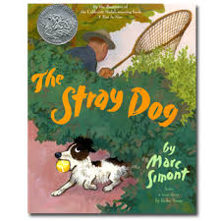
Text 1:
Our new words are picnic, scruffy, collar, leash. Help your child learn the words. Click https://sites.temple.edu/texttotalk/stray-dog/ to see pictures.

Text 2:
Ask your child what they would pack for a picnic. Look for a scruffy dog or cat in the neighborhood, or a dog or cat with a collar or leash.

Charlie Anderson

Text 1:
Our new words are woods, disappear, rattle, worried. Help your child learn the words. Click https://sites.temple.edu/texttotalk/charlie/ to see pictures.

Text 2:
Ask your child what they think they would see if they went into the woods (plants or animals). Ask your child what makes them worried.

Pet Show
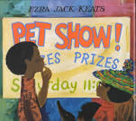

Text 1:
Our new words are chase, parrot, canary, whiskers. Help your child learn the words. Click https://sites.temple.edu/texttotalk/pet-show/ for pictures.

Text 2:
Ask your child what animals have whiskers. Ask your child what pet he or she would like to have, a canary or parrot.

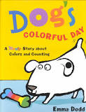

Dog’s Colorful Day

Text 1.
Our new words are jam, spot, stain, splatter. Help your child learn the words. Click https://sites.temple.edu/texttotalk/dog/ to see pictures.

Text 2:
Ask your child what jam tastes like, or eat some together. See if you can find a spots, splatters, or stains somewhere to examine.

The King’s Taster

Text 1:
Our new words are platter, herb, whisked, venison. Help your child learn the words. Click https://sites.temple.edu/texttotalk/king for pictures.

Text 2:
Ask your child what is put on a platter (food). Ask him or her to tell you what an herb and venison is. Practice whisking.

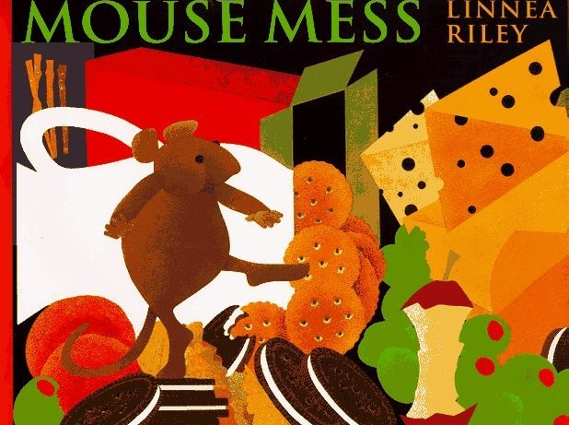
Mouse Mess

Text 1:
Our new words are castle, olives, smear, soak. Help your child learn the words. Click https://sites.temple.edu/texttotalk/mouse for pictures.

Text 2:
Ask your child who lives in a castle. Eat olives together. Practice smearing butter on bread or soaking a sponge in water.

What do you do with a tail like this? / Seven Blind Mice
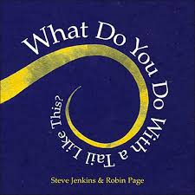

Text 1:
Our new words are characteristic, tail, pillar, cliff, spear. Help your child learn the words. Click https://sites.temple.edu/texttotalk/tail for pictures.

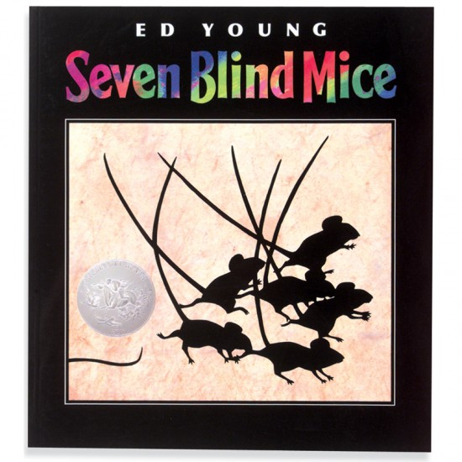
Text 2:
Ask your child to tell you the characteristics of a mouse. Look for an example of a pillar or cliff in your neighborhood.

