Text to Talk: Connecting Schools and Families

Exercise Study

How do our bodies work when we exercise?
Text 1:
Our new words are flexible, perspire, muscle, strengthen. Help your child learn the words. Click https://sites.temple.edu/texttotalk/bodies/ for definitions.

Text 2:
Ask your child what each word means, and if they don't know, explain the meaning to them or show them an example.

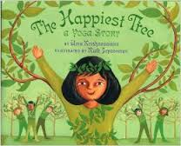
The Happiest Tree

Text 1:
Our new words are improved, clumsy, performance, and topple. Help your child learn the words. Click https://sites.temple.edu/texttotalk/tree/ for definitions.

Text 2:
Ask your child to act out a “performance” with some of his/her toys. Ask him to make his toys “clumsy” and to “topple” over.

We All Went on a Safari!

Text 1:
Our new words are safari, ancient, dew, and ostrich. Help your child learn the words. Click https://sites.temple.edu/texttotalk/safari/ for definitions.

Text 2:
Ask your child what he or she would like to see on a safari. Help them name some animals they might see.

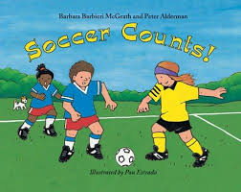
Soccer Counts

Text 1:
Our new words are whistle, officials, soar, and tie. Help your child learn the words. Click https://sites.temple.edu/texttotalk/soccer/ for definitions.

Text 2:
Ask your child what a tie score is. Ask why an official might blow a whistle. Ask why a ball might soar through the air.

Bear on a Bike
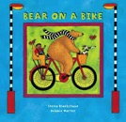
Text 1:
Our new words are market, marigold, prowl, and snarl. Help your child learn the words. Click https://sites.temple.edu/texttotalk/bear/ for definitions.

Text 2:
Ask your child what market, marigold, prowl, and snarl mean, and if they don't know, explain the meaning to them or show them an example.

JoJo’s Flying Side Kick
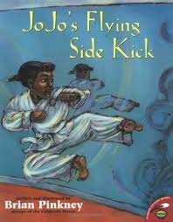
Text 1:
Our new words are jitters, lunge, technique, and applaud. Explain the words to your child. Click https://sites.temple.edu/texttotalk/jojo/ for definitions.

Text 2:
Ask your child what give them the jitters. Ask them to show you how to lunge with good technique or applaud.

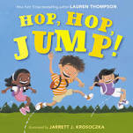
Hop, Hop, Jump

Text 1:
Our new words are squint, grin, shrug, and reach. Explain the words to your child. Click https://sites.temple.edu/texttotalk/hop/ for definitions.

Text 2:
Ask your child to show you how to squint, grin, shrug, and reach, and if they don't know, explain and show the meaning to them.

Rah, Rah, Radishes!
Text 1:
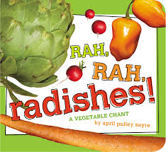
Our new words are Brussels sprout, cayenne, stash, cupboard. Help your child learn the words. Click https://sites.temple.edu/texttotalk/rad/ for definitions.

Text 2:
Ask your child what Brussels sprout, cayenne, stash, and cupboard mean, and if they don't know, explain the meaning to them.

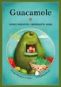
Guacamole
Text 1:
Our new words are guacamole, avocado, ripe, and tender. Help your child learn the words. Click https://sites.temple.edu/texttotalk/guac/ for definitions.

Text 2:
Ask your child what guacamole, avocado, ripe, and tender mean, and if they don't know, explain the meaning to them.

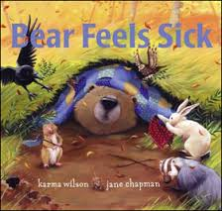
Bear Feels Sick

Text 1:
Our new words are autumn, heap, wheeze, and frolic. Help your child learn the words. Click https://sites.temple.edu/texttotalk/bear-feels-sick/ for definitions.

Text 2:
Ask your child what autumn, heap, wheeze, and frolic mean, and if they don't know, explain the meaning to them.

Max

Text 1:
Our new words are join, stretch, leap and invite. Help your child learn the words. Click https://sites.temple.edu/texttotalk/max/ for definitions.

Text 2:
Ask your child what join, stretch, leap and invite mean, and if they don't know, explain the meaning to them.

My Steps

Text 1:
Our new words are stoop, crumble, shady, and shiver. Help your child learn the words. Click https://sites.temple.edu/texttotalk/my-steps/ for definitions.

Text 2:
Ask your child what stoop, crumble, shady, and shiver mean, and if they don't know, explain the meaning to them.

