Text to Talk: Connecting Schools and Families

Clothes Study

What Texts Should I Send?
We have prepared all the texts for you to send. (If you want to send additional texts about other words or books that is fine! We just ask that you send our texts at a minimum.) You can see the Clothes Study texts that are to be sent over Remind starting on page 2 of this document. There are texts from Creative Curriculum books, with four words for you to focus on in class and for the families to help the children learn. You will send these texts around the time you read each book.

For example, if you read Abuela’s Weave on Monday, you can send Text 1 on Monday and Text 2 on Tuesday or Wednesday. Or, if you wish to send the first text before you read the book and the second after, that is ok too. For Text to Talk, the critical thing is for the texts to be sent; the exact timing of when they are sent is less important and is left up to the teacher.

The goal is to send all the texts for each Study. Even if you are not able to read a particular book, the parents will still appreciate receiving the texts and new words. For the purposes of our study, it’s important that all are sent out. For example, if you don’t read Abuela’s Weave, please still talk about the words in class and send the texts home to the families.

Clothes Study Books and Words

Clothes Study Books | Clothes Study TtT words
Abuela’s Weave | thread, weave, Abuela, loom
Button, Button, Who’s Got the Button | cape, buckle, belt, knot
Caps for Sale | peddler, ordinary, irritate, cap
Colors, Colores | tide, clover, orchard, violet
Goldilocks and the Tree Bears | promise, medium, porridge, curious
Little Red Riding Hood | stray, splendid, bouquet, cottage
Llama Llama Red Pajama | hum, whimper, holler, patient
Mama and Papa Have a Store | buttons, thread, cloth, magenta
The Paper Bag Princess | expensive, fiery, fierce, magnificent
The Girl Who Wore Too Much | stumble, wrinkle, exhausted, simple
The Mitten | wool, knit, burrowed, prickles
The Quinceanera | celebration, seamstress, pearl, silk
Uncle Nachos Hat | fanned, trunk (a box to store clothes), gentleman
Wash and Dry | grimy, slimy, delicate, sudsy
Who Wears What | uniform, badge, astronaut, mask

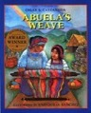
Abuela's Weave
Text 1.
Our new words are thread, weave, Abuela, loom. Help your child learn the words. Click https://sites.temple.edu/texttotalk/abuela/ to see pictures.

Text 2.
Look at the pictures (click https://sites.temple.edu/texttotalk/abuela/) and ask your child to find the pictures of thread, weave, and loom.

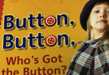
Button, Button, Who’s Got the Button
Text 1.
Our new words are cape, buckle, belt, knot. Help your child learn the words. Click https://sites.temple.edu/texttotalk/button/ to see pictures.

Text 2.
Find examples in your home of a cape, buckle, belt, and knot. Help your child practice using the words.

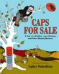
Caps for Sale
Text 1.
Our new words are peddler, ordinary, irritate, cap. Help your child learn the words. Click https://sites.temple.edu/texttotalk/caps/ for pictures.

Text 2.
Ask your child what peddler, ordinary, irritate, and cap mean. Talk with them about the pictures on https://sites.temple.edu/texttotalk/caps/.

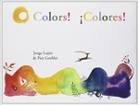
Colors Colores
Text 1.
Our new words are tide, clover, orchard, violet. Help your child learn the words. Click https://sites.temple.edu/texttotalk/colors/ for pictures.

Text 2.
Look for a 4-leaf clover with your child. Talk about what grows in an orchard. Look for something that is violet.

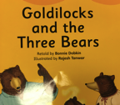
Goldilocks and the Three Bears
Text 1.
Our new words are promise, medium, porridge, curious. Explain the words to your child. Click https://sites.temple.edu/texttotalk/goldilocks/ to see pictures.

Text 2.
Ask your child what Goldilocks eats. Ask your child what a promise is. Ask your child to find a toy that is “medium” in size.

Little Red Riding Hood
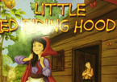
Text 1.
Our new words are stray, splendid, bouquet, cottage. Explain the words to your child. Click https://sites.temple.edu/texttotalk/red/ to see pictures.

Text 2.
Ask your child how to make a bouquet. Ask where Little Red’s grandmother lived (in a cottage). Ask your child what splendid and stray mean.

Llama Llama Red Pajama

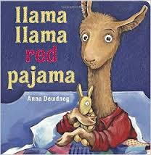
Text 1.
Our new words are hum, whimper, holler, patient. Explain the words to your child. Click https://sites.temple.edu/texttotalk/llama/ to see definitions.

Text 2.
Ask your child what a hum, whimper, and holler sound like. Ask your child to show how he or she can “wait patiently”.

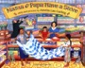
Mama and Papa Have a Store

Text 1.
Our new words are buttons, thread, cloth, magenta. Explain the words to your child. Click https://sites.temple.edu/texttotalk/store/ to see pictures.

Text 2.
Ask your child to find buttons, thread, or cloth in your home. Ask your child to find the color magenta.

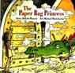
The Paper Bag Princess

Text 1.
Our new words are expensive, fiery, fierce, magnificent. Talk about the words with your child. Click https://sites.temple.edu/texttotalk/paper/ for definitions.

Text 2.
Ask your child to show you what a fierce or magnificent dragon would look like or what a dragon’s fiery breath would feel like.

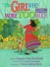
The Girl Who Wore Too Much
Text 1.
Our new words are stumble, wrinkle, exhausted, simple. Explain the words to your child. Click https://sites.temple.edu/texttotalk/girl/ to see definitions.

Text 2.
Ask your child to tell the difference between simple and fancy. Ask your child to find a wrinkle on some clothes or on a piece of paper.

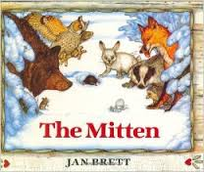
The Mitten

Text 1.
Our new words are wool, knit, burrowed, prickles. Talk about the words with your child. Click https://sites.temple.edu/texttotalk/the-mitten/ to see pictures.

Text 2.
Show your child a sweater and explain how a sweater is knit from wool. Ask your child what animal would burrow underground in the winter.

The Quinceanera
Text 1.
Our new words are celebration, seamstress, pearl, silk. Help your child learn the words. Click https://sites.temple.edu/texttotalk/quince to see pictures.

Text 2.
Ask your child what pearls or silk look like. Ask your child what a seamstress does. Ask your child what happens at a celebration.

Something from Nothing
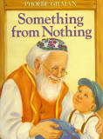

Text 1:
Our new words are torn, vest, pebble, and material. Help your child learn the words. Click https://sites.temple.edu/texttotalk/something/ for definitions.

Text 2:
Ask your child what torn, vest, pebble, and material mean, and if they don't know, explain the meaning to them or show them an example.

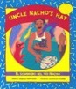
Uncle Nachos Hat

Text 1.
Our new words are fanned, trunk (a box to store clothes), gentleman. Click https://sites.temple.edu/texttotalk/uncle-nacho/ to help your child learn.

Text 2.
Ask your child what it feels like to be fanned. Ask your child what they’d store in a trunk. Ask your child how a gentleman might behave.

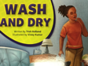
Wash and Dry

Text 1.
Our new words are grimy, slimy, delicate, sudsy. Talk about the words with your child. Click https://sites.temple.edu/texttotalk/wash/ to see pictures.

Text 2.
Ask your child whether they would be grimy if they played in mud. Ask your child if their hands get sudsy with soap when washing them.

Who Wears What

Text 1.
Our new words are uniform, badge, astronaut, mask. Help your child learn the words. Click https://sites.temple.edu/texttotalk/who/ for definitions.

Text 2.
Ask your child what uniform a police officer wears. Ask your child why a doctor might wear a mask or an astronaut a helmet.

