Text to Talk: Connecting Schools and Families

Buildings Study Texts

What Texts Should I Send?
We have prepared all the texts for you to send. (If you want to send additional texts about other words or books that is fine! We just ask that you send our texts at a minimum.) You can see the Building Study texts that are to be sent over Remind starting on page 2 of this document. There are texts from nine Creative Curriculum books, with four words for you to focus on in class and for the families to help the children learn. You will send these texts around the time you read each book.

For example, if you read A Chair for My Mother on Monday, you can send Text 1 on Monday and Text 2 on Tuesday or Wednesday. Or, if you wish to send the first text before you read the book and the second after, that is ok too. For Text to Talk, the critical thing is for the texts to be sent; the exact timing of when they are sent is less important and is left up to the teacher.

The goal is to send all the texts for each Study. Even if you are not able to read a particular book, the parents will still appreciate receiving the texts and new words. For the purposes of our study, it’s important that all are sent out. For example, if you don’t read A Chair for My Mother, please still talk about the words in class and send the texts home to the families.

Building Study Books and Words

Building Study Books | Building Study TtT words
A Chair for My Mother | boss, hum, bank, deliver
Building a House | hammer, saw, carpenter, plumber
Build it from A to Z | smooth, rubber, hollow, solid
Buildings, Buildings, Buildings | library, post office, factory, museum
House, Sweet House | square, round, tent, igloo
The Three Little Javelinas | desert, javelinas, snouts, cactus
The Pot that Juan Built | flames, potter, decoration, unearthed
The True Story of the Three Little Pigs | secret, straw, doorknob, impolite
The Three Little Pigs | piglet, relaxed, haystack, creative

A Chair for My Mother
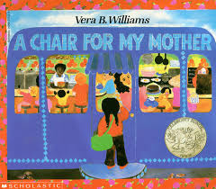
Text 1.
Our new words are boss, hum, bank, deliver. Click https://sites.temple.edu/texttotalk/a-chair-for-my-mother/ to see pictures and definitions and talk about the words.

Text 2:
Talk about the words with your child. You could show your child how to hum a song, show them a bank, or pretend to deliver food together.

Building a House

Text 1:
Our new words are hammer, saw, carpenter, plumber. Click https://sites.temple.edu/texttotalk/building-a-house/ to see pictures and definitions. Explain the words.

Text 2:
Ask your child what a hammer and saw do, and who uses them (a carpenter). Ask your child what a plumber does.

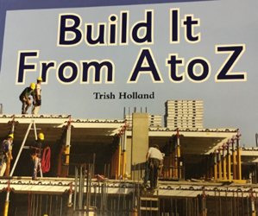
Build it from A-Z

Text 1:
Our new words are smooth, rubber, hollow, solid. Explain the words to your child. Click https://sites.temple.edu/texttotalk/build-it-from-a-to-z/ to see definitions.

Text 2:
Play a finding game with your child and find smooth, rubber, hollow, and solid objects at home. Thank you!

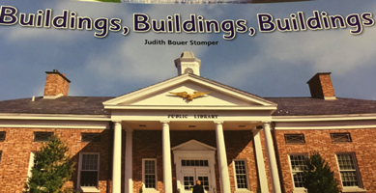
Buildings, Buildings, Buildings

Text 1:
Our new words are library, post office, factory, museum. Talk about the words and click https://sites.temple.edu/texttotalk/buildings/ for definitions.

Text 2:
Talk with your child about what happens at the library, post office, factory, and museum. If you can, visit one!

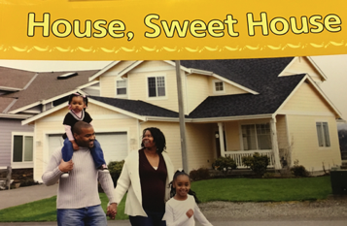
House, Sweet House

Text 1:
Our new words are square, round, tent, igloo. Click https://sites.temple.edu/texttotalk/house-sweet-house/ for definitions. Talk about the words with your child!

Text 2:
Play “I Spy” with your child and find square and round objects. Talk about why someone might use a tent or igloo.

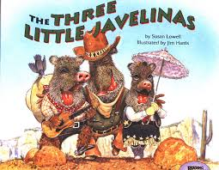
The Three Little Javelinas

Text 1:
Our new words are desert, javelinas, snouts, cactus. Click https://sites.temple.edu/texttotalk/javelinas/ for definitions. Talk about them with your child!

Text 2:
Ask your child what they might find in the desert (javelinas, cactus, other desert animals). Ask your child what a snout is.

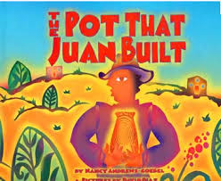
The Pot That Juan Built

Text 1:
Our new words are flames, potter, decoration, unearthed. Click https://sites.temple.edu/texttotalk/the-pot/ for pictures. Talk about them with your child!

Text 2:
Ask your child what decorations a potter might put on a pot. Ask your child what they might unearth if they dig in the ground.

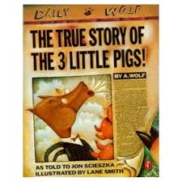
The True Story of the Three Little Pigs

Text 1:
Our new words are secret, straw, doorknob, impolite. Click https://sites.temple.edu/texttotalk/the-true/ for pictures. Talk about the words with your child.

Text 2:
Ask your child what the 3 little pigs used to build their home. Ask what impolite means.

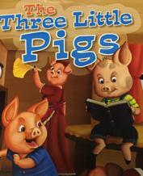
The Three Little Pigs

Text 1:
Our new words are piglet, relaxed, haystack, creative. Click https://sites.temple.edu/texttotalk/pigs/ for definitions and pictures of the words.

Text 2:
This week we read “The Three Little Pigs.” Ask your child to tell the story. Retelling is a great way for children to practice new words.

At the End of The Study
Text 1:
Dear parents, thank you for all your work building your child’s vocabulary. Your child has learned about many words in the past few weeks.
Text 2:
Please review the words with your child. You can look at our previous texts and see if your child understands what the words mean.
Text 3:
Continuing watching the videos of the books, or take the books out from the library. Find opportunities to practice using the words!

