Cleaning the Objective Lens
  CAUTION | - Do not wipe or rub the objective lens if there is dirt or dust on it. Doing so could scratch the surface of the lens.  - Do not wipe the objective lens with disinfectant ethanol, eyeglass cleaner, or silicone-coated paper.  - Doing so could corrode the surface of the lens or leave streaks.

Recommended cleaning items:
Kimtech wipes | De-natured Alcohol Spray or Purosol | Blower
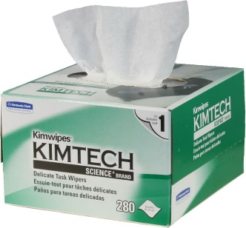 | 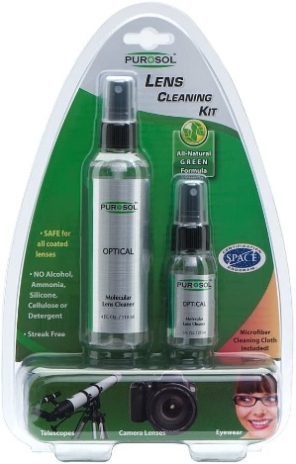 | 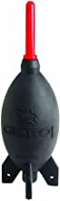

Cleaning Procedure:
If the objective lens is dirty, clean it according to the procedure below:  - Illuminate the objective lens with a flashlight and check for any dirt  - Use a blower to blow away any dust or dirt on the lens.  - Do not use a brush to dust off.  - Do not allow the blower to touch the objective lens. | 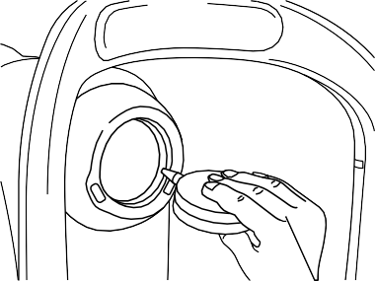
- Lightly dampen a Kimtech wipe with lens cleaner and lightly wipe the objective lens. Starting from the center of the lens, wipe the lens in spirals toward the circumference.  - Change the lens cleaning paper and wipe the objective lens until the dirt is gone and there are no streaks. | 