TITLE OF DESIGN COMPETION SUBMISSION
(should accurately describe the design, avoid vague general titles and abbreviations)
Presenting Author’s Name, Other Authors’ Names.
Authors’ Affiliated Institution(s).

The length of the actual abstract must be no more than 2 printed pages conformed to the established margins.

Problem Statement and Need:
This project addresses an unmet clinical, research, industrial, or societal need by focusing on a specific user group and the task(s) they need to complete. Current solutions are briefly described to explain what doesn’t work well and why a new design is needed, including how these limitations affect users and, more broadly, society. The problem statement concludes by defining the scope of the project and clarifying which limitations the proposed design will address.

Design Inputs
Briefly describe the current stage of the project, such as needs assessment, concept development, prototyping, or testing. Indicate which design requirements are being evaluated and summarize any methods used or planned, including measurements, analyses, simulations, or experiments. Include preliminary results if available, or describe expected outcomes and next steps if testing is ongoing. Final results are not required.

Design Approach / Solution
Briefly describe the proposed system, device, or methodology and how it is intended to be used by the user. Highlight key design features, system architecture, materials, biological considerations, modeling strategies, or experimental plans that are important for understanding how the design functions. If applicable, describe the current build or prototype and how it is being used, emphasizing components or design choices that are innovative or critical to performance.
Be sure to include drawings and/or workflow illustrations highlighting choices KEY to understanding proper function and if construction has begun, include images of your built solution, highlighting components KEY to understanding proper function.

Verification / Project Status
Briefly describe the current stage of the project, such as needs assessment, concept development, prototyping, or testing. Indicate which design requirements are being evaluated and summarize any methods used or planned, including measurements, analyses, simulations, or experiments. Include preliminary results if available, or describe expected outcomes and next steps if testing is ongoing. Final results are not required.

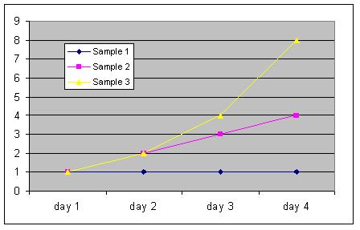Figure 1. Sample Only

Ethical, Regulatory, and Societal Considerations
Briefly address relevant ethical issues, regulatory pathways, sustainability concerns, accessibility, or broader societal impacts of the design.

Anticipated Impact and Future Work
Conclude with the expected impact of the project and remaining work within the capstone timeline.

References: If it is necessary to cite references, insert the primary author's name and initials followed by the abbreviated journal title, the year of publication, and the volume and page numbers in parentheses. For example:
- Dodd LG. Am J Clin Pathol. 1990;93:141-144.
- Wanti A. et al. Science. 2018;6(26):972-1018
- Oke A. et al. Nature. 2019;3(21):15-19
Acknowledgements: Acknowledgements to funding sources or contributions of individuals not rising to the level of authorship. If it is necessary to include acknowledgements, insert the funding agency and grant number.

