Title of Abstract (should accurately describe questions answered by the study, avoid vague general titles and abbreviations)
Presenting Author’s Name, Other authors’ names.
Authors’ affiliated institution(s).

Introduction: The introduction should clearly characterize the scientific question investigated. Background information should be provided to the extent that it introduces the current study and documents its importance to the literature. A scientific abstract should contain the same type of information as is contained in a full paper, although on a limited and condensed scale. The abstract should have a title, introduction, methods, results, and conclusions. The length of the actual abstract must be no more than 2 printed pages conformed to the established margins. Submissions cannot have been presented, published, or submitted for presentation or publication elsewhere.

Methods: (materials and analytical procedures used) Materials and Methods used in the study should be briefly explained in this section; for example, what essential reagents were used, what patients or tissue samples were studied, what special techniques were applied and how, and what type of study was performed (e.g. prospective, retrospective, case-control). General reagents (e.g. buffers, deionized water) need not be included if they are not unique to the work. Particular attention should be given to products or equipment that bear registered trade names. Provide the company name and its city and state address parenthetically following the first mention of the product. Demonstrate how the methods presented will address the questions in the introduction section.

Results: (Summary of the results in sufficient detail to support conclusion.) Results of significant positive and negative findings should be presented as concisely as possible. Most abstracts are rejected because of inadequate data. To state "results will be presented" is uninformative and of little value. Make sure any conclusions you reach are supported by the data presented. When expressing laboratory values, use conventional units followed by SI units in parentheses. No conclusions or discussion of the results should be included in the results section.

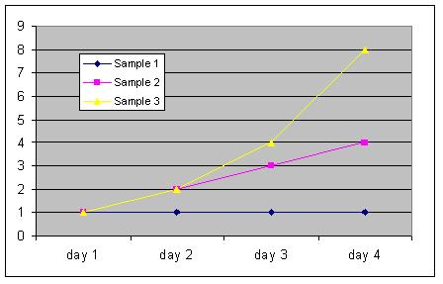Figure 1. Sample Only

Conclusions: Conclusions reached (do not state “results will be discussed”). Conclusions should be stated concisely and include any recommendations for future study, as well as the implications and significance of the data presented. Do not introduce concepts not considered in the body of the abstract.

References: References to published literature. If it is necessary to cite references, insert the primary author's name and initials followed by the abbreviated journal title, the year of publication, and the volume and page numbers in parentheses. For example:
- Dodd LG. Am J Clin Pathol. 1990;93:141-144.
- Wanti A. et al. Science. 2018;6(26):972-1018

Acknowledgements: Acknowledgements to funding sources or contributions of individuals not rising to the level of authorship. If it is necessary to include acknowledgements, insert the funding agency and grant number.

