Allison Byrne & Lisa Chemplayil

AUDIENCE

Harrisburg Population

TOPIC

Climate Change

TIME NEEDED

60 Minutes

LEARNING OBJECTIVES

At the completion of this lesson, at least 75% of participants will be able to: name three causes of climate change on a post test.

At the completion of this lesson, at least 75% of participants will be able to: name one way to prevent climate change on a post test.

STANDARDS AND HEALTHY PEOPLE OBJECTIVES

Healthy People 2030 objectives

Reduce the amount of toxic pollutants released into the environment – EH-06

Increase trips to work made by mass transit – EH-02

CDC Healthy School Standards

5.12.2 Determine the value of applying a thoughtful decision-making process in health-related situations

7.8.1 Explain the importance of assuming responsibility for personal health behaviors.

7.12.2 Demonstrate a variety of health practices and behaviors that will maintain or improve the health of self and others

7.12.3 Demonstrate a variety of behaviors to avoid or reduce health risks to self and others

MATERIALS NEEDED
- Slideshow
- Wifi
- White board
- Dry erase markers
- Computer (1)
- Index Cards (enough for everyone to have 2)
- Pens (enough for everyone to have 2)
- Worksheet (enough for everyone to have 2)
  - Source: What kind of footprint? Carbon Footprint - Lesson. TeachEngineering.org. (2021, November 4). Retrieved November 9,

PREPARATION
Prior to the session, the slideshow will be loaded on the computer and all videos will be loaded. Worksheets will be printed and ready to be distributed. Index cards will be handed out and distributed along with pens and worksheets.

PROCEDURE

- Slide 1 and 2 (7 minutes)
  - Introduction
    - Click to Slide 1
      - Introduce instructors (3 min)
    - Click to slide 2
      - State both objectives for the lesson (4 min)
- Slide 3 (4 minutes)
  - Introduce climate change
  - Engage participants by asking the class for their definitions of climate change.
  - Say “ What is Climate Change? Climate change is a change in the usual weather found in a place. This could be a change in how much rain a place usually gets a year or it could be a change in a place’s usual temperature for a month or season.” (National Aeronautics and Space Administration [NASA], 2021)
- Slides 4, 5, & 6 for scientific evidence on climate change. (14 minutes)
  - Click to slide 4 (3 min)
    - Ask students to identify what they already know about the impacts and scientific evidence for climate change.
    - Say “overall global shifts in weather have been observed through extreme weather phenomenon.”
    - Say “Ice cores drawn from Greenland, Antarctica, and tropical mountain glaciers show that Earth’s climate responds to changes in greenhouse gas levels. Ancient evidence can also be found in tree rings, ocean sediments, coral reefs, and layers of sedimentary rocks. This ancient, or paleoclimate, evidence reveals that current warming is occurring roughly ten times faster than the average rate of ice-age-recovery warming.”
    - Source: (National Aeronautics and Space Administration [NASA], 2021)
  - Click to slide 5 (3 min)
    - Ask students to identify pictures on slides, and ask them how it relates to climate change.
    - Explain the pictures. Say “Ice mass in Antartica has been steadily decreasing as a result of greenhouse gas emissions into the atmosphere increasing global temperatures. You can see how the overall mass slowly decreases. Global warming has also caused unpredictability in weather conditions in places such as California, that extends the dry season and increases the likelihood of wildfires, as you can see here.”
  - Click to slide 6 (8 minutes)
    - Introduce video- Say this is a video introducing some of the causes and effects of climate change (1 minute)
    - Play video (3 minutes)
    - https://www.youtube.com/watch?v=G4H1N_yXBiA
    - National Geographic, Causes and effects of Climate Change
    - Talk about what the participants learned from the video (2 minutes)
      - Ask for 1 take-away from the video from a class participant, posing question ti class
- Slide 7 (6 minutes)
  - Introduce brainstorming activity
    - Brainstorm activity
      - Tell participants they will have 5 minutes to think about some potential causes of climate change. Once the 5 minutes have passed, a list will be generated on the white board.
      - Ask: What are some causes of climate change?
      - Write a list of participants responses on the white board
- Slide 8 (6 minutes)
  - Introduce the causes of climate change
  - Say “Global climate change is heavily impacted by human influence”
  - Say “ The five main causes of climate change are fossil fuels, deforestation, increased livestock farming and production, fertilizers containing nitrogen, and fluorinated gases.”
    - Expand on the causes of climate change
      - Burning coal, oil and gas produces carbon dioxide and nitrous oxide.
      - Cutting down forests (deforestation). Trees help to regulate the climate by absorbing CO2 from the atmosphere. When they are cut down, this increases the overall amount if CO2 in the atmosphere.
      - Increasing livestock farming. Cows and sheep produce large amounts of methane when they digest their food.
      - Fertilizers containing nitrogen produce nitrous oxide emissions.
      - Fluorinated gases are emitted from equipment and products that use these gases. Such emissions have a very strong warming effect, up to 23,000 times greater than CO2.
        - (European Commission on Climate Action, n.d.)
  - Encourage students to engage with the image on slide, say “notice here in this image the human impact on climate change”
- Slide 9 (6 minutes)
  - Introduce think pair share (2 minutes)
    - Tell students: Okay, I want you to turn to the partner next to you about some prevention measures you know of for climate change. We will regroup in 4 minutes.
    - Ask: What are some prevention measures for climate change?
  - Complete think pair share and regroup (4 minutes)
- Slide 10 (3 minutes)
  - Introduce prevention measures
  - Say “Climate change is rooted in the unsustainable use of resources. Many small changes in everyday lives are needed in addition to large overarching measures.Ultimately climate change is the result of increased greenhouse gas emissions and overuse of resources. Everyday measures can be taken such as utilizing using more green energy, eating less meat, utilizing public transportation, riding a bike, or just monitoring energy usage.”
  - Ask students if they are familiar with and what they know about carbon footprints
- Slide 11 (3 minutes)
  - Say “ What is a Carbon Footprint? A carbon footprint estimates the total amount of greenhouse gases emitted during the production, processing and retailing of consumer goods. We all have carbon footprints.”
- Slide 12 (7 minutes)
  - Carbon Footprint Worksheet
    - Introduce worksheet. Say: We will be completing a worksheet today that will measure your carbon footprint.
  - Give students 5 minutes to complete the worksheet
  - After the worksheet is complete, take 2 minutes to ask participants to share their results and to offer talking points of what they found interesting.
- Slide 13 (3 minutes)
  - Ask participants to complete the google form to assess if objectives were met
    - Link to form: https://forms.gle/Hpa2X31vssG8giiQ9

- Conclusion (1 minute)
  - Thank the class for their participation
  - Conclude Presentation

References

European Commission on Climate Action. (n.d.). Causes of climate change. Climate Action. Retrieved October 26, 2021, from https://ec.europa.eu/clima/climate-change/causes-climate-change_en.
NASA. (2021, October 12). Climate change evidence: How do we know? NASA. Retrieved October 26, 2021, from https://climate.nasa.gov/evidence/.
National Geographic 2017, https://www.youtube.com/watch?v=G4H1N_yXBiA
What kind of footprint? Carbon Footprint - Lesson. TeachEngineering.org. (2021, November 4). Retrieved November 9, 2021, from https://www.teachengineering.org/lessons/view/cub_footprint_lesson1.

Appendix A
Post-Test Answer Key

Question 1:
Name three causes of climate change.

Possible answers:
- greenhouse gases
- fossil fuels
- Deforestation
- Increased livestock farming/production
- Fertilizers containing nitrogen
- Fluorinated gases

Question 2:
Name one way to prevent climate change.

Possible answers:
- Utilizing more green energy
- Eating less meat
- Utilizing public transportation
- Riding a bike
- Monitoring energy usage

Appendix B
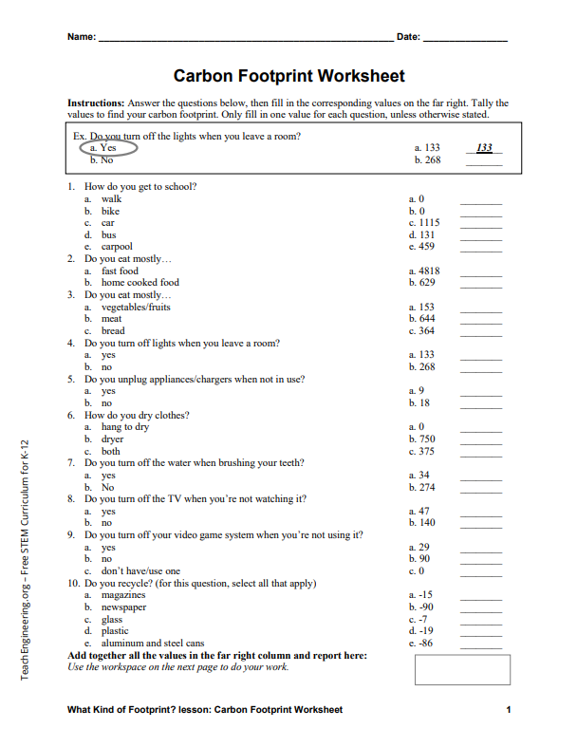
Carbon Footprint Worksheet

