New Feature: Credit for In-Progress Courses



Overview

* DARS has a new feature! Courses you are currently registered for, including ones you’re taking right now, now display their credits on your Degree Audit.
* It is easy to tell registered coursework apart from completed courses! Registered courses appear with an **RG** next to them, while completed courses display the **grade earned**.



* Credits in DARS still show an RG when you a repeating a course. You may not earn credits twice for the course. Only specific courses can be taken twice – see an advisor for more details.

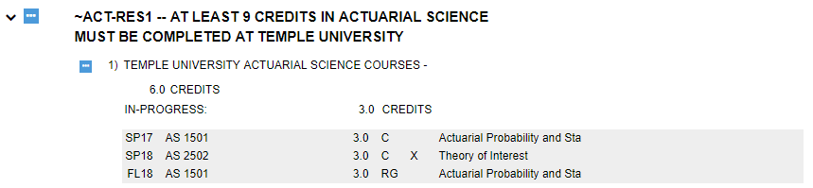

* Credits for registered courses will be displayed separately from completed coursework on the charts and graphs. The registered courses will display in **blue**, while the completed courses will remain **green** and the incomplete courses will remain **red**.

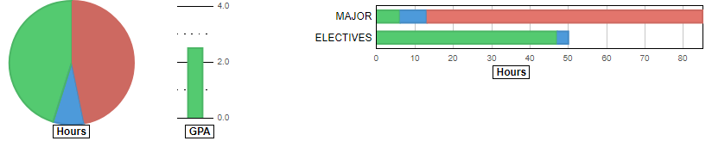

* Similarly, if a Requirement is completed with registered courses, instead of getting a green check mark to show ‘Complete’, it will have a **blue triple-dot symbol** to show ‘Complete with Registered Coursework’. Keep in mind that this symbol will appear even if you are taking more courses for the Requirement than you need to; always check with your advisor if you have questions about what courses you still need to take.



* Additionally, the completed hours at the top of a Requirement or Subrequirement will show the registered courses as a separate ‘In Progress’ hour total. They show credits and/or courses where appropriate.

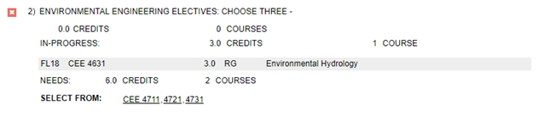



* It is important to remember, however, that your in-progress courses aren’t granting you that credit yet. **You must complete the courses with the appropriate grade to earn the credit indicated!** If you have questions regarding in-progress credit, how it is displaying on your DARS audit, or how it will end up applying to your degree, consult with your advisor.