New Feature: Credit for In-Progress Courses



Overview

* DARS has a new feature that enhances degree audit accuracy! Registered courses, which previously appeared with ‘0’ Credits on the DARS Audit, now display credit hours.
* It is easy to tell registered coursework apart from completed courses. Registered courses still appear with an **RG** next to them.



* Keep in mind that if a student is repeating a course, the student may not be earning credits for it twice even if credits show up with the **RG** – students are being directed to consult with their advisors for details regarding what courses they can repeat for additional credit.

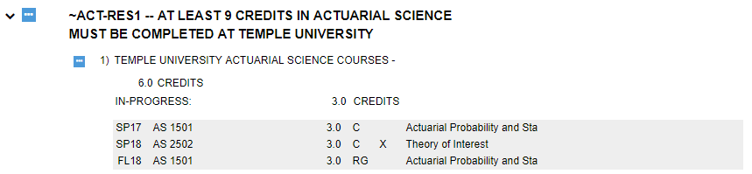

* Credits for registered courses will be displayed separately from completed coursework on the charts and graphs. The registered courses will display in blue, while the completed courses will remain green and the incomplete requirements will remain red.

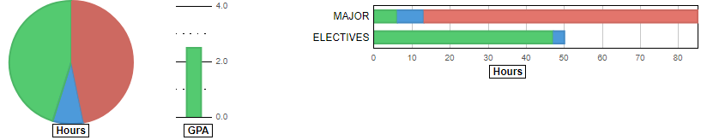

* Similarly, if a Requirement is completed with registered courses, instead of getting a green check mark to show ‘Complete’, it will have a blue triple-dot to show ‘Complete with Registered Coursework’. Keep in mind that this symbol will appear even if the requirement is over-satisfied by the registered coursework; students are directed to always consult with their advisor if they have questions about what courses they still need to take.

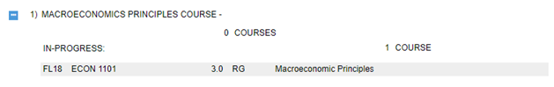

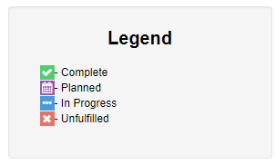

* Additionally, the completed hours at the top of a Requirement or Subrequirement will show the registered courses as a separate ‘In Progress’ hour total.

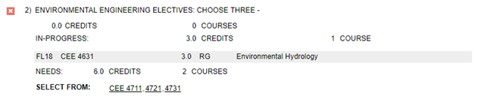

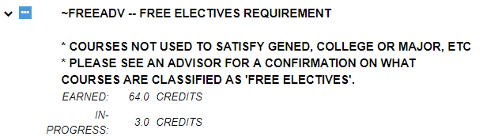

Important Info

* Be advised that if a student is registered for a course that the student already has a grade in (for example, if they are retaking it to get a better one), credit for the course will appear **twice** on the audit until the student gets a grade in the second instance of the course.



* Be aware that if a standard Requirement is fully completed via any combination of courses (regardless of whether they are complete, planned, or in-progress), it will stop displaying in progress courses as a separate credit total from completed ones for that requirement on main audit. The courses will remain separated on the charts and graphs, and the requirement will still retain the ‘Complete with Registered Coursework’ or ‘Complete with Planned Coursework’ indicator.

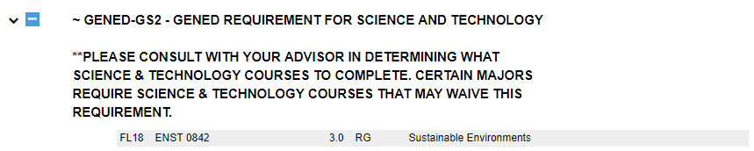

* Keep in mind that if a student is taking a course that oversatisfies an existing, completed requirement rather than being needed for an incomplete requirement, the completed requirement that it sorts into will display with the blue ‘Complete with Registered Coursework’ indicator instead of the green ‘Complete’ indicator until the additional course obtains a grade.



* Note that differences in requirement encoding can cause differences in how in-progress courses are presented on the audit. See the following screenshot for an example demonstrating the differences between a subrequirement including ‘sets’ of courses (where some options include an ‘and’ in the encoding) and one whose options do not include any and’ed sets. More detailed examples are presented in the Formatting Notes section on the following pages.

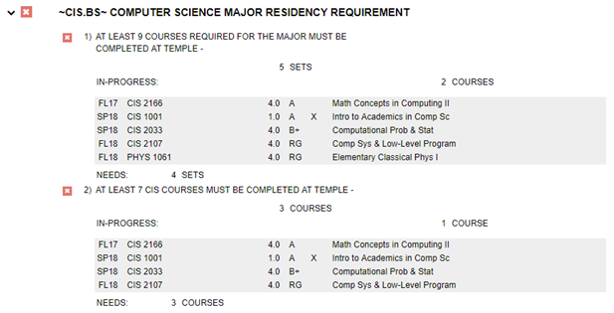

Formatting Notes

Bear in mind that the display format for registered courses will differ based on the details of the requirement and subrequirement that those courses are in, as well as the completion status of the requirement or subrequirement.

* In the most basic circumstance, if a requirement has subrequirements that are looking for a number of courses (as opposed to a number of credits) that are complete, the subrequirement does not have any ‘and’s in its encoding, and all of the other subrequirements of the requirement are complete it will display with the blue triple-dot as complete with registered courses and not give any additional lines about what number of courses are or are not registered.



* If, however, a requirement has subrequirements that are looking for a number of courses, the subrequirement does not have any ‘ands’ in its encoding, and they are not all complete (even if one is an OR’d option that is no longer being displayed), it will display the number of courses complete, then, on a line below that, it will display the number of courses that are in-progress.

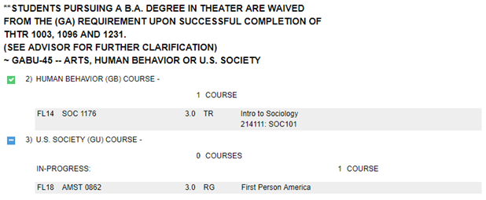

* In the case that a subrequirement is looking for a number of courses completed, but it has one or more ‘and’s in its encoding, it will display the number of sets taken (regardless of whether or not they involve currently registered courses), then, on a line below that, it will list how many of the courses are in-progress.

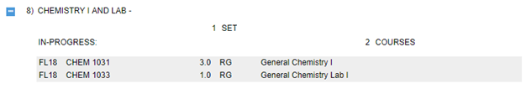

* If a subrequirement is tracking credits completed (as opposed to courses completed), it will display the number of completed credits taken in parenthesis, then, on a line below that, it will display the number of credits in-progress. It will display this regardless of whether or not it is complete, and it will use the blue triple-dot icon even if there are enough credits for it to otherwise have the green check mark. If it is incomplete, it will also display a third line with how many more credits are needed.

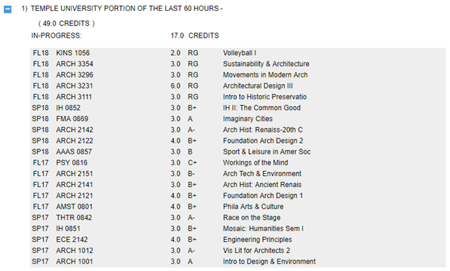

* If, however, an overall requirement (as opposed to a subrequirement) is looking for a total number of credits (rather than a total number of courses), it will, if incomplete, display the number of credits earned on one line, then the number of credits in-progress, then the number of credits still needed.

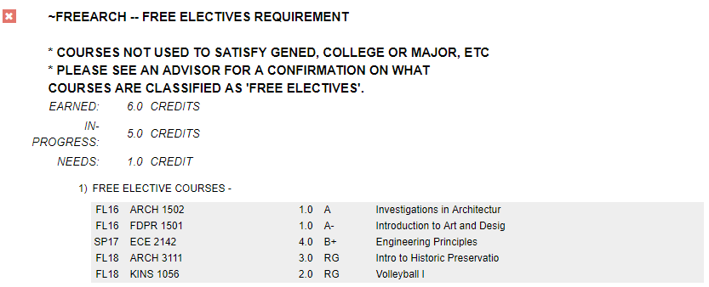

* If completed, however, an overall requirement looking for a total number of credits will display the number of earned credits and then the number of in-progress credits on two separate lines without a third line for the number needed.

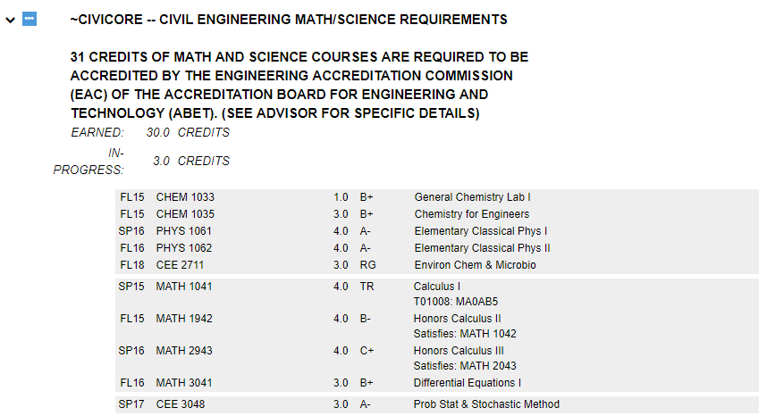

* If a subrequirement requires both a set number of credits and a set number of courses to be considered complete, it will display the number of credits and courses that are complete on one line, then the system will display the number of credits and courses that are in-progress on another.

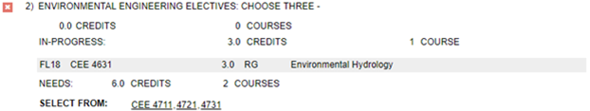

* In a more complex situation, if an overall requirement requires both credits and a set number of sub-requirements fulfilled, with the sub-requirements looking for a mix of credits and courses, it will display an earned line, showing the number of credits complete, as well as the number of subrequirements fully completed, then it will display a line showing how many credits are in-progress (but this line will not, in situations where they are incomplete, note how many sub-requirements they are spread across), then a third line showing how many credits and sub-requirements are still needed, with each individual sub-requirement nested under the requirement also displaying what it requires in the format befitting its subrequirement type (as described above).

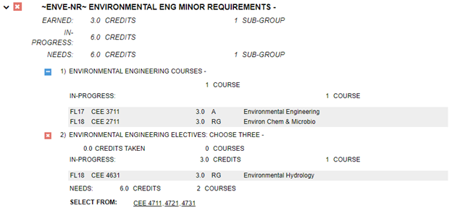

* Note that in-progress course presentation can also be altered by OR’d requirements. If two or more requirements are OR’d together in the encoding, courses that are applying against what is needed by the requirements themselves (as opposed to their subrequirements) do no specifically list in-progress courses differently from non-in-progress courses, but their subrequirements, if counting credits, do. Bear in mind that ‘Complete with Registered Courses’ triple-dot icons will appears for subrequirements that include registered courses, but that icons will not appear for requirements that are not the first out of the OR’d requirement group or for subrequirements that do not include registered courses.

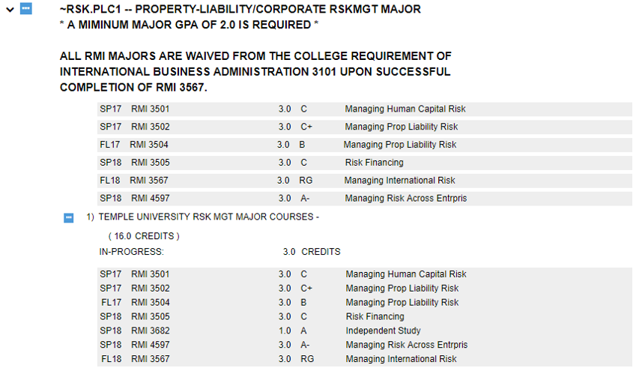

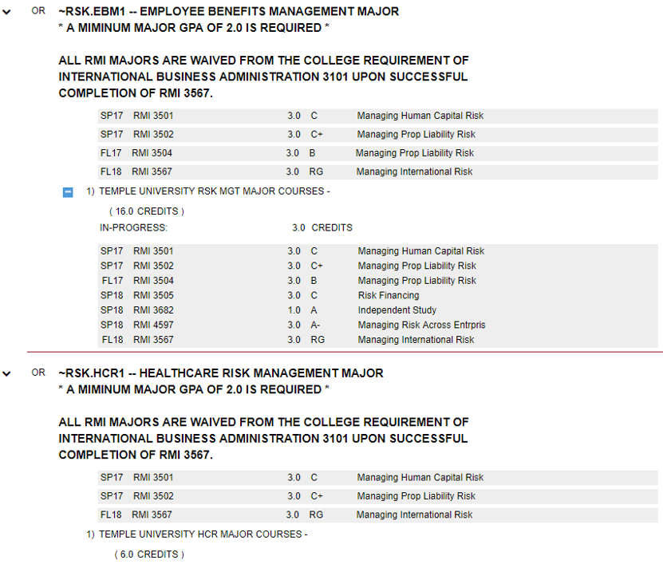

* Be aware that other, rarer situations with special encoding may cause other slight changes in display format.