For the Majors:
- Open Internet Explorer.
WARNING: Other browsers do not work for running this report. Chrome, Firefox, and Edge will not be able to run the report.

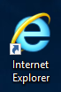

- Go to automation.temple.edu. Click ‘Start the Applications Manager Client’.

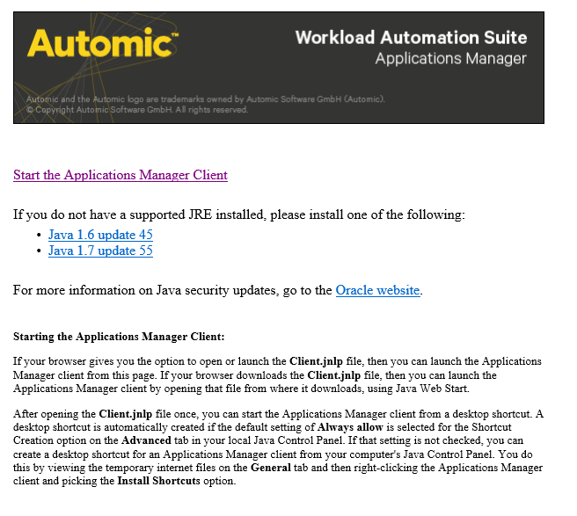

- Java will launch. Choose ‘Allow’ on the first prompt and ‘Run’ on the second prompt.
WARNING: If Java asks to update, DO NOT UPDATE. If you update Java, the report will become permanently unrunnable on your computer. If you update Java, contact Computer Services so that they can revert your Java version.

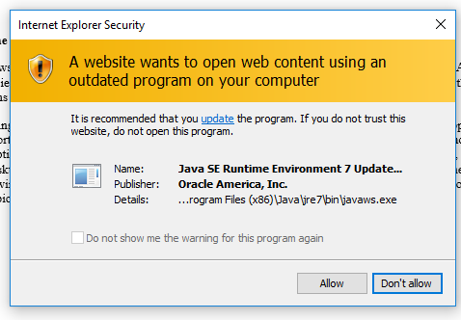
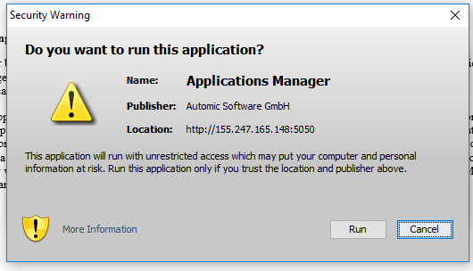

- Log in with your User Name and Password. Keep Automation Engine ‘PRDAMP’ and Language ‘User Default’. The click ‘OK’.

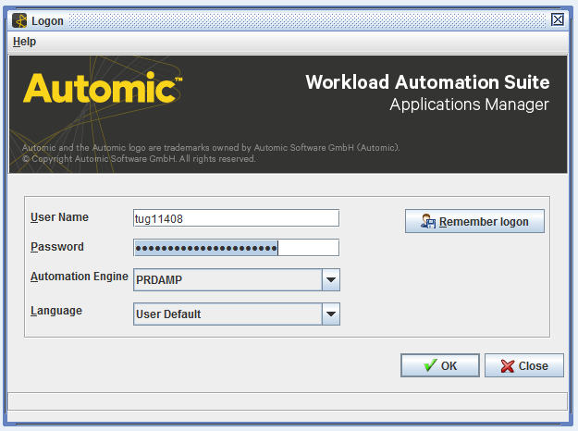

- Click ‘Ok’ to bypass the information popup.

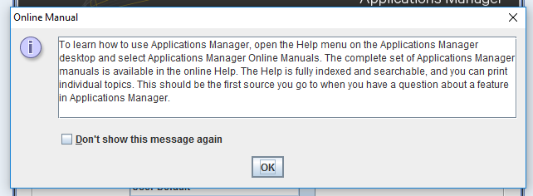

- Click the ‘Requests’ button in the top bar. It is shaped like a green arrow.

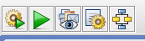

- Choose ‘S_DARS_STUDENTS_PLANS_PROCESS’ from the list. Then click ‘Request’ at the bottom of the pop-up.
NOTE: Make sure you choose the version with ‘PROCESS’ in the name and a ‘P’ in the right-hand column. The other ‘Dars Students Plans’ items are sub-components of it and do not run individually.

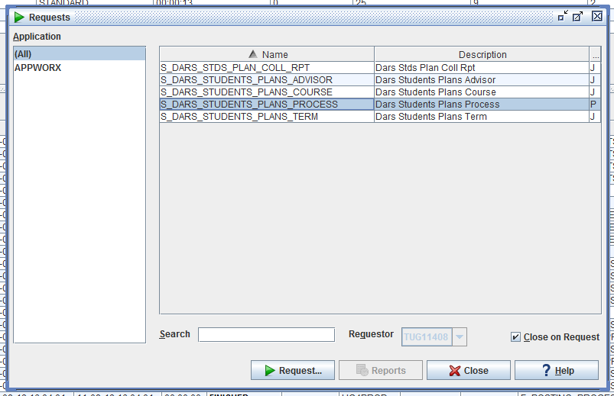

- Choose your school’s College Code from the drop-down menu. Then choose ‘Submit & Close’.

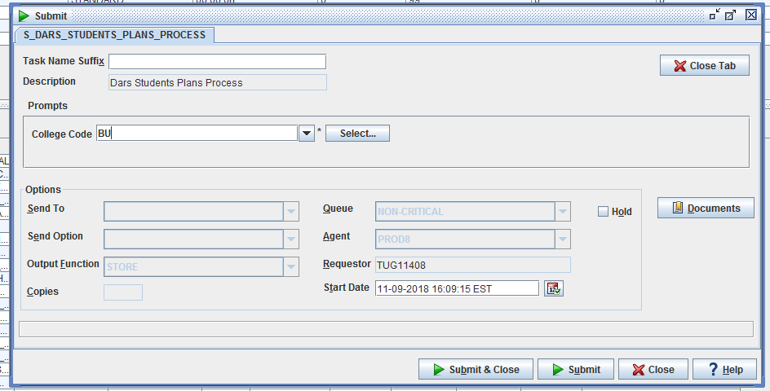

- Select ‘Backlog’ on the left-hand menu to monitor your report as it runs.

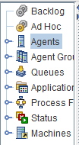

- Your report will run on the status list with your username in the ‘Requestor’ column. When it is complete, it will disappear from the ‘Backlog’ status list.

- Go to TUPortal. Select ‘E-Print’ from the list on the left.

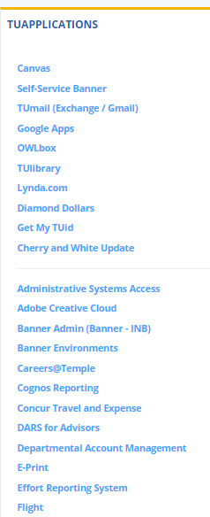

- Choose the ‘XLS’ button next to the report that you ran to download the report.
NOTE: The Drill icon next to the ‘XLS’ button will let you view older versions of the report that you previously ran.

- Open the report with Excel. You will be given a warning about the report’s data. This is not an actual error and the file is safe to open. Choose ‘Yes’.

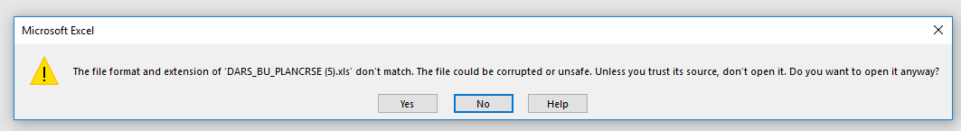

- To avoid having to click through the Excel error again when reopening the report, choose ‘Save As’ from the File menu and save the report as an ‘Excel Workbook’ on the ‘File Type’ dropdown (as opposed to ‘Text (Tab Delimited)’, which it will default to).

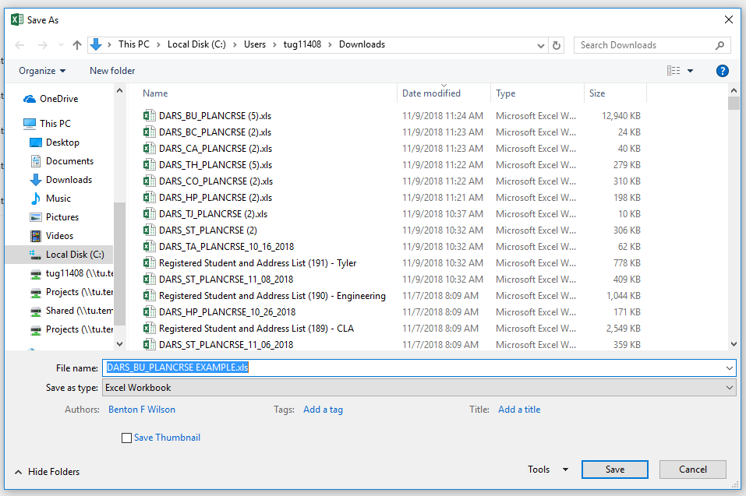

- Your report is now ready for use!

