Operational Procedure
- It is extremely important that, when done using the Roadmap or Plan Builder, users log out of the system using the Cogwheel Icon located in the upper right. First click the Cogwheel Icon, then, when the expanded menu appears, click Log Out. Failure to log out properly can lead to future Plan Builder sessions pulling up data for unselected students who were viewed during earlier sessions.
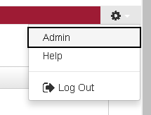
- As the Roadmap Builder and Plan Builder currently do not use the same authentication services, users should make sure they have logged out from both the Plan Builder (located at https://prd-dars.temple.edu/selfservice) and the Roadmap Builder (located at https://prd-dars.temple.edu/udirect).
- For an optimal experience, do not simultaneously open more than one Plan at the same time.
- Be particularly wary that you do not open two copies of the same Plan at the same time. Be aware that when you run an Audit with Planned Courses, it will, in some browsers, open in a new tab. This means that the Plan is still open; re-opening the Plan from the tab that contains the Audit with Planned Courses can cause the aforementioned system issues, so one of the two tabs should be closed when the Audit is done being reviewed.

