Roadmap and Student Plan Creation



DARS u.achieve 4.3

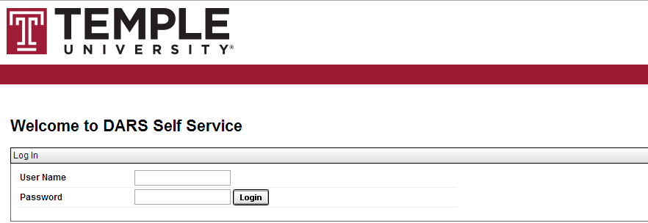

Steps

Follow these steps to build a roadmap for an academic program.

1. Log In to the Self Service application using your AccessNet credentials.
2. Click on the **Roadmaps** icon from the Home page.

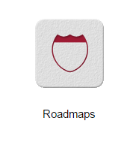

1. If you see the Manage Roadmaps page when you log in, proceed to the next step.

If you do not appear on the Manage Roadmaps page when you log in, select the drop-down arrow to the right of **Roadmaps** on the top bar. Select **Manage** from the drop-down.

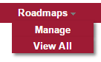

1. **Locate the school/college** that the degree you desire to create the Roadmap for is part of from the list of colleges and degree programs. **Click the plus icon** to the left of the college. **Continue by expanding pluses** through major and degree type levels until the degree program you are looking for is reached.



1. Once you have drilled down to the degree program, **click the degree program’s name**.

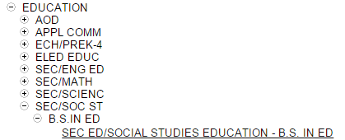

**Note:** This page also has the **Roadmap Tips**. They explain how to change to other Programs in addition to providing an on-page refresher as to how to make a new Roadmap.

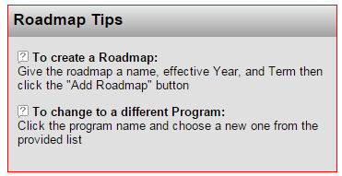

1. Type the name you want to give your roadmap in the **Roadmap Name** box.

When creating Roadmaps for each major (and concentration, where applicable), it is standard policy to have a separate Roadmap for each GenEd category that a student can possess. It is policy to not have separate versions of Roadmaps for Honors students, as doing so creates a confusing large number of Roadmaps. When naming a Roadmap, start with the year that the Roadmap is for, then the abbreviation of the major, then an abbreviation of the concentration (if applicable), then the GenEd type (with the appropriate names for the three GenEd categories shown below).

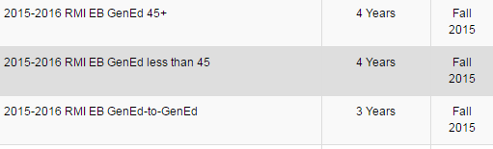

1. Choose the term you wish the roadmap to apply for from the **Effective Term drop-down menu**. Ensure that the **Effective Year** and **Years to Graduation** also match up with the program you are making the roadmap for.

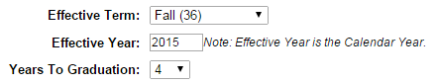

1. Click on the **Add Roadmap** button.



1. The new Roadmap will be added to the **Available Roadmaps** section at the bottom of the Manage Roadmaps page. **Click on the roadmap’s name** to begin editing its contents.

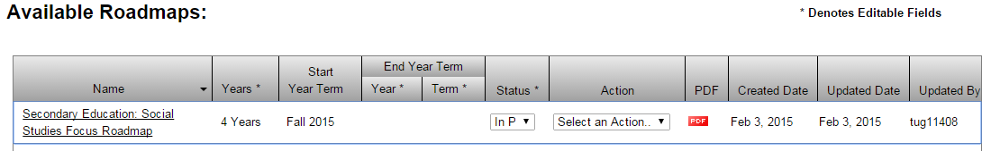

**Note:** When the Roadmap is entered, it will take a moment to load. This is because it has to build the degree audit for that major. The Roadmap will automatically be entered when the Loading Bar popup finishes and closes itself.

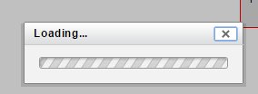

1. Create the Roadmap by dragging courses from the left-hand Audit section of the page to the semesters on the right-hand section of the page. As each degree program will involve different courses and considerations, instead of a step-by-step explanation of this, a set of Tips will be provided. These Tips will be contain information on how to perform all actions needed to construct your Roadmap, as well as warnings about how to avoid common problems in Roadmap creation. **See the Tips Section**, which starts on page 6, for this information now, and return to this step-by-step instruction list when done.

STOP

SEE THE TIPS SECTION BEFORE GOING TO THE NEXT PAGE

1. To verify that your completed Roadmap meets all requirements that the DARS (Degree Audit Reporting System) thinks are required for your degree, **select the check-mark icon** to verify the Roadmap.

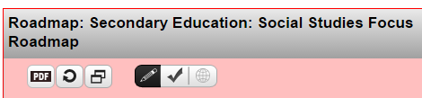

1. The system will highlight any items that are not linked to Requirements on the Audit in red on the right-hand Roadmap side and expand any items it believes should have been added that were not on the left-hand Audit side. Use your judgment to determine if these items are truly unneeded/missing. In the case of items not linked to requirements, attach them to requirements as appropriate. Once you have made any necessary corrections, your Roadmap is ready for review as a PDF.
2. To see how your Roadmap looks as a PDF, **click the PDF Button**. This will show you a sample PDF of the Roadmap that can be printed or saved.

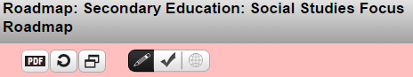

1. Once you have looked over the PDF, **close the tab** that the PDF is in to return to the Roadmap Creation page. If you think changes need to be made to the Roadmap, you can make them now. Otherwise, you have completed making the roadmap.
2. Log out when done. To do this, click the **Cogwheel Icon** in the upper right, and then select **Log Out** from the drop-down menu. As the system does not use single-sign-on, users should make sure they have logged out from **both** the Plan Builder (located at https://prd-dars.temple.edu/selfservice) and the Roadmap Builder (located at https://prd-dars.temple.edu/udirect).

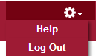

Tips Section

**Contents:**

* **Roadmap Page Basics** (Page 7)
* **Adding Non-GenEd Courses** (Page 9)
* **Deleting Courses and Requirements** (Page 12)
* **Moving Requirements Between Semesters** (Page 12)
* **Adding GenEd Courses and Other Lists** (Page 13)
* **Variable Or’ed Groups** (Page 14)
* **Adding Free Electives** (Page 16)
* **Adding Course Ranges** (Page 18)
* **Editing List Names/Credits** (Page 23)
* **Style Preferences** (Page 25)
* **Required Courses and Status Indicators** (Page 30)
* **Special Course Groupings From The Audit** (Page 32)
* **Changing Requirement/Course Display Order** (Page 33)
* **GenEd-45 Roadmap Creation** (Page 35)
* **Common Issues: Missing Edit/Delete Buttons** (Page 40)
* **Common Issues: Changing Hours Displayed** (Page 40)
* **Common Issues: A Requirement Has Come Delinked** (Page 41)
* **Copying a Complete Roadmap** (Page 44)
* **Switching To Student (Plan Creation) View** (Page 46)
* **Student View: Creating a New Plan** (Page 48)
* **Student View: The Move Preferred Button** (Page 50)
* **Student View: Adding Courses** (Page 51)
* **Student View: Adding Wildcard Courses** (Page 52)
* **Student View: Adding Course Ranges (And Manually Choosing Courses)** (Page 53)
* **Student View: Moving Courses On The Plan** (Page 55)
* **Student View: Deleting Courses** (Page 56)
* **Student View: Adding And Removing Semesters** (Page 57)
* **Student View: Validating With An Audit** (Page 58)
* **Student View: Preferred Plans** (Page 59)
* **Icons For Roadmap Creation Page** (Page 60)
* **Icons For Plan Creation Page** (Page 64)

It is strongly suggested that an individual making a Roadmap reads all portions of the Tips Section relevant to that Roadmap before beginning to construct the Roadmap.

**Roadmap Page Basics**

* The Roadmap Creation Page is divided into two columns. The left-hand column, which contains the **Audit Section**, is where you will be finding courses to add to the Roadmap you are creating. The right-hand column, which contains the **Roadmap Section**, is where you will be building the Roadmap out of those courses.

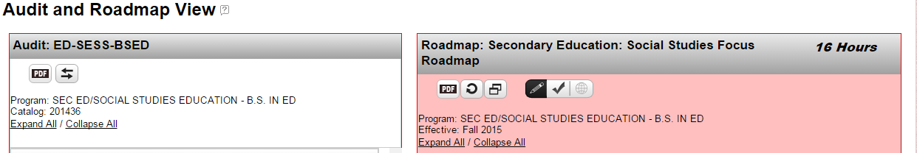

* The Audit Section in the left-hand column tracks requirements that the system recognizes as necessary for completing the chosen degree program. These include both taking specific courses (or courses from specific sub-groups) and taking a certain number of hours of courses overall. The number of hours that need to still be added to a particular requirement or sub-requirement are written to the right-hand side of that requirement or sub-requirement’s name.

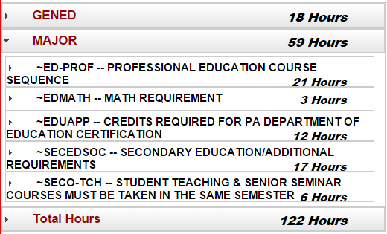

* Take note of the **Legend** on the page, which indicates important icons used in Roadmap creation.

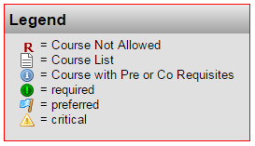

* To view the sub-requirements of a requirement or the courses that can apply towards a requirement or sub-requirement, **click the arrow to its left**. Similarly, if a requirement or sub-requirement is already expanded, the arrow can be clicked to stop showing its contents. The **Expand All** and **Collapse All** buttons can also be used.

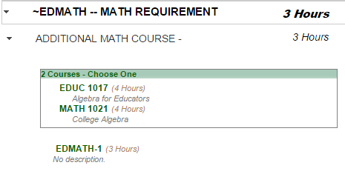

* Note that when all sub-requirements of something are met, it will automatically close itself, meaning you will have to re-open it if you want to select other things that are in it as alternate options.
* Requirements, Courses, Semesters, and Years on the Right-Hand Roadmap side can be collapsed and expanded just like Requirements, Sub-Requirements, and Courses on the left-hand Audit side. Simply **click the arrow to the left** to expand or collapse one.

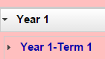

**Adding Non-GenEd Courses**

* To add a course listed under one of the requirements from the Audit Section, **drag the course’s name** over on top of the term you want the course added to and release the mouse. This will add the course as its own requirement in that term.

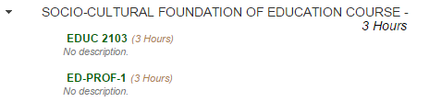

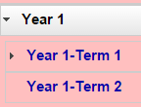

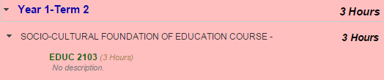

* An item will become checked-off on the left-hand side when all of its sub-requirements have been added to the right-hand side. The number of hours next to it will also become zero.

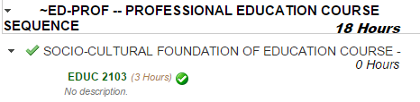

* To add all of the courses in a requirement from the Audit Section to the same semester, **drag the requirement’s name** over on top of the term you want all of those courses added to and release the mouse. This will add all of the courses to the same requirement in that term.

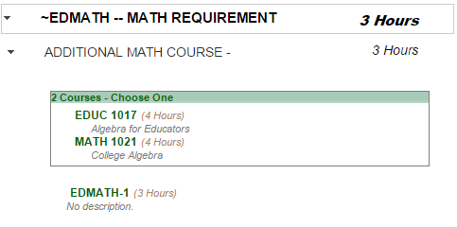

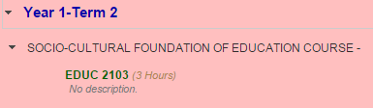

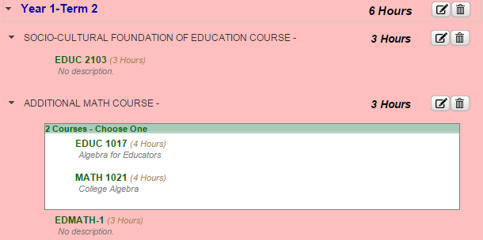

* To check if a course you are looking to add to the Roadmap side exists on the Audit side, click then **Expand All** button on the audit side. Once this is done, press **ctrl+f** on the keyboard. This will bring up the Find Box. **Type the name or number of the course** you are looking for in the Find Box. This will take you to the course name if it exists on the page and highlight it. The arrows in the Find Box allow you to search upwards and downwards for other places where the words you have typed into it are located. When done with the Find Box, click the x on the right side of the Find Box to close it. You can then click Collapse All on the Audit Column to close all of the open requirements if you desire.



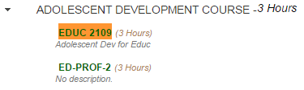

**Deleting Courses and Requirements**

* To delete a course or requirement that was added accidentally, **click the Trash Can Icon** to the right of the course or requirement’s name. Then **click** ‘**Yes’** to confirm the deletion. If deleting a course leaves you with an empty requirement that you do not want, repeat the process to delete the requirement.

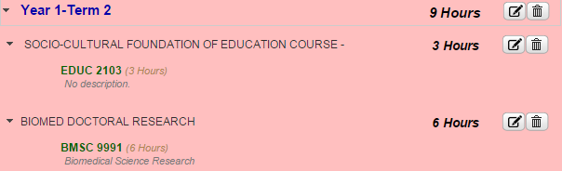

**Moving Requirements Between Semesters**

* To move a requirement from one semester to another, **drag the requirement’s name** from its current position on the right-hand side so that it is over the name of the semester you wish for it to be changed to, then release the mouse. Then click **‘Move’**. This removes the requirement from the old semester and places it into the new one.

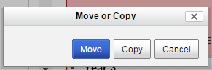

**Adding GenEd Courses and Other Lists**

* When adding a GenEd item to your roadmap, you will see that, in addition to individual courses, **Lists** are present on the Audit side. These Lists contain information about all of the courses that are included in the GenEd requirement they are for. The rectangular page-symbol shown in the image below denotes something as a List.

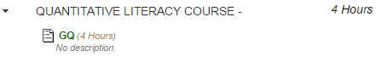

* When adding a GenEd requirement with a list, only the list itself needs to be dragged over. The various courses that count as part of it do not need to be added individually. To add the list, simply select its name, and drag it over into the target semester as though it were a course.



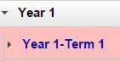

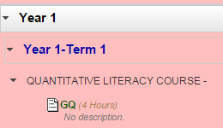

* Do not select the heading above the list instead of the list itself. If the heading is moved into the Roadmap instead of the list, all of the courses will be added individually in addition to being added as part of the list. If this occurs, select the **trash can icon** to remove the category so that the list itself can then be added.



**Variable Or’ed Groups**

* OR groups can be used to create relationships between Requirements where a student only has to take one option from a number of possible options across different Requirements in the same semester.
* **Click the Edit button** to the right of the Requirement you want to OR.

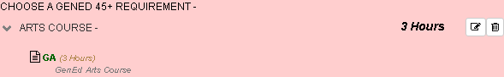

* **Check the box** next to ‘Or’ed?’.

If you have previously added a different group of Or’ed courses (such as a different GenEd Breadth option), select a new number from the Or’ed drop-down.



* **Type the name** that you want all of the Or’ed options to appear under category-wise into the Or Group Name Box.



* Click the **Save Button**.

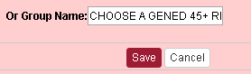

* **Repeat this process** for each other Requirement that fits into the group. Make sure that all of the Lists in the group have the **same Or’ed** **group number**.

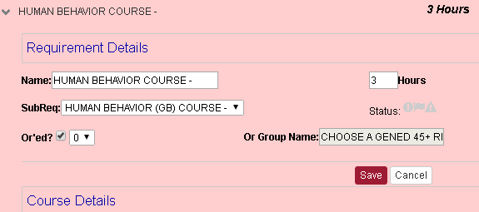

* When this process is complete, the Requirements involved will appear within blocks beneath a heading with the Group Name at the top and the word ‘Or’ between each of them, as shown below.

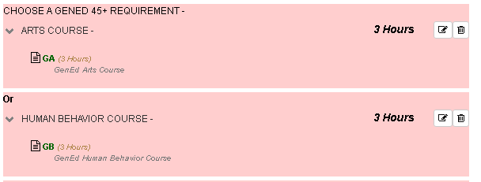

* **Note:** If you want different Or’ed groups in the same semester, give each group a different Or’ed group number. This will give the different groups different boxes to sit in. When doing this, make sure that the Requirements in each group are next to each other, moving their order within the semester if need be.
* **Note:** If the courses you want to OR are in the same Requirement, OR groups cannot be used. Instead, set the Hours for the Requirement to a number that will check off once a single valid option from the Requirement is added and rename the Requirement to indicate that a student should choose one (or some other specific number) of courses.
* **Note:** Courses cannot be Or’ed across different semesters using the Roadmap Builder.

**Adding Free Electives**

* Free Electives, where a student can take any course they desire under the elective umbrella that do not possess a specific List to choose from, must be added to the Roadmap in a manner different from GenEds and mandatory courses. To begin, **locate the Free Elective category** for the degree program on the left-hand Audit Side. **Expand it**, so that the **\*\*\*\*\*\*\*\*\*\*** can be seen.

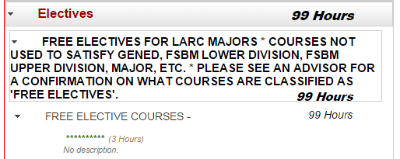

* **Drag the \*\*\*\*\*\*\*\*\*\*** over to the desired Term other side as though it were a normal course.





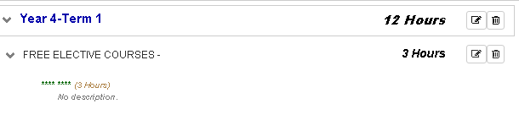

* Click the **edit button** next to the newly-added requirement.



* **Enter the number of hours** for the course. Do not click save yet.



* **Change the name** of the item if needed. Check the Style Guide for info on standard naming practices. Do not click save yet.



* Click **Course Details**.

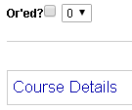

* **Change the course’s description** to show that it is an elective course.Click **Save**.

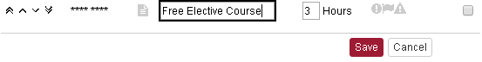

* The process is complete. The elective has been added to the Roadmap.

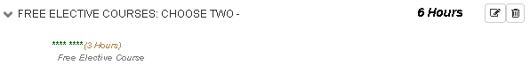

**Adding Course Ranges**

* Most course ranges are currently represented in the system with a partial wildcard. Add those to the Roadmap like they were any other course (making sure to change the name at the course level from ‘no description’ to something more informative regarding what the partially *’d range represents).

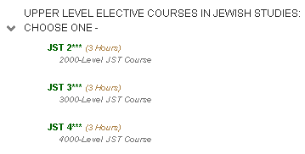

* Some course ranges, however, are identified by yellow boxes on the Audit Side of the Roadmap Creation Page. Follow the following procedure to properly add those courses to the Roadmap.

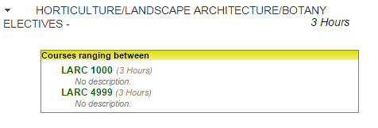

* **Drag the entire yellow Course-Range Box** over to the desired term.





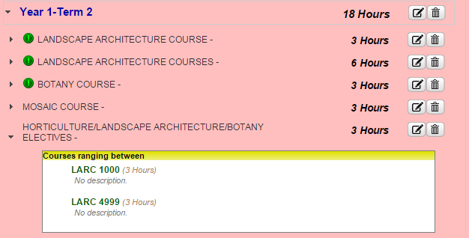

* Click the **Edit Button** next to the Requirement that the yellow box is now in on the Roadmap Side.

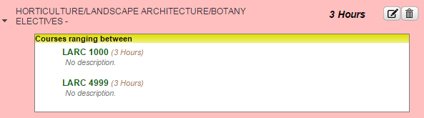

* Click **Course Details** within the Requirement.

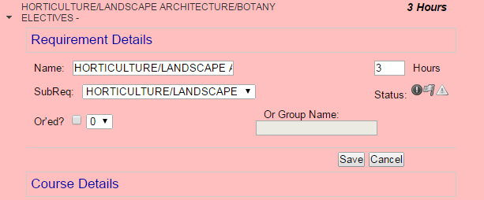

* **Tick each Check Box** within the yellow box.

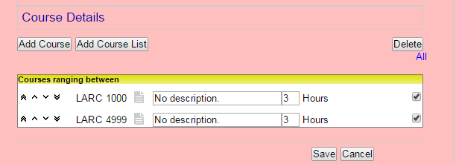

* Press the **Delete Button**.



* Notice that while all of the courses have been removed from the Requirement, that the yellow box remains in it as a header. This allows the link to the Degree Audit’s Requirement to be maintained by the Roadmap’s Requirement without students having the ability to incorrectly drag over the nonexistent courses that often begin and end course ranges. Click **save**.

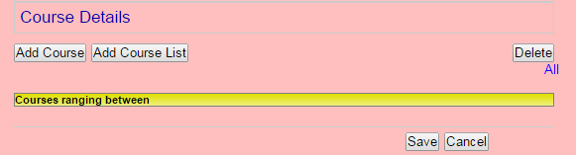

* Click the **Edit Button** next to the requirement again.

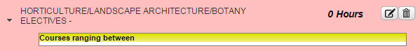

* Removing the courses from the yellow box removed the hours from the Requirement, automatically setting its hours to zero. **Enter the hours value** desired in the Hours box.

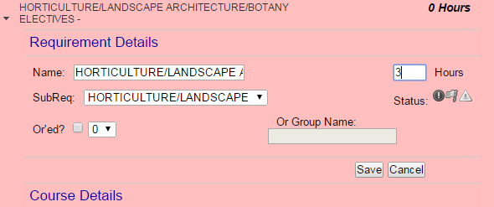

* **Change the name of your Requirement** to indicate what courses can be taken within the range.

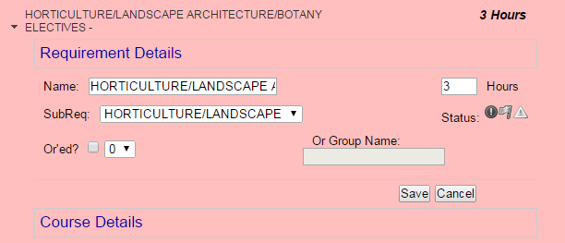

* Click **Save**.



* The course range has successfully been added to your Roadmap.

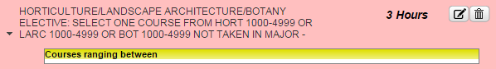

* **Note:** If a Requirement includes multiple course ranges, only one needs to be dragged over to the Roadmap. The single box will anchor the Requirement on the Roadmap to the Requirement on the Audit, meaning that it will check off if met by any course combination that satisfies the Requirement on the Audit, regardless of whether or not that course combination is directly on the Roadmap.

**Editing List Names/Credits**

* Some courses, particularly GenEd courses, will appear with the estimated number of credits for encoding purposes. It is best to edit the courses credit and name that you want to show up as a category name on PDF printouts of the Roadmap. These lists will expand into their component courses when viewed by a student online, but they will only display as-shown on the Roadmap PDF.



* To edit one of these lists’ credits and description, click the edit button to the right of the Requirement that the List is in. (The same process would apply if you wanted to edit the credits and description for an individual course).

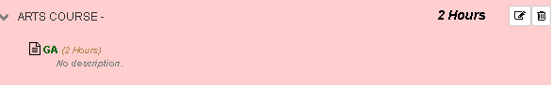

* If the number of hours for the course has to be updated, edit the Hours field. Do not click save yet. Doing so at this stage will end the editing process, and the hours field will still not display correctly on the PDF.

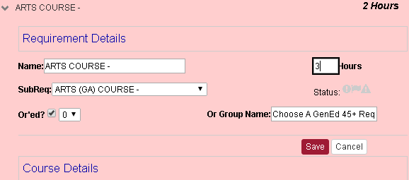

* Click Course Details.



* Type the Course Description and Hours you want to display on the PDF version of the Roadmap into their respective fields.



* Click Save to finalize the changes.

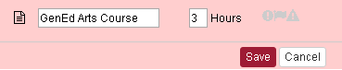

* The Course Description and Hours will now display correctly in the PDF.



* The similar process can also be used to fix other errors in PDF display text, such as an ampersand (&) in a Course Description or Requirement name displaying as an ‘&amp;’, in which case it should be replaced with the word ‘and’. The edit in such a case would occur in the Requirement’s name before ‘Course Details’ was clicked. See the Style Preferences section for more details.

**Style Preferences**

* It is considered standard policy for Requirement names to be in ALLCAPS and for individual course names to be in A Mix of Capital Letters and Lowercase. This allows for ideal format-matching between user-entered Requirement and course names and system-generated ones. Include the word ‘COURSE’ in the requirement name where appropriate. Additionally, include a space and ‘-‘ dash after the requirement name.

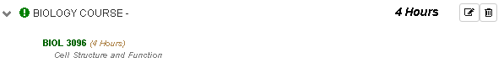

* If adding a course where students have a choice between courses within the same Requirement, add ‘: CHOOSE # -’ to the Requirement title.

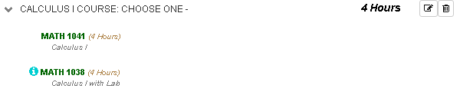

* If adding Free Electives, use the phrasing ‘: CHOOSE ONE -’, ‘: CHOOSE TWO -’, etc, if the desired number of credits of Free Electives to be taken in that semester is a multiple of three. If the desired number of credits of Free Electives to be taken in that semester is not a multiple of three, instead use the wording ‘: CHOOSE TWO CREDITS WORTH -’, ‘CHOOSE FIVE CREDITS WORTH-’, etc. In instances where less than three credits of Free Electives are in a semester, set the hours at the course level to equal the hours at the requirement level; in instances where three or more credits of Free Electives are in a semester, set the hours at the requirement level to 3.

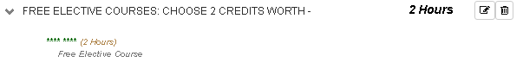

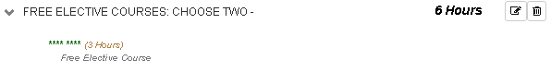

* When adding courses that must be taken in specific groups, the standard phrasing to use is ‘: CHOOSE ONE SET <ADDITIONAL INFORMATION ON WHAT SETS ARE VALID>’, as shown below.

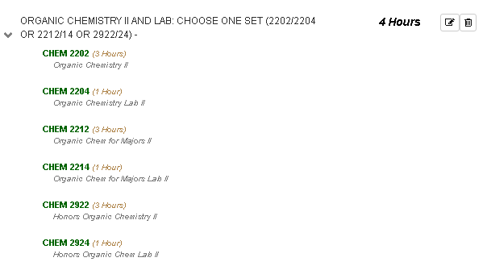

* When creating Roadmaps for each major (and concentration, where applicable), it is standard policy to have a separate Roadmap for each GenEd category that a student can possess. It is policy to not have separate versions of Roadmaps for Honors students, as doing so creates a confusing large number of Roadmaps. When naming a Roadmap, start with the year that the Roadmap is for, then the abbreviation of the major, then an abbreviation of the concentration (if applicable), then the GenEd type (with the appropriate names for the three GenEd categories shown below).

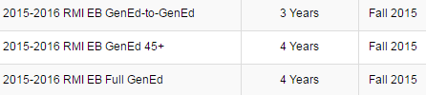

* When creating Roadmaps for majors that possess concentrations, if those majors also possess versions of the degree without a concentration, that version must use NoConc as its ‘Concentration Abbreviation’ to maintain proper ordering of Roadmaps for students.



* When naming requirements, use the word ‘COURSE’ in the name if the student is taking a single course (whether it is a single specific course of a ‘CHOOSE ONE’ situation), and use the word ‘COURSES’ if the student is taking either more than one course or ‘# CREDITS WORTH’ of courses.





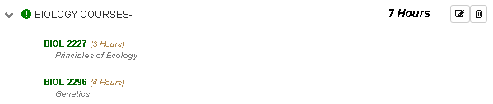



* While courses from Lists can be added individually, the default stylistic preference is to add lists of courses as Lists. If a List is added, students will be able to view all courses currently in the list when using the roadmap. Lists have the additional benefit of automatically updating as courses are added to or removed from the List over time.

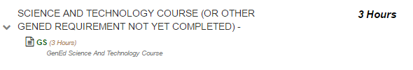

* When adding a list, make sure to name the list so that it appears in PDF view with a name instead of saying ‘no description’.

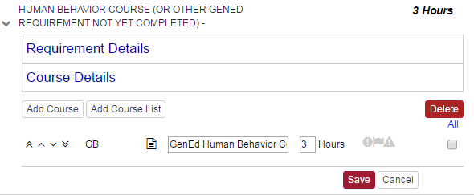

* When naming a Requirement, Course, Roadmap, or other item with an editable text-field, certain special characters are to be avoided.

These symbols work and are acceptable for use:

! @ # $ % ^ * ( ) - ` ~ _ + = { [ } ] | \ : ; ' , . ? /

These symbols are incompatible with the system and are not to be used:

& " < > œ é

* It is standard policy for GenEd courses to be added in specific locations instead of being Or’ed in large groups, but to include the additional text ‘(OR OTHER GENED FROM A CATEGORY NOT YET TAKEN)’ in their Requirement name. This reminds students that they may take their GenEds in an order they desire while keeping the Roadmap from becoming cluttered or checking off as complete if the student selects too many GenEds from the same category. Also, adjust/update the credit hours for the GenEd courses.

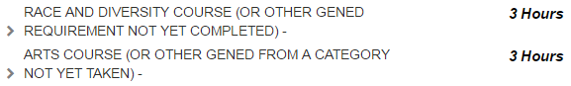

* It is standard policy for Requirements to be marked as Required at the Requirement level if the student does not have a choice in what to take to meet those Requirements.

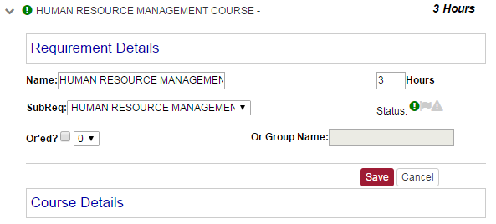

* If a specific course that is part of a Requirement is Required as a choice, whereas the student has an option to pick between other courses within that Requirement, that specific course should be marked as Required at the course level, and the Requirement’s name should include the phrasing ‘: TAKE <REQUIRED COURSE(S) AND CHOOSE # OTHERS –”.

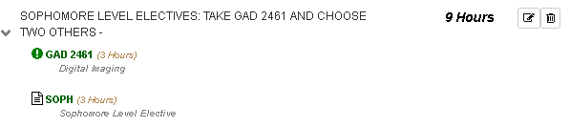

* It is currently preferred for schools to create a custom Requirement with 1 credit hour with no courses in it and the ‘Critical’ icon selected to place in the final semesters of their GenEd-45+ and GenEd-to-GenEd Roadmaps. The Requirement’s name is to include text explaining that students may need to take additional courses that are not on the Roadmap to meet their major’s credit hour requirement for graduation. The text used by the Fox School of Business is shown here as an example.

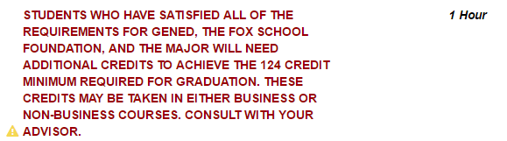

**Required Courses and Status Indicators**

* When a student does not have a choice between multiple different courses and has to take a particular course or group of courses, those courses should be marked as Required. To do so, **click the Edit Button** next to the Requirement that contains the Course(s) or List that is to be marked as preferred.

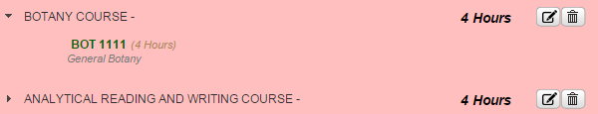

* If you wish to mark an entire Requirement as required, **click the Required Icon** (which looks like an exclamation point).

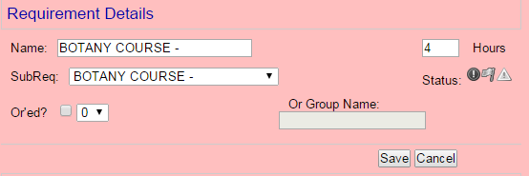

* If you clicked the Required Icon, click **Save**.

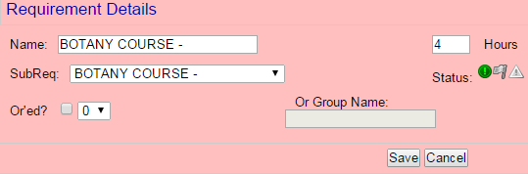

* If, however, you want to mark a specific Course as Required, **click Course Details**. This should only be done in instances where students have to take a course that is part of a requirement and then have a choice between other courses in the same requirement in the same semester.

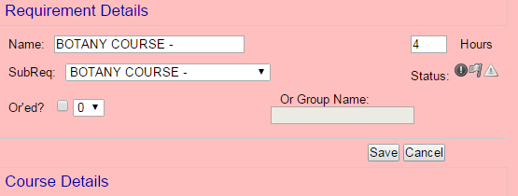

* Then **click the Required Icon** (which looks like an exclamation point) next to the preferred Course or List.



* Then **click Save**.

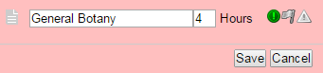

* This process will have left the desired Requirement marked as Required. This Preferred status will show up both on the Roadmap itself and on PDF copies of the Roadmap.
* The triangular status indicator is presently reserved for use with special warnings (usually present on GenEd-45+ Roadmaps but also used in some other circumstances specific to particular schools and colleges). The flag status indicator is presently not used on Temple Roadmaps.

**Special Course Groupings From The Audit**

* Some courses exist on the Audit with special conditions attached to them through encoding. This section explains how to identify those types. Note that ALL of these types of courses can be pulled individually from their boxes to be added to the Roadmap as standard courses. It is only if the whole box or requirement is pulled over that the courses retain their special encoding.
* An Already-OR’d Choose-# Group comes in a **green** box. These pre-encoded OR conditionals are the only way to represent an OR relationship between courses within the same Requirement within the system. In general, Roadmap builders should manually drag over the courses contained within the group when adding them to the Roadmap; current style preferences include a minimization of unnecessary boxes on Roadmaps, with choices for students between courses within the same Requirement instead being consistently represented by a ‘CHOOSE #’ statement in the Requirement name on the Roadmap. There are some instances involving elective groups where the green box will be tactically kept to keep students from choosing too many of a particular sub-category of elective, but those are the exception rather than the standard rule.

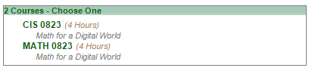

* A Take These Courses Group comes in a **brown** box. It works similarly to any other course save for the unusual-looking format on the audit. Drag it out of its box when transferring it so that the box does not appear on the final Roadmap since the brown boxes are not a preferred format for Roadmap items.

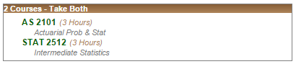

* A Course Number Range comes in a yellow box. Most course ranges have been converted into partially-wildcarded course options, but some unusual ranges retain this boxed format. It contains the courses located both at the beginning and end of the numeric range. If these courses are not real courses, the system will fill in ‘No description’ as the course description for them.

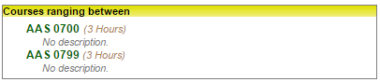

**Changing Requirement/Course Display Order**

* To change the order in which Requirements display, **click the Edit Button** next to the Term they are in.

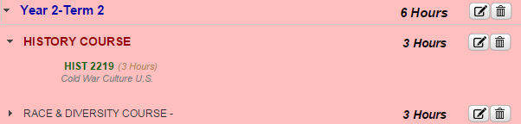

* The buttons to the left of the Requirement name change their order.

The leftmost button, with two arrows pointing up, moves the Requirement to the top of the list.

The second button from the left, with one arrow pointing up, moves the Requirement up the list a single spot.

The second button from the right, with one arrow pointing down, moves the Requirement down the list a single spot.

The rightmost button, with two arrows pointing down, moves the Requirement to the bottom of the list.

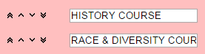

* Once you have the Requirements in the desired order, click **Save**.

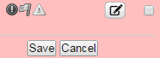

* If you want to change the order of Courses and/or Lists within a Requirement, **click the Edit Button** next to the requirement that contains those Courses or Lists.

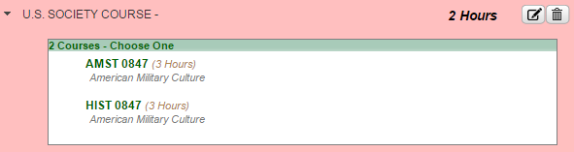

* Then click **Course Details**.

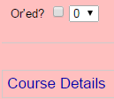

* The buttons shown to the left of the Courses and/or Lists work the same as the buttons to the left of the requirements.

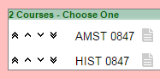

* When done changing the order of the Courses and/or Lists, click Save.



**GenEd-45 Roadmap Creation**

* **NOTE:** Some steps of this process may need to be skipped or modified if your Program provides a waiver for one or more GenEd Courses. Do not add waived GenEd courses to your Roadmap that would not otherwise be on there due to this guide’s instructions.
* Begin by **copying an existing Roadmap**. **Edit the name** to include the GenEd-45 desgination (using abbreviations such as ‘G-45’ if the full designation does not fit). Make sure to **set the proper Effective Term and year**.

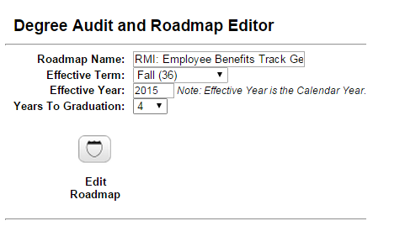

* **Edit the copied Roadmap**. **Delete ALL GenEd courses on the Roadmap** using the Delete Course Icon**.**



* **Begin re-adding** the GenEd Requirements, using the **GenEd-45 versions**, which are located below the Full GenEd versions on the Audit Side.

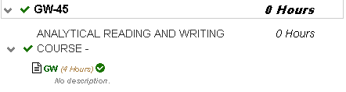

* **Repeat** this process to add the GenEd Analytical Reading and Writing, Quantitative Literacy, Global/World Society, and Race and Diversity courses.

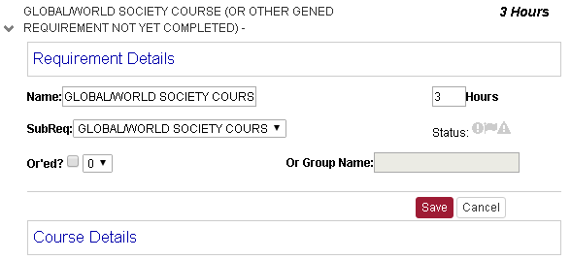

* **Repeat** this process for Arts, Human Behavior, and U.S. Society. **Move these courses** so that they are all in the same semester at the bottom of that semester’s list. Use the semester occupied by the first of the three to appear on the Roadmap.

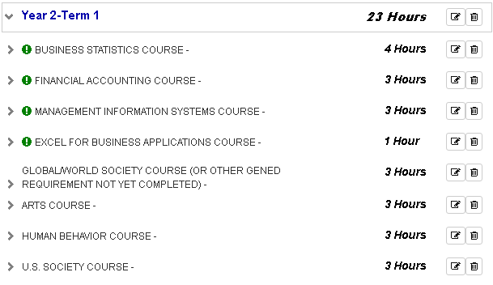

* **Edit** the GenEd Arts course. **Place it in an OR’d group** with the name ‘CHOOSE A GENED-45+ REQUIREMENT -’. **Save** this change.

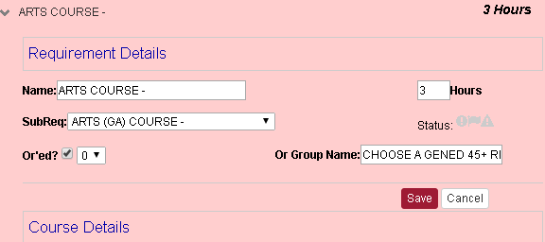

* Place Human Behavior and U.S. Society in the **same OR Group**.

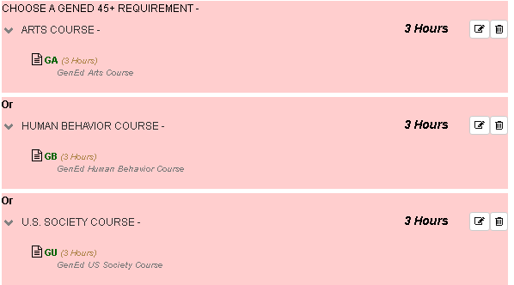

* **Copy these three courses** into another semester.

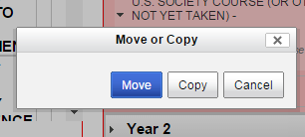

* **Go to the semester** with the copied versions of the three courses. **Edit the OR group name** there to be ‘CHOOSE A GENED 45+ REQUIREMENT NOT YET COMPLETED’.

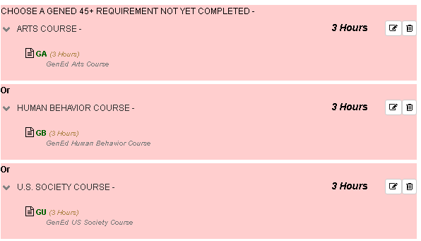

* **Repeat this process** for the Mosaic courses, naming their OR group ‘GENED MOSAIC: CHOOSE ONE -’

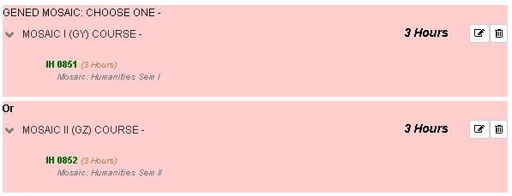

* It is currently preferred for schools to create a custom Requirement with 1 credit hour with no courses in it and the ‘Critical’ icon selected to place in the final semesters of their GenEd-45+ and GenEd-to-GenEd Roadmaps. The Requirement’s name is to include text explaining that students may need to take additional courses that are not on the Roadmap to meet their major’s credit hour requirement for graduation. The text used by the Fox School of Business is shown here as an example.



* The edits to convert the Roadmap to a GenEd-45 version are complete. It can now be published.

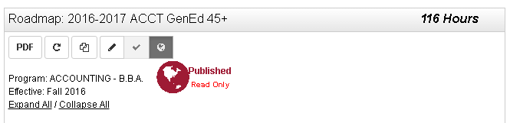

**Common Issues: Missing Edit/Delete Buttons**

* Note that if you have clicked the Edit button for one Course or Requirement and are in the middle of editing it, the Edit and Delete buttons for other courses and requirements will not appear. To use these buttons, you must first **click ‘Save’ or ‘Cancel’** to close the ongoing edit.

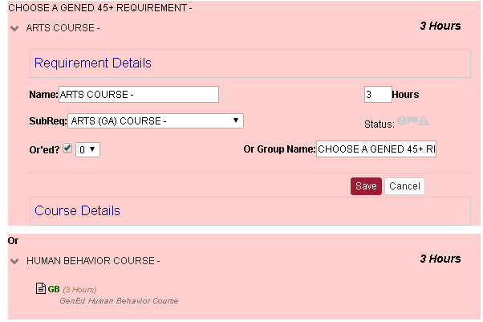

**Common Issues: System Won’t Accept Credit Range**

* The Roadmap system does not accommodate ranges of credits for a course. If a course option could have multiple credit values, the **lowest** possible value must be placed in the Roadmap.

**Common Issues: A Requirement Has Come Delinked**

* Sometimes, Requirements on Roadmaps can become detached from their corresponding Requirements on Audits. These can be detected through their **large, red names** on the Roadmap side of the page.

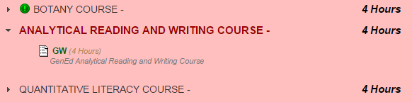

* If the Roadmap in question is Published, it will need to be placed back into Edit Mode before the delinked Requirement can be fixed. To do this, **click the Edit button**.

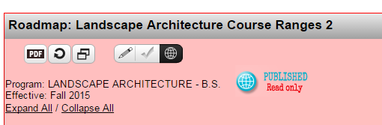

* With the Roadmap placed into Edit Mode, **click the Edit Button** next to the Requirement that has become delinked.

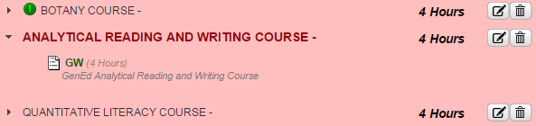

* Then **select the Requirement from the Audit** that you want the Requirement on the Roadmap to be connected to from the SubReq drop-down menu.

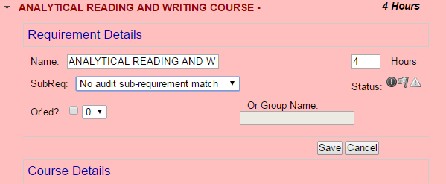

* Then **click Save**.

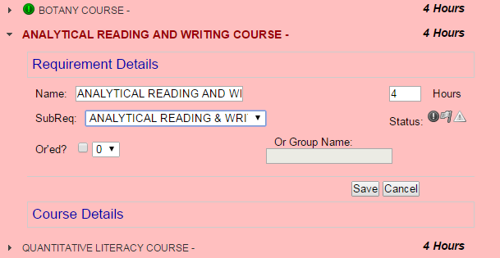

* The Requirement will successfully be re-linked to the Audit.

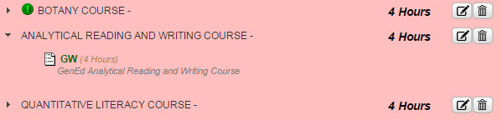

* If you unpublished the Roadmap to perform this fix, re-publish the Roadmap.
* **Note:** Sometimes, when working with a GenEd-45+ Roadmap, a Requirement will only come partially-unhooked and will display as being linked to a regular-GenEd version of the requirement in some views / situations and linked to nothing in other views / situations. In these cases, it is best to delete the requirement in question entirely and re-add it from the Audit.

**Copying a Complete Roadmap**

* If you have completed a Roadmap and want to copy it, **go to the Manage Roadmaps page**.

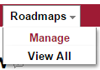

* **Locate the degree program** you desire to copy the Roadmap for from the list of degree programs. If your degree program is within a category with a plus icon next to it, **click the plus icon**.



* Once you have located the desired degree program, **click the degree program’s name**.



* **Select Copy** from the Select an Action drop-down on the line for the Roadmap that you want to copy.



* **Edit the Roadmap Name, Effective Term, Effective Year, and Years to Graduation** to reflect what you want the new copy of the Roadmap to possess. Fields that you wish to leave the same as for the original Roadmap do not need to be edited.

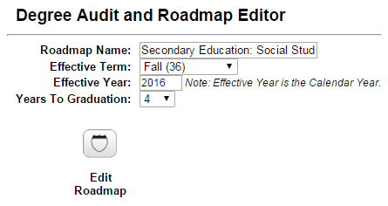

* **Press the Edit Roadmap button.** This will take you to the Roadmap Creation Page for the newly-copied Roadmap. Note that this button must be pressed to complete copying the roadmap, even if you do not intend to edit its contents.



**Switching To Student (Plan Creation) View**

* Once your Roadmap is created and Published, it is generally a good idea to verify how it appears in Student View to make sure it will be useful to students making a Plan from it.
* To enter Student View, first **select Search** from the Students dropdown in the top menu bar.

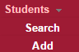

* If the system asks you to log in, simply re-enter your User Name and Password. Then **click the Login button**. You do not require a student account to log on here.

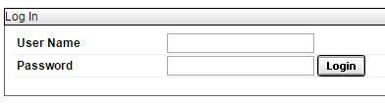

* To proceed with Plan creation and further testing, you will need to **select a student** to use as the tester. Either enter the student’s ID or, if you do not have the ID of a student to use for testing purposes, enter the first and/or last name of the student and select them from the search results.

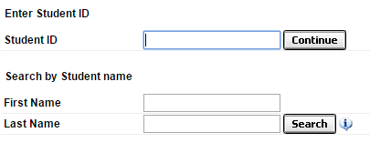

* When a student has been selected, **choose Plans** from the lower portion of the Menu Bar.



* If the system asks you to log in, simply re-enter your User Name and Password. Then **click the Login button**. You do not require a student account to log on here.

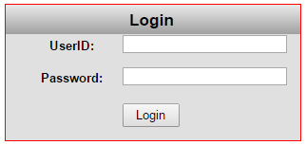

* If the error message “Sorry, there was an error processing your request.” appears, that means that the student you chose has settings on its account in the system that make it unable to create Plans from Roadmaps at the current time, and a different student will need to be chosen for testing. If you think this shouldn’t be the case, run a DARS Audit for the student and make sure they possess a Learner Record, as a lack of a Learner Record is the most common cause of this message.



**Student View: Creating a New Plan**

* Once you are on the Plans page, **choose the ‘Create a New Plan’ tab**.

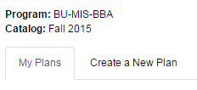

* **Choose your major** from the drill-down list nested within its college, department, and program. Nested under your major are the available Roadmaps for that major. **Choose the Roadmap you want to plan from. Make sure that the Roadmap is for your Catalog Term, and only choose a GenEd-45/G-45 Roadmap if you are a GenEd-45 student.** (To check your Catalog Term and whether you are a GenEd-45 student, run an Audit. See the FAQ for additional information).

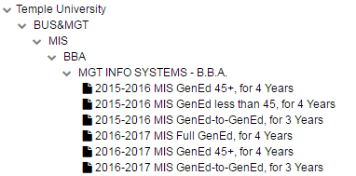

* Enter the **Plan Name**, **Term**, **Year**, and **Years To Graduation** for the Plan being created, then **click the Add Plan button**. For the Year and Term, make sure you enter the current or future term that you want to start you Plan in. This **does not** have to match your catalog term or year of the Roadmap selected (and cannot do so if you have a Catalog Term from the past). Note that you cannot create Plans that start in the past.

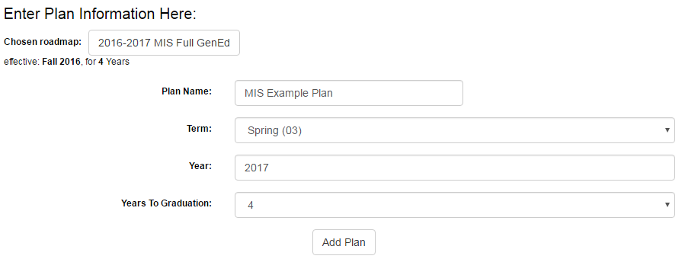

* Your Plan has been created. To access and edit it, click its name in the list of your Plans. Pre-existing Plans can also be opened from this list.



* The Plan Creation Page consists of two main sections. The Roadmap Side is on the left and displays the Roadmap you are planning from. It will come pre-constructed with the standard required set of courses for your degree program. The Plan Side is on the right. It is where you add courses to your own personal, customized Plan.

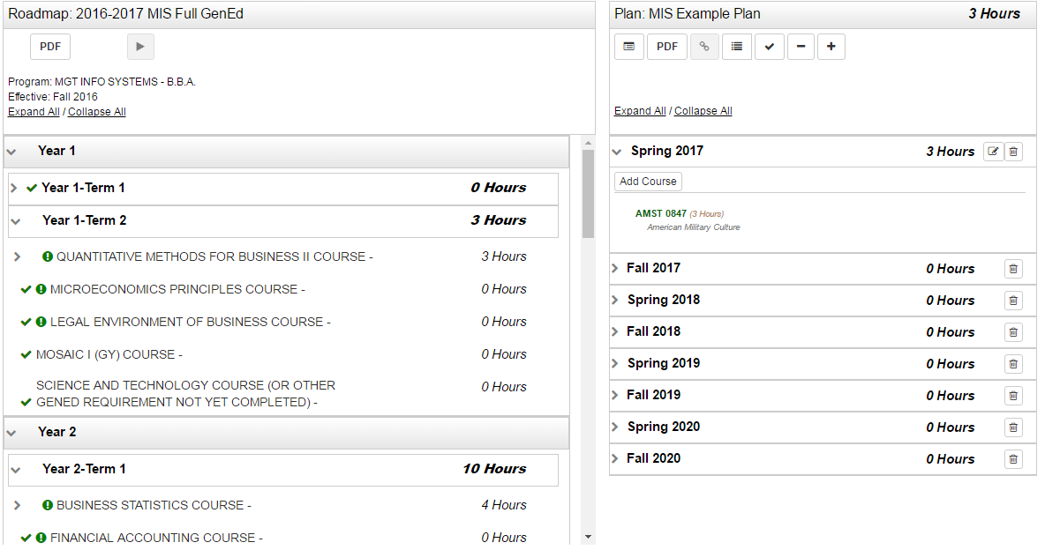

**Student View: The Move Preferred Button**

* The Move Preferred Button is present on the Roadmap Side of the Plan Creation Page. Clicking it will move every course that is marked as Required, Preferred, or Critical from the Roadmap to your Plan. See the Icons section for an overview of icons like Required, Preferred, and Critical. **Clicking it** **is recommended** (but is not required if you want to customize your Plan’s course-positioning).



* Items will check off when added to the Plan.

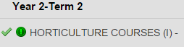

**Note:** The Move Preferred Button can only be used when either (a) there are no courses present on your Plan or (b) the ‘Remove All Courses’ button has just been clicked.

**Student View: Adding Courses**

* Adding courses to your Plan is simple. **Click and drag** the name of the course on the Roadmap that you want to add. Position it **directly over the name** of the target semester, which will highlight itself in blue. Then **release**.

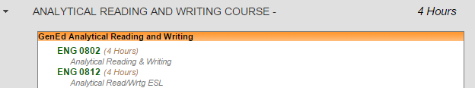

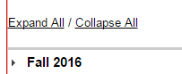

* The course is successfully added to the Roadmap.

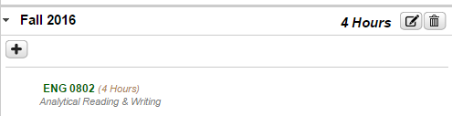

**Student View: Adding Wildcard Courses**

* Some courses, like Free Electives, are represented by a string of wildcard characters rather than an individual course name. To add one of them to your Plan, simply **drag the wildcard string** over like any other course.

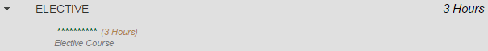



* Then, when the popup appears asking what course you want to add, enter the **Department Abbreviation and Course Number** for the desired course, and then **click OK**.

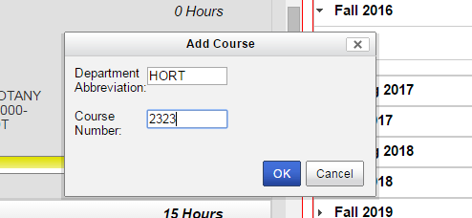

* The course will be added to the selected semester on the Plan

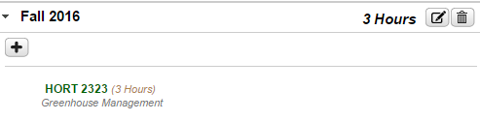

**Student View: Adding Course Ranges (And Manually Choosing Courses)**

* Most course ranges are currently represented with a partial wildcard. Dragging one of these courses over works in the same way that dragging the full-wildcard Free Elective does. Note that the pop-up for entering the course you want to take will only allow choices that meet the partial wildcard’s restrictions.



* Some course ranges cannot be dragged over like individual courses or wildcards. A yellow box will be displayed, indicating that a course in the range listed in the requirement name has to be taken, but said course has to be added manually.

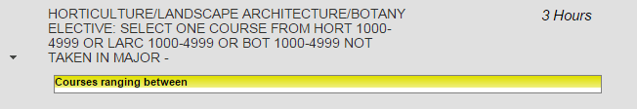

* **Click the plus sign** inside the term on the Plan that the course within the range is to be added to.

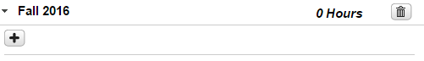

* Enter the **Department Abbreviation and Course Number** for the desired course, and then **click OK**. This step is the same as when adding a wildcard course.



* The course will be added to the selected semester on the Plan.



* Note: The page **must be refreshed** before the course is checked off on the Roadmap Side of the page. This can be accomplished by clicking the Validate Plan button on the page or using the normal refresh-page button in your web browser.



* Note: The same process can be used to add a course that you want to take that isn’t on the Roadmap to your Plan. Bear in mind that manually-added courses that aren’t on Roadmaps often won’t correspond to items on your Audit that are required for graduation.

**Student View: Moving Courses On The Plan**

* If you want to move a course to a different semester, **click its name and drag it**. Position it **directly over the name** of the target semester, which will highlight itself in blue. Then **release**.

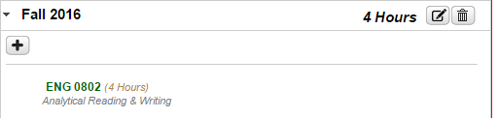



* The course will be moved to the target semester.

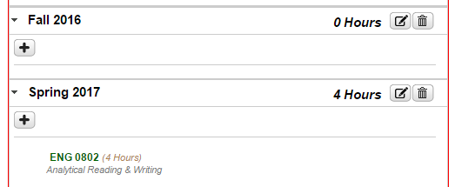

**Student View: Deleting Courses**

* If you want to delete a course, **select the Edit Button** next to the semester it is in.

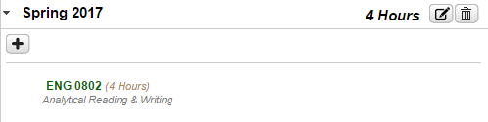

* **Click the check mark** next to the course you want deleted. Then **select Delete**.

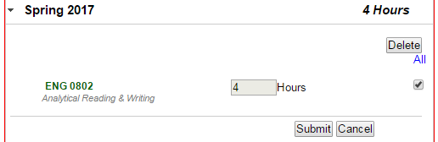

* **Select Yes** on the pop-up.

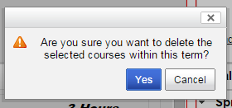

* The course will be deleted.

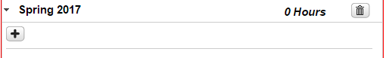

**Student View: Adding And Removing Semesters**

* To add a semester, **click the Plus Sign Icon** at the top of the Plan.



* **Select the year and term** to add from the drop-down menus. **Click ok**.

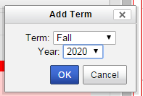

* The semester will be added to your Plan.

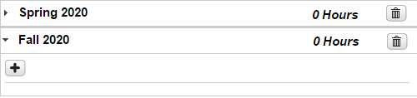

* **Note:** If you add an additional semester to a Plan, using Move Preferred will add courses to the Plan in the order that semesters appear on the Plan, rather than adding to them to the semesters that are named on the Roadmap. (For example, if a Roadmap includes Year 1: Term 1, Year 1: Term 2, and Year 2: Term 1 as its first three semesters, and a Plan includes Fall 2016, Spring 2017, Summer 1 2017, and Fall 2017 as its first four semesters, the courses in Year 2: Term 1 of the Roadmap will be placed in the Summer 1 2017 Semester, not the Fall 2017 semester, even though the Summer semester counts as part of Year 1.)
* To delete a semester, **click the Trash Can Icon** to its right.



* **Select Yes** on the pop-up.

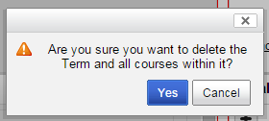

* The semester will be deleted.

**Student View: Validating With An Audit**

* Once a Plan is complete, the Plan should be verified by running an Audit. The Audit Button can be found on the Plan side of the Plan Creation Page; it is the furthest on the left. Click this button to run an Audit With Planned Courses.

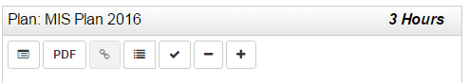

* When it is clicked, the Audit page appears and displays an audit that includes Planned courses. The planned courses are indicated by a bluish-purple list-icon next to requirements they fulfil and a ‘PL’ next to their credits.

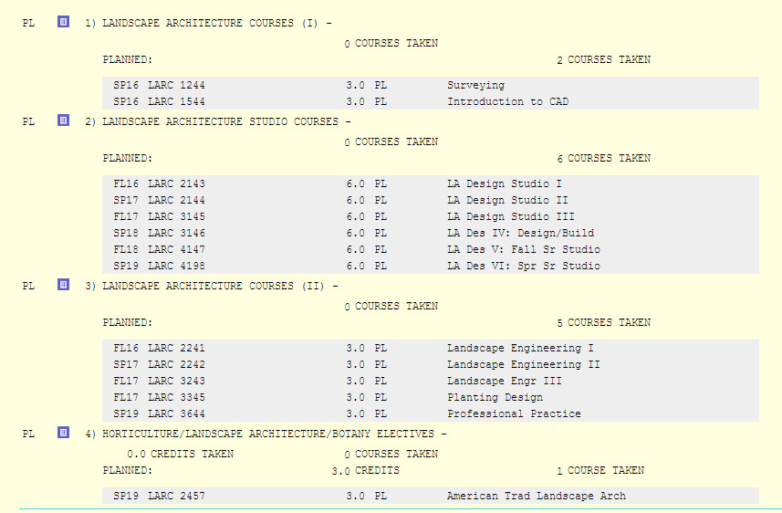

* Note that when you run an Audit with Planned Courses, it will, in some browsers, open in a new tab. **This means that the Plan is still open**; re-opening the Plan from the tab that contains the Audit with Planned Courses can cause two copies of the same Plan to be open at once (which should be avoided for system performance and stability reasons), so **one of the two tabs should be closed** when the Audit is done being reviewed.

**Student View: Preferred Plans**

* When you have one or more plans, a single one of those plans is considered your Preferred Plan. An individual’s Preferred Plan is marked with a radio button to its left. Which plan is currently considered Preferred can be changed by clicking one of the other radio buttons in the list. The Plan marked as Preferred cannot be deleted. This means that once a student creates a Plan, that student will always have at least one Plan. Non-Preferred Plans are able to be deleted using the ‘Select an Action’ drop-down menu.

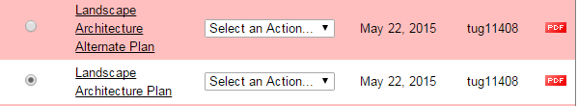

Icons

Roadmap Creation Page

* The **View Audit PDF Button** is found on the Audit Side of the Roadmap Creation Page. Clicking it will open a PDF version of the Audit being viewed in a new tab.



* The **Sync Audit Button** is found on the Audit Side of the Roadmap Creation Page. Clicking it will open a new tab that compares Audit requirements (including ones normally hidden during Roadmap creation) with what is present in the Roadmap.



* The **View Roadmap PDF Button** is found on the Roadmap Side of the Roadmap Creation Page. Clicking it will open a PDF version of the Roadmap being viewed in a new tab.



* The **Refresh Button** is found on the Roadmap Side of the Roadmap Creation Page. It refreshes the page, which can be useful for making sure the Roadmap and Audit are fully synchronized.



* The **Clone Roadmap Button** is found on the Roadmap Side of the Roadmap Creation Page. It takes the clicker onto a page that begins the process of creating a copy of the Roadmap.



* The **In Progress Button** is found on the Roadmap Side of the Roadmap Creation Page. It is clickable if the Roadmap is not already in In Progress Mode. Clicking it changes the Roadmap to In Progress Mode, in which the Roadmap can be edited, and in which the Roadmap is not being checked for completeness against the Audit. Clicking it can take a Published Roadmap out of Published Mode and allow it to be edited again.



* The **Mark As Complete Button** is found on the Roadmap Side of the Roadmap Creation Page. It is clickable if the Roadmap is in In Progress Mode (but not Published Mode). Clicking it changes the Roadmap to Complete Mode and checks it for completeness against the Audit. Items on the Roadmap that are not noted as needed on the Audit Side are marked with red names. This check will be performed each time the Roadmap is opened while in Complete Mode or the page is refreshed while the Roadmap is in Complete Mode.



* The **Publish Button** is found on the Roadmap Side of the Roadmap Creation Page. It is clickable if the Roadmap is in Complete Mode (but not In Progress Mode). Clicking it changes the Roadmap to Published Mode. A Roadmap in Published Mode is viewable by students (and usable by them during Plan Creation), and it cannot be edited. A Roadmap can be unpublished by clicking the In Progress Button and returning it to In Progress Mode.



* The **Edit Button** is found on the Roadmap Side of the Roadmap Creation Page. It is located next to Terms and next to Requirements. It is only visible if no Term or Requirement is currently being edited. Clicking it opens the Term or Requirement it is attached to, allowing its details to be edited.



* The **Delete Button** is found on the Roadmap Side of the Roadmap Creation Page. It is located next to Requirements. Clicking it will open a pop-up that allows the deletion of the Requirement it is attached to.



* The **List Icon** is found both on the Audit Side and Roadmap Side of the Roadmap Creation Page. On the Audit Side, it indicates that an item is a List. Lists automatically display all courses they contain to students when viewed by a student during Plan Creation. They also automatically update themselves as new courses are added or removed from their categories within the system. On the Roadmap Side, if next to an item that is not open for editing, it similarly denotes that the item is a List. When a Requirement is open for editing and the Course Details are open, the icon appears next to each item within the set of courses within that requirement. If it is grayed out, it indicates that the item is not a List. If white, it indicates that the item is a List. Clicking it changes the status of the item from non-List to List or List to non-List.



* The **Prerequisite Or Corequisite Icon** is found on both the Audit Side and Roadmap Side of the Roadmap Creation Page. Temple’s system is set up so that it only identifies Corequisites (with Prerequisites being checked during an Audit of a Plan). Seeing it next to a course means that course has at least one Corequisite.



* The **Required Icon** is found on the Roadmap Side of the Roadmap Creation Page. It can be found next to each course or List in the Course Details section of a Requirement while that Requirement is being edited. If it is grayed out, that course or List is not marked as Required. If it is green, that course or List is marked as Required. Clicking it toggles between the two states. When a course or List is marked as Required, the icon also appears in non-clickable form next to the course or List’s name on the Roadmap. Items marked as Required are moved from the Roadmap to a student’s Plan if that student clicks the Move Preferred Button during Plan Creation.



* The **Preferred Icon** is found on the Roadmap Side of the Roadmap Creation Page. It can be found next to each course or List in the Course Details section of a Requirement while that Requirement is being edited. If it is grayed out, that course or List is not marked as Preferred. If it is blue and brown, that course or List is marked as Preferred. Clicking it toggles between the two states. When a course or List is marked as Preferred, the icon also appears in non-clickable form next to the course or List’s name on the Roadmap. Items marked as Preferred are moved from the Roadmap to a student’s Plan if that student clicks the Move Preferred Button during Plan Creation. This icon is currently not used by Temple.



* The **Critical Icon** is found on the Roadmap Side of the Roadmap Creation Page. It can be found next to each course or List in the Course Details section of a Requirement while that Requirement is being edited. If it is grayed out, that course or List is not marked as Critical. If it is yellow, that course or List is marked as Critical. Clicking it toggles between the two states. When a course or List is marked as Critical, the icon also appears in non-clickable form next to the course or List’s name on the Roadmap. Items marked as Critical are moved from the Roadmap to a student’s Plan if that student clicks the Move Preferred Button during Plan Creation. This icon is currently only used for marking special warning requirements by Temple.



* The **Course Not Allowed Icon** is found in the Legend of the Roadmap Creation Page. It is currently not used by Temple.



* The **Check Mark Icon** is found on the Audit Side of the Roadmap Creation Page. It indicates that the Requirement or Subrequirement it is next to is met if it is next to a Requirement or Subrequirement. It indicates that the course or List it is next to is included in the Roadmap if it is next to a course or List.



* The **Tooltip Icon** is found near the top of the Roadmap Creation Page. Hovering over it gives a basic description of how to add courses to a Roadmap.



Plan Creation Page

* The **Roadmap/Audit PDF Button** is found on the Roadmap/Audit Side of the Plan Creation Page. Clicking it will open a PDF version of the Roadmap or Audit being viewed in a new tab.



* The **View Audit Button** is found on the Plan Side of the Plan Creation Page. Clicking it displays an Audit of the Plan in its current state.



* The **Plan PDF Button** is found on the Plan Side of the Plan Creation Page. Clicking it will open a PDF version of the Plan being created in a new page.



* The **See Completed Courses Button** is found on the Plan Side of the Plan Creation Page. Clicking it will show which courses the student building the plan has already completed so that the other parts of the plan can be filled out.



* The **Validate Plan Button** performs a review of the student’s current Plan, comparing it to the Degree Audit. It will highlight unnecessary courses, show the status of courses as complete/missed or failed/etc., and determine if the current Plan meets the requirements of the Degree Audit.



* The **Move Preferred Button** is found on the Roadmap/Audit Side of the Plan Creation Page, but it is only present when a Roadmap is attached to the Plan being created. Clicking it moves all Preferred, Required, and Critical Courses (designated as such on the Roadmap during Roadmap creation).



* The **Remove All Courses Button** is found on the Plan Side of the Plan Creation Page, but it is only present when a Roadmap is attached to the Plan being created. Clicking it removes EVERY course from the Plan, leaving all semesters on the Plan empty. Its most common use is undoing an accidental use of the Move All Button instead of the Move Preferred Button.



* The **Add Term Button** is found on the Plan Side of the Plan Creation Page, but it is only present when a Roadmap is attached to the Plan being created. Clicking it allows the student to add an additional term to the Plan being created.



* The **Edit Button** is found on the Plan Side of the Plan Creation Page, appearing next to semesters that contain requirements. Clicking it allows the student to edit details about the semester (including removing courses from that semester).



* The **Delete Button** is found on the Plan Side of the Plan Creation Page, appearing next to semesters. Clicking it allows for the semester in question to be removed from the Plan.



* The **Add Course Button** is found on the Plan Side of the Plan Creation Page, appearing inside semesters. Clicking it allows for the student to add a course to the Plan regardless of whether or not it is on a Roadmap attached to the Plan.



* The **Incomplete Planned Course Icon** is found on the Plan Side of the Plan Creation Page next to some courses. It is located next to courses that a student has planned but has not completed.



* The **Course Not Offered Icon / Course Issue** is found on the Plan Side of the Plan Creation Page next to some courses. It indicates that the course planned is not currently projected to be available in the term it was placed (or another, less-common error).



* The **Remove Roadmap Button** is found on the Plan Side of the Plan Creation Page when a Roadmap has been attached and the View Associated Roadmaps Button has been toggled to ‘on’. Clicking it detaches the associated Roadmap from the Plan.



* The **Completed Course Icon** is found on both sides of the Plan Creation Page. On the Roadmap/Audit Side, it indicates that the Requirement it is next to is met by the Plan or that the Course it is next to is present on the Plan. On the Plan Side, it indicates that the course it is next to has been successfully completed by the student who planned it.



* The **In Progress Course Icon** is found on the Plan Side of the Plan Creation Page. It denotes that the course next to it is currently being taken by the student.



* The **Completed Course, No Credit Icon** is found on the Plan Side of the Plan Creation Page. It indicates that the course it is next to was taken, but did not provide the student with credit (for example, if the student failed it).



* The **Prerequisite Or Corequisite Icon** is found on both the Audit Side and Roadmap Side of the Roadmap Creation Page. Temple’s system is set up so that it only identifies Corequisites (with Prerequisites being checked during an Audit of a Plan). Seeing it next to a course means that course has at least one Corequisite.



* The **Required Icon** is found on both the Roadmap/Audit Side and Plan Side of the Plan Creation Page. It denotes that the item it is next to was marked as Required on the Roadmap it comes from during Roadmap Creation. Items marked as Required will be moved from a Roadmap to the Plan if Move Preferred is clicked.



* The **Preferred Icon** is found on both the Roadmap/Audit Side and Plan Side of the Plan Creation Page. It denotes that the item it is next to was marked as Preferred on the Roadmap it comes from during Roadmap Creation. Items marked as Preferred will be moved from a Roadmap to the Plan if Move Preferred is clicked.



* The **Critical Icon** is found on both the Roadmap/Audit Side and Plan Side of the Plan Creation Page. It denotes that the item it is next to was marked as Critical on the Roadmap it comes from during Roadmap Creation. Items marked as Critical will be moved from a Roadmap to the Plan if Move Preferred is clicked.



* The **List Icon** is found both on the Roadmap/Audit Side of the Plan Creation Page. It indicates that the item it is next to is a List. If a list is drug over to the Plan Side, the student will be prompted to select an individual course from that List, as the Plan Side cannot contain Lists.

