Style Preferences
- It is considered standard policy for Requirement names to be in ALLCAPS and for individual course names to be in A Mix of Capital Letters and Lowercase. This allows for ideal format-matching between user-entered Requirement and course names and system-generated ones. Additionally, include a space and ‘-‘ dash after the requirement name.
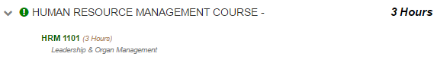
- While courses from Lists can be added individually, the default stylistic preference is to add lists of courses as Lists. If a List is added, students will be able to view all courses currently in the list when using the roadmap. Lists have the additional benefit of automatically updating as courses are added to or removed from the List over time.
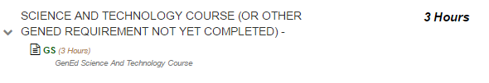
- When adding a list, make sure to name the list so that it appears in PDF view with a name instead of saying ‘no description’.
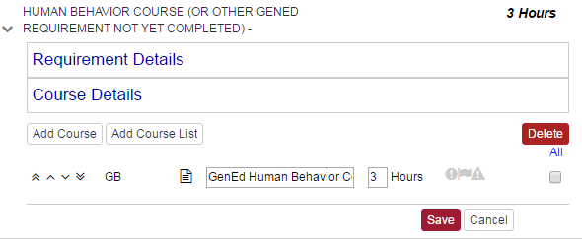
- When naming a Requirement, Course, Roadmap, or other item with an editable text-field, certain special characters are to be avoided.
These symbols work and are acceptable for use:
! @ # $ % ^ * ( ) - ` ~ _ + = { [ } ] | \ : ; ' , . ? /
These symbols are incompatible with the system and are not to be used:
& " < > œ é
- It is standard policy for GenEd courses to be added in specific locations instead of being Or’ed in large groups, but to include the additional text ‘(OR OTHER GENED FROM A CATEGORY NOT YET TAKEN)’ in their Requirement name. This reminds students that they may take their GenEds in an order they desire while keeping the Roadmap from becoming cluttered or checking off as complete if the student selects too many GenEds from the same category. Also, adjust/update the credit hours for the GenEd courses.
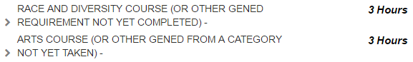
- It is standard policy for Requirements to be marked as Required if the student does not have a choice in what to take to meet those Requirements.
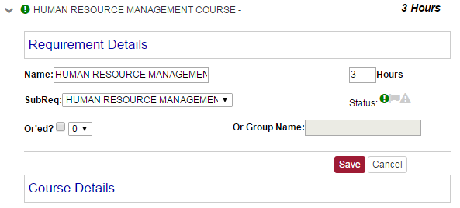
- When creating Roadmaps for each major (and concentration, where applicable), it is standard policy to have a separate Roadmap for each GenEd category that a student can possess. It is policy to not have separate versions of Roadmaps for Honors students, as doing so creates a confusing large number of Roadmaps. When naming a Roadmap, start with the year that the Roadmap is for, then the abbreviation of the major, then an abbreviation of the concentration (if applicable), then the GenEd type (with the appropriate names for the three GenEd categories shown below).
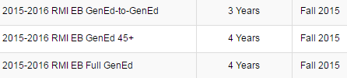
- When creating Roadmaps for majors that possess concentrations, if those majors also possess versions of the degree without a concentration, that version must use NoConc as its ‘Concentration Abbreviation’ to maintain proper ordering of Roadmaps for students.
- It is currently preferred for schools to create a custom Requirement with 1 credit hour with no courses in it and the ‘Critical’ icon selected to place in the final semesters of their GenEd-45+ and GenEd-to-GenEd Roadmaps. The Requirement’s name is to include text explaining that students may need to take additional courses that are not on the Roadmap to meet their major’s credit hour requirement for graduation. The text used by the Fox School of Business is shown here as an example.
