Requesting a Degree Audit in Self Service



DARS Self-Service

Steps

Follow these steps to run a degree audit.

1. Click Run Audit button for Current Program with default settings

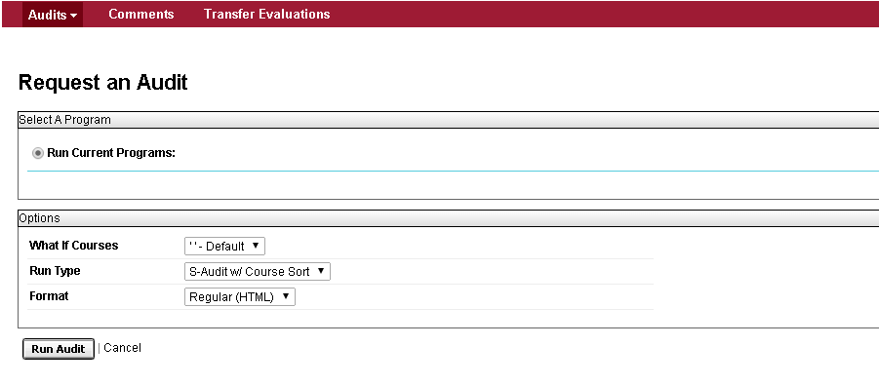

1. The message “updating every 3 seconds” should display



1. In seconds, audits will appear in the list of **Completed Audit Requests** with the most recent at the top of the list

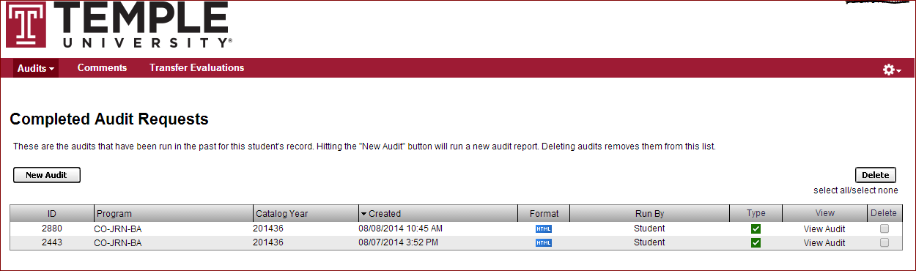

1. Click on the “View Audit” link to open audit (take note of the “**Created**” date/time)

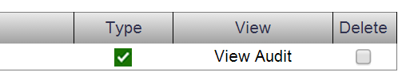

1. All sections of the Interactive Audit will be open automatically.
2. Requirements and sub-requirements that are complete will be indicated by a green check mark symbol. Incomplete requirements and sub-requirements will be indicated by a red X.





1. To view the course description for a specific course in the audit, click on the course number link. A new window containing information about the course will open.

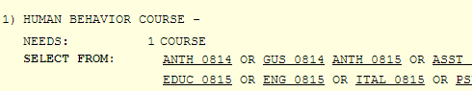

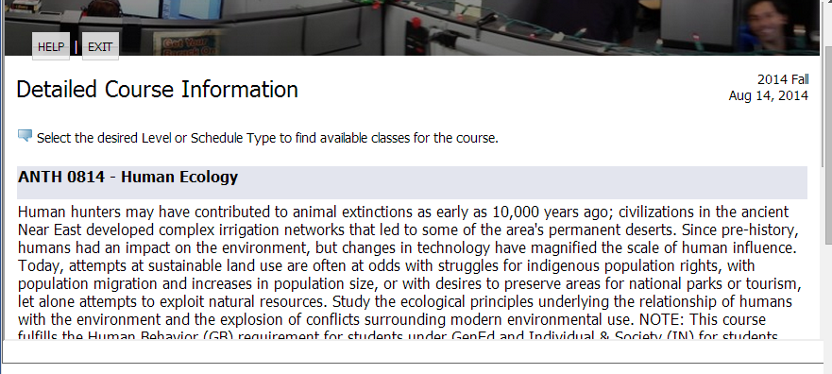

1. Click on the Course History tab to view your academic history and registered courses.



* 1. You can filter your course information by clicking on the interactive bar graphs or by the drop down menus for term and grade.

1. Should there be transfer coursework, AP, or IB credit in your academic history, it will display on this page. Click on **Transfer Evaluations** in the menu bar to view.

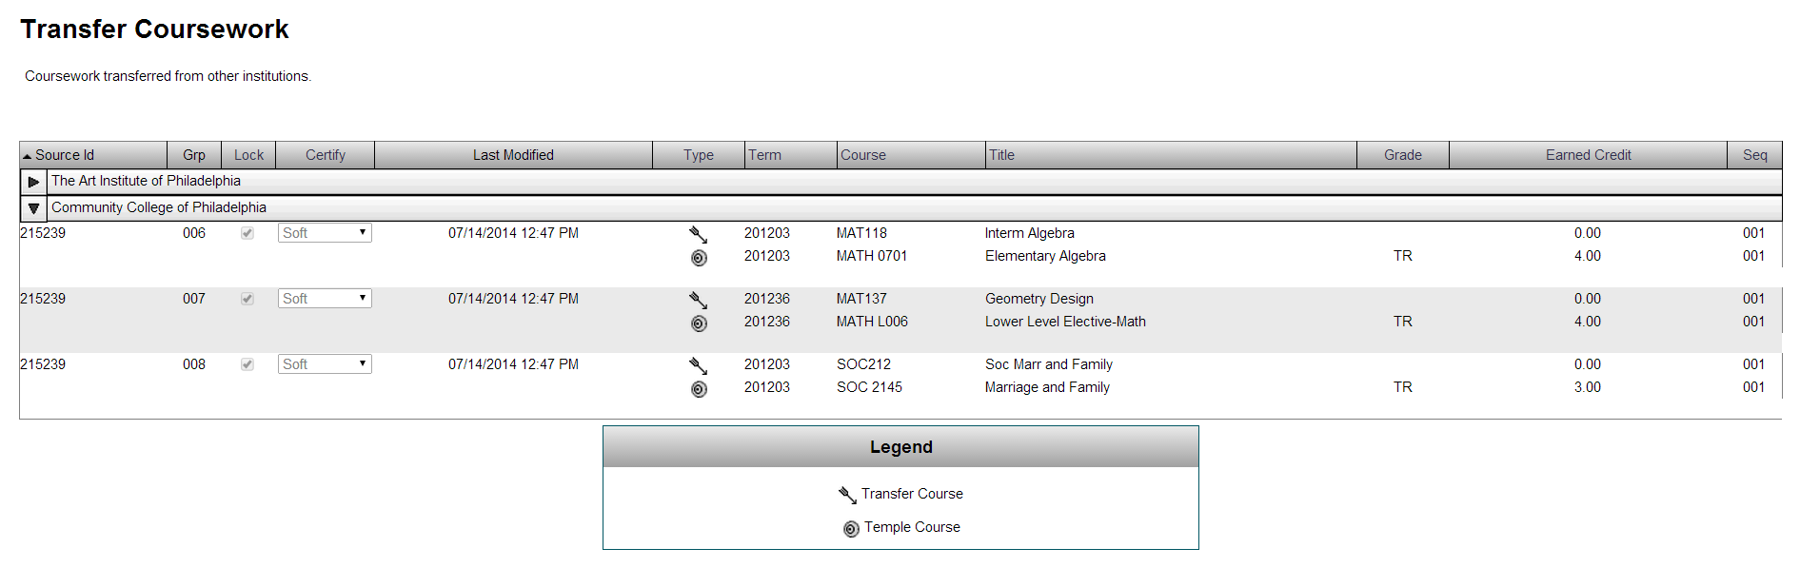

1. Each course in the **Transfer Coursework** list will be marked with a symbol in the **Type**column, identifying it as either a transfer course or the Temple equivalent.

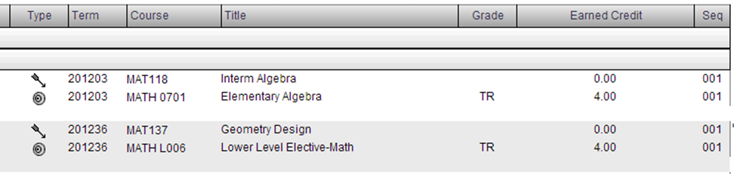

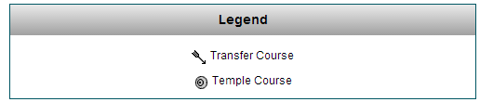

1. To log out, scroll to the right, click on the cog wheel icon, and select “log out”:

