Degree Audit in Self Service



DARS Self Service Features

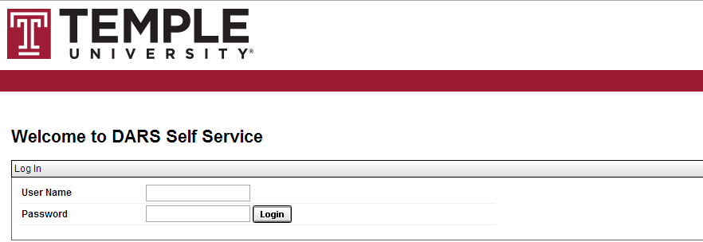

Features

Listed below are some of the user friendly features of Self Service:

1. The Interactive Audit

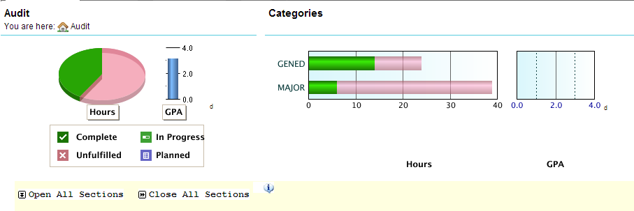

* 1. Charts and graphs – Hover over the hours and GPA charts to view detailed information. Click on the GenEd and Major bars to drill down into the requirements for each of these areas.
  2. Open all Sections / Close all Sections – To view all sections of the audit, select “Open All Sections” (Note: This is the default setting for interactive audits when first opened). To collapse all sections, select “Close All Sections”.
  3. Printer Friendly – This will generate a printer friendly version of the audit without charts and graphs.
  4. Legend - Hover over the legend icon to view information about the symbols used on the audit.
  5. Course Descriptions - To view the course description for a specific course in the audit, click on the course number link. A new window containing information about the course will open.
  6. Course History -View your academic history and registered courses. Filter course information by clicking on the interactive bar graphs or by the drop down menus for term and grade.

1. **Transfer Evaluations** – View all transfer coursework, AP, and IB credit. If you transferred courses from multiple institutions, click the down arrow  next to the institution name to expand/collapse each record.
   1. Source ID – A unique identifier for the transfer institution.
   2. Lock/Certify – Defines the type of locked status – a soft lock indicates that the evaluation can be updated if the equivalencies are reviewed by faculty.
   3. Type – Identifies the course as either a transfer course or its Temple equivalent.

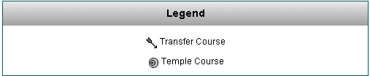

* 1. Course – The top course in the group is the course from the transferring institution and the bottom course is the Temple equivalent.
  2. Grade – Displays TR if you received transfer credit for the course or NT if you did not receive transfer credit for the course.
  3. Earned Credit – The amount of hours that counts towards academic history.

1. Audit – Select Request New or Manage (review list or delete audits).
2. To log out, scroll to the right, click on the cog wheel icon, and select "Log out":

