Requesting a Degree Audit in Self Service



DARS Self-Service

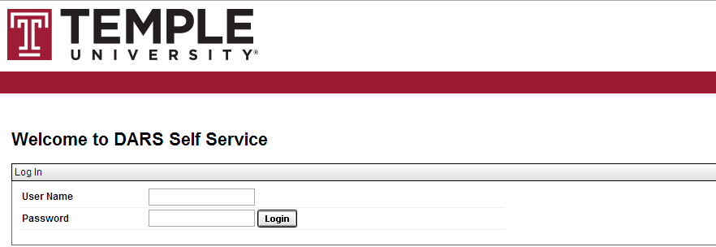

Steps

Follow these steps to request a degree audit for a student.

1. Log In to the Self Service application using your AccessNet credentials
2. Click on the Student icon from the Home page

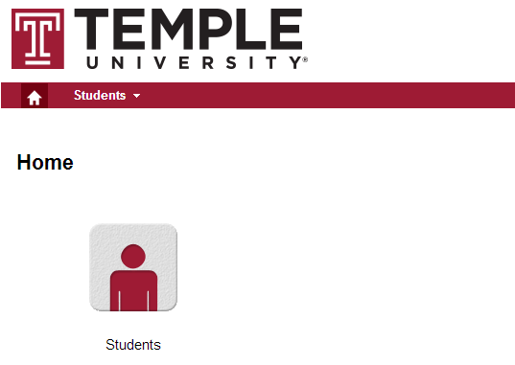

1. Enter the Student’s TUid or initiate the Student name search feature (note: fields are not case sensitive and you can search by partial Last or First name), click **Continue** or **Search** button

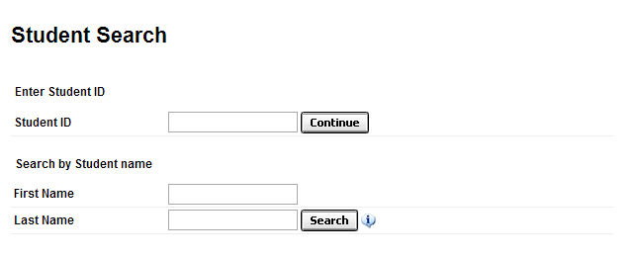

1. Verify Student name and TUid from header



1. Click **Run Audit** button for Current Program with default settings (What-if is not available at this time)

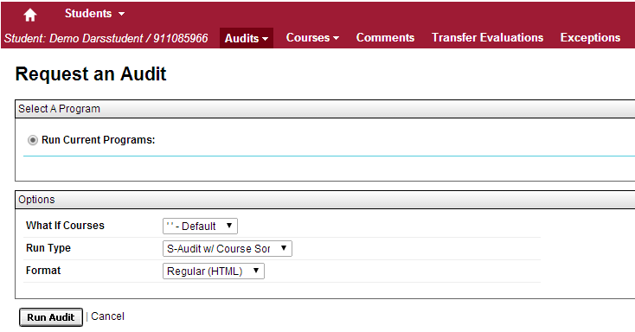

1. The message “updating every 3 seconds” should display



1. In less than 20 or 30 seconds, audits will appear in the list of **Completed Audit Requests** with the most recent at the top of the list

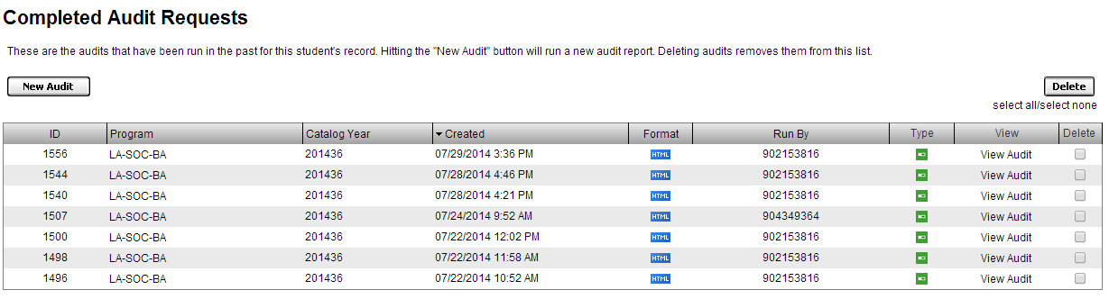

1. Click on the **Program** or **View Audit** link to open the audit (take note of the “**Created**” date/time)



1. To log out, scroll to the right, click on the cog wheel icon, and select "Log out":

