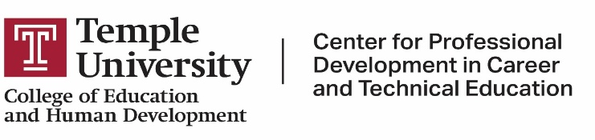
Undergraduate Course Overview
Courses are Online* or Virtual**

Level 1 (Experience-Based Certificate – EBC)
- Total Courses: 6 / Total Credits: 18
- Completion Timeline: Must complete Level 1 required coursework within 5 years from the date the EBC is issued
CTE 3101 | Principles of CTE | 3 Credits – Meets virtually
CTE 3102 | Teaching Strategies in CTE | 3 Credits – Meets virtually
CTE 3103 | Curriculum in CTE | 3 Credits – Meets virtually
ENG 0802 | Analytical Reading and Writing | 3 Credits – Online ***
SPED 2231 | Introduction to Special Education | 3 Credits – Online ***
EDUC 4788 | Supervised Teaching | 3 Credits
Level 2 (Career & Technical Instructional I – C&T I)
- Total Courses: 14 / Total Credits: 42
- Completion Timeline: Must complete Level 2 required coursework within 8 years of service from the date the C&T I is issued

CTE 4416 | Professionalism, Evaluation, & Assessment In Secondary Education | 3 Credits – Meets virtual
CTE 4324 | Industry-Based Coordination Methods for Work-Based Learning | 3 Credits – Meets virtually
CTE 4331 | Industry-Based Instructional Methods for Work-Based Learning | 3 Credits – Meets virtually
CTE 3372 | Project-Based Learning for CTE | 3 Credits – Meets virtually
AOD 1166 | Interpersonal Processes thru the Life Span | 3 Credits – Online ***
EDUC 2103 | Socio-cultural Foundations of Education in the US | 3 Credits – Online ***
EDUC 2109 | Adolescent Development for Educators | 3 Credits – Online ***
HDCE 2304 | Families and the Community | 3 Credits – Online ***
MATH 1015 | Intro to Numbers and Figures | 4 Credits – Online ***
EDUC 1016 | Math for Educators | 4 Credits – Online ***
SPED 3211 | Effective Instructional Strategies for Students with Disabilities | 3 Credits – Online ***
SPED 4103 | Classroom Management & Positive Behavior Support | 3 Credits – Online
SPED 4105 | Assessment in Special Education | 3 Credits - Online
TESL 3631 | Principles & Practices for Teaching English Learners | 3 Credits - Online

Additional Requirement: Must demonstrate satisfactory teaching performance in your place of employment for three years while holding a Career and Technical Instructional I Certificate before applying for the Career and Technical Instructional II Certificate. Classes may be taken during this time.

*Online courses are 100% online (asynchronous)
**Virtual courses meet via zoom 1 night per week
***Indicates an equivalent course may be available at a community college – requires advisor permission

