Mosaic II: Spring 2015
Prof. Andrew Mossin

Spaces of Utopia: A Hands-on Approach

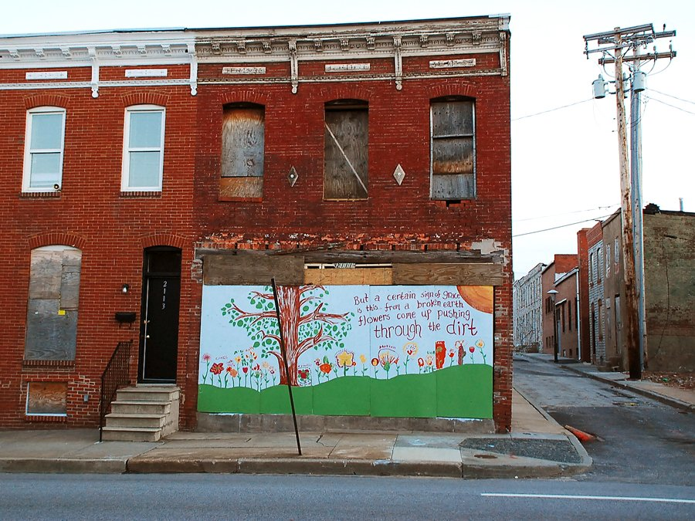

Due: Posted to Blackboard by Sunday, February 15, by 12 noon
Length: Five images with captions; use Harvey as your model for how to write your captions. Captions should be 1-2 sentences in length (longer as you see fit) and should clearly explain how the image fits the criteria for the terms Harvey uses in his discussion.
Grade points possible: Two quiz grades maximum (20 points)

Task: For this out-of-class assignment you will need to visit locations around the Philadelphia area that represent at least five (5) of the following conditions described by Harvey in Spaces of Hope:

Abandonment - Plate 8.1, p. 135
Impoverishment – Plate 8.3, 137
Suburban sprawl – Plate 8.4, 139
Developer’s utopia – Plate 8.5, 140
Urban spectacle – 8.8, 144
Gentrification – 8.10, 146
New urbanism – 8.11, 147
Neighborhood revitalization – 8.12, 149
Deindustrialization – 8.13, 151
Privatopias – 8.15, 153

What to do next: Gather your images in a single Word document with captions clearly marked below each image and post these to the assignment link accessible via the Content area on Blackboard. On Monday we will discuss the images I have selected to extend our conversation about Harvey. Students whose images are selected should be prepared to explain how you took this image and why it represents the selected term.

