Mosaic I: Spring 2015
Prof. Andrew Mossin
Fifty Days At Iliam Extra Credit
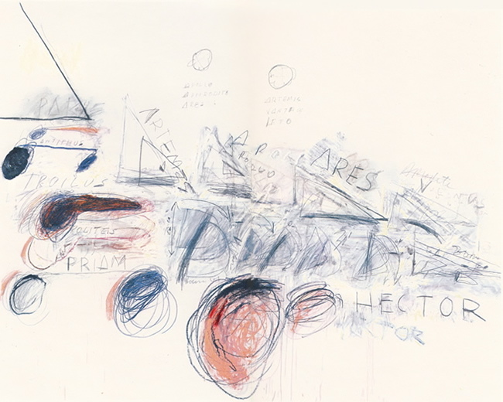

Due: No later than April 24, in class; proof of visit to the museum in the form of a
ticket stub from the Philadelphia Museum must accompany your submission
Length: 500-600 words, typed, double-spaced, MLA-style format, with Works Cited
Maximum Points: 30 (3 quiz grades)

For this extra credit assignment you will need, first, to visit the Cy Twombly exhibit of Fifty Days at Iliam at the Philadelphia Museum of Art. The exhibit is viewable in Gallery 185, Modern and Contemporary Art, on the First Floor of the Museum. Take careful notes of what you observe in the artwork, as these will form the basis of your essay.

Write a response to the exhibit in which you make an argument about one thematic aspect of the paintings as it relates to a central issue in our work with Iliad. For example, you could pair discussion of Cy Twombly’s deploying of male sexuality with Homer’s representation of masculinity in one particular scene from Iliad. Whatever you do, though, please be clear that this is not a review of your visit to the Cy Twombly exhibit. This is a thesis-driven argumentative essay—not a summary or review!! You need to make an argument about a specific theme or issue that you see in a painting (or paintings) and demonstrate its connection to Iliad. Therefore, you need to organize this essay around a clear thesis or central claim and provide evidence from both the painting(s) and Homer’s text to support this claim.

You must document all source use, including Cy Twombly’s work and Iliad, appropriately and accurately, following MLA formatting throughout. The link to Diana Hacker’s documentation website is provided you in our course syllabus. Essays that incorrectly or fail together to use MLA citation will be graded down accordingly.

