# Library Assessment Repository Interests Survey

## Report submitted by

## Nancy Turner

## On behalf of LLAMA Assessment Community, Organizational Practices Group

## June 11, 2017

The Library Assessment Repository Needs survey was conducted between April 27 through June 9, 2017 and resulted in an enthusiastic 379 responses. Hosted on SurveyMonkey (the Temple University instance), the survey was promoted through several assessment-focused listservs and social media outlets. The co-chairs of LLAMA Assessment Marketing and Communication, Ellen Sadfley and Meg Scharf, assisted with this effort.

This report summarizes the responses to the 11 question survey. The full data set will be made available on ALA Connect’s Repository project folder.

## Question 1: Which of the following best describes the type of library you work in or support?

While the vast majority of respondents work in academic libraries, special effort was made to disseminate the survey to librarians at other library types. 50 responses came from non-academic libraries.

|  |  |  |
| --- | --- | --- |
| Which of the following best describes the type of library you work in or support? | | |
| Answer Options | **Response Percent** | **Response Count** |
| Public | 7.7% | 29 |
| Academic | 86.8% | 329 |
| School | 1.3% | 5 |
| Special | 0.8% | 3 |
| Government or State | 2.1% | 8 |
| Archives | 0.0% | 0 |
| Other (please specify) | 1.3% | 5 |
| *Answered Question* | | **379** |

Other types of libraries included:

* LIS education program
* International organization
* Contract technical services
* Medical
* State Correctional

## Question 2: Select the following item which most closely resembles your current role with assessment or evaluation activities

The majority of respondents are actively engaged in assessment activity at their library, either within a specific area (33%), as a primary responsibility (26.9%) or as part of a team (24.5%).

|  |  |  |
| --- | --- | --- |
| Answer Options | Response Percent | Response Count |
| It is my responsibility to assess or evaluate activities for some areas of my library’s operations or services | 33.0% | 124 |
| It is my primary responsibility to assess or evaluate activities for my library or organization | 26.9% | 101 |
| I am part of a team that does assessment or evaluates activities for my library or organization | 24.5% | 92 |
| I do not currently assess or evaluate activities but I am interested in learning more about library assessment | 6.9% | 26 |
| Other (please specify) | 8.8% | 33 |

## Question 3: Please indicate all of the options that describe how you might use a freely available, online Library Assessment Repository

|  |  |  |
| --- | --- | --- |
| Answer Options | Response Percent | Response Count |
| Search the repository for examples of instruments or tools to use | 95.5% | 360 |
| Review results, reports or case studies as examples of best practice | 85.1% | 321 |
| Deposit instruments (surveys, rubrics, questionnaires) or tools created by my library or organization to share with others | 82.2% | 310 |
| Locate peers or colleagues doing similar work as me | 77.2% | 291 |
| Review findings from similar studies to compare to my own findings | 76.4% | 288 |
| Find answers to commonly asked questions | 70.3% | 265 |
| Share assessment results or findings from studies done by my library or organization | 65.5% | 247 |
| Find other repositories that include assessment-related resources in my area of interest | 59.9% | 226 |
| Other (please specify) | 3.4% | 13 |

## Question 4: On the following scale please indicate how likely you would be to use these types of resources if they were part of a freely available online Library Assessment Repository:

By a large margin, the types of resource most likely to be used are assessment instruments (surveys, questionnaires, rubrics). Least likely to be used are raw data. (Scale Green=High; Red =Low).

|  |  |  |  |  |  |
| --- | --- | --- | --- | --- | --- |
| **Answer Options** | **Least likely** | **Somewhat likely** | **Likely** | **Most likely** | **Response Count** |
| Assessment instruments (surveys, questionnaires, rubrics, etc.) | 3 | 25 | 105 | 245 | 378 |
| Reviews of assessment-related tools | 9 | 73 | 153 | 140 | 375 |
| Unpublished assessment results | 43 | 163 | 121 | 43 | 370 |
| Article preprints | 51 | 145 | 131 | 45 | 372 |
| Case studies | 15 | 110 | 167 | 79 | 371 |
| Raw data | 118 | 151 | 69 | 31 | 369 |
| Environmental scans (community profiles, market studies) | 44 | 113 | 151 | 64 | 372 |
| Literature reviews | 38 | 97 | 173 | 65 | 373 |

## Question 5: What factors would contribute to your willingness to use these resources?

We received 272 free-text comments about factors contributing to the likelihood of use. In order of frequency, themes included: quality, relevance to the work, peer-review, ease of access and freely available, robust search functionality and good organization and metadata. Representative comments:

* Easy to navigate and find resources
* Quality of resources
* How well the resources there aligned with what I'd like to measure
* Ease of use and quality control

## Question 6: How likely would you be to deposit the following types of materials?

Survey responses indicate somewhat less likelihood of deposit of assessment resources than the likelihood of use (see Question 4). Yet 264 said they would be likely or most likely to deposit assessment instruments. This is highest ranking type of material for deposit.

|  |  |  |  |  |  |
| --- | --- | --- | --- | --- | --- |
| **Answer Options** | **Least likely** | **Somewhat likely** | **Likely** | **Most likely** | **Response Count** |
| Assessment instruments (surveys, questionnaires, rubrics, etc.) | 26 | 77 | 125 | 139 | 367 |
| Reviews of assessment-related tools | 89 | 124 | 104 | 46 | 363 |
| Unpublished assessment results | 131 | 121 | 83 | 26 | 361 |
| Article preprints | 153 | 114 | 73 | 17 | 357 |
| Case studies | 107 | 129 | 94 | 23 | 353 |
| Raw data | 173 | 101 | 69 | 18 | 361 |
| Environmental scans (community profiles, market studies) | 128 | 121 | 84 | 27 | 360 |
| Literature reviews | 126 | 125 | 80 | 25 | 356 |

## Question 7: What factors would contribute to your willingness to share your resources?

We received 244 free-text comments related to factors contributing to a willingness to share. Ease of use and accessibility are primary factors. Users need to feel that their material is of a quality worth sharing. Factors that serve as constraints to sharing included institutional administration or IRB, and privacy concerns.

Representative comments:

* Whether I perceive them to be useful to the assessment community.
* Approval from institutional admin?
* Ease of adding the documents. Knowing they would be useful to others.
* First, time, second whether I would be able to frame or annotate my data so it would not be misinterpreted.

## Question 8: Where do you currently go to seek information about library assessment or evaluation topics?

|  |  |  |  |
| --- | --- | --- | --- |
| Answer Options | Yes | No | Response Count |
| Published literature | 360 | 9 | 369 |
| Professional conferences | 336 | 19 | 355 |
| Friends/professional colleagues in my network | 321 | 31 | 352 |
| Listservs (specify below) | 251 | 104 | 355 |
| Websites related to assessment (specify below) | 179 | 169 | 348 |
| Another repository that includes assessment related resources (specify below) | 44 | 284 | 328 |

## Question 9: What assessment listservs, websites or repositories do you currently use?

We received 214 responses to this question. Many report starting with a Google search, or navigating to guides set up at specific schools or individuals engaged with assessment. bookmarked libguides at Resources listed include:

**Listservs**

* ARL-Assess is the electronic list most frequently used, but others mentioned include:
* ACRL-Assess
* MAES Assessment
* LibQUAL
* Canadian Association of Research Libraries
* Reference & Users Services (RUSA)
* Research Institute for Public Libraries
* Information Literacy Instruction
* Assessment in Action (AiA)
* Project SAILS
* Community and Junior College (CJC)
* American Evaluation Association (EvalTalk)
* Collections-Assessment
* Library Information Technology Association
* PubLib
* LLAMA Library Administration
* MedLib

**Websites**

* ARL Statistics
* Library Assessment Conference Proceedings
* Conference posters, presentations
* Association of American Colleges & Universities
* ACRL Value of Academic Libraries
* ACRL Framework Information Literacy Sandbox
* MERLOT (Multimedia Educational Resource for Learning and Online Teaching)
* Tableau community
* Library organization sites, including LLAMA Assess, RUSA, PubLib Webjunction, Association of Christian Librarians
* Personal websites of assessment professionals (Megan Oakleaf, Lisa Hinchliffe)

## Question 10: Do you have other thoughts related to the value of a Library Assessment Repository?

We received 163 responses to this question. Most were quite positive about the concept of a repository, but as indicated above, the bar for scope, quality and technical requirements will be high.

* It would be a great step forward, and is very much needed.
* Shared knowledge is the fundamental goal of research, so I support such an endeavor
* This is a terrific idea.
* I would really like to see on run by librarians that has materials, data, etc that I can trust.
* I am new to assessment and would like to know more about listservs, websites and other repositories. If this could serve that function - great!
* Lots of other repositories related to library assessment have been initiated, but they all end up being stale. So I'd be concerned that the same fate would befall this one.

Librarians at small libraries would be especially served by a resource such as this:

* We are a very small institution - methodologies, data, topics, etc. are NOT the same as at large research institutions - so content relevant to small college libraries would increase its value
* Sounds great; please do what you can to include resources that are relevant to small college libraries and community college libraries, not just large, research, or elite institutions

While the value was noted, there was some skepticism about the viability of such a project. .

* I wonder if there is anyone who would actually take the time to deposit things in it. How many of us are already depositing articles/materials in our institutional repository? Would we deposit in more than one?
* Good luck - I contributed several items to the old MAES repository and was sorry it was not more robust and sustainable.

Related to this were suggestions that we look to consider partnering with other organizations.

* It seems like various ALA committees are involved in a similar endeavor, so perhaps coordinating efforts would be useful.
* I would have to wonder that there is not already something that has been created and that LLAMA could tap into.

If we do pursue such an effort, the bar would be quite high, as indicated by survey results and comments.

* I think it is a great idea. I think that it would be useful in setting up expert panels who could help to validate survey and other assessment instruments as well.
* I think it is a great idea. How will we know when it will be up and running?

## Recommendations and Potential Next Steps

We look forward to discussing results, recommendations and next steps at the ALA 2017 Annual meeting. Some preliminary thoughts:

* Over 80 respondents offered to be available for additional feedback. This cohort would serve as robust resource for ideas on technical platforms and potential partnerships. They may be willing to serve on a working group, as depositors of material, and testers. We will be reaching out to them.
* Once a technical platform has been established, we recommend populating the repository in a phased approach, perhaps initially with a single type of resource. Assessment instruments would make the most sense, as these are discrete objects, not subject to IRB restrictions for sharing, and received the highest ranking as likely to search for and deposit in a repository.
* The survey confirmed the value and need for a repository of library assessment resources. Smaller libraries, and librarians who are seeking support and information as they take on new responsibilities in assessment, expressed a particular need for the resources and networking opportunities made available through a repository.

## Appendix:

1. Question 5: What factors would contribute to your willingness to use these resources. Responses as a word cloud.

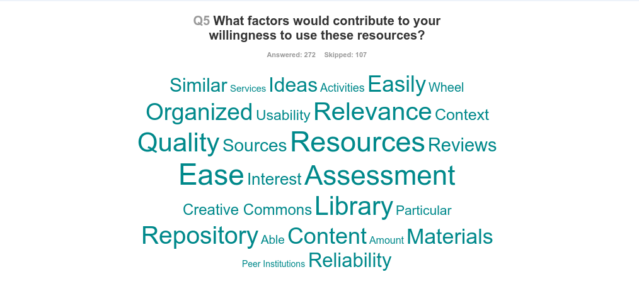

1. Question 7: What factors would contribute to your willingness to share your resources? Reponses as a word cloud.

